Online resources

Fig. S1 Summary of study designs
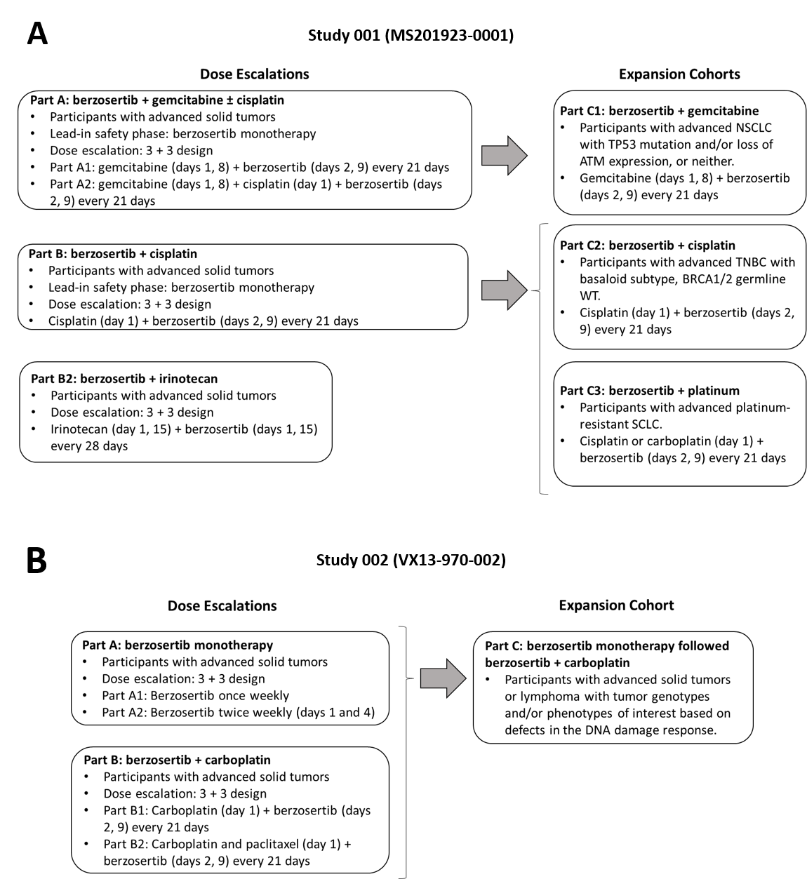
Designs of Study 001 and Study 002 are illustrated in panels A and B, respectively. The population PK analysis included data from all Berzosertib study parts, except Part B2 as those data were not available at the time of the analysis.

Fig. S2 Berzosertib concentration profiles after the first dose by dose levels and combination arm in Study 001 and Study 002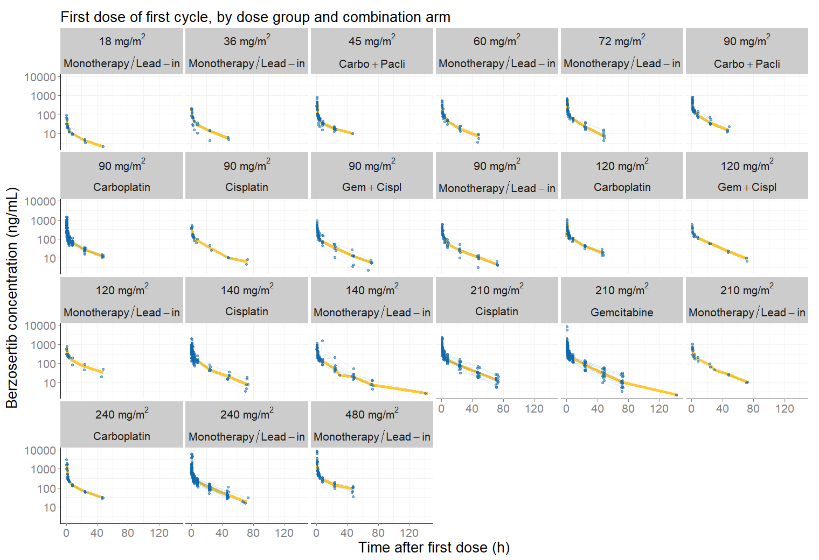
Carbo carboplatin, Cispl cisplatin, Gem gemcitabine, Pacli paclitaxel
Observed berzosertib concentrations are shown over time for each dose level and combination arm. Blue points connected by lines are individual observations; the yellow line a smoothing curve

Fig. S3 Goodness-of-fit plots for the full covariate model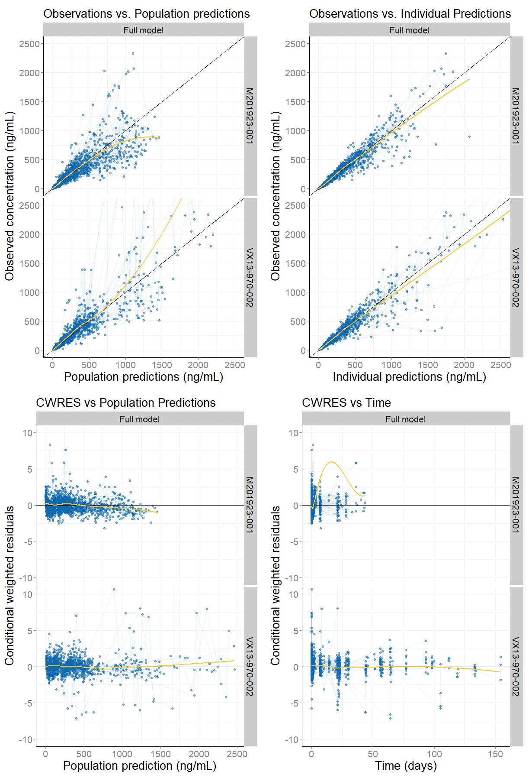
CWRES conditional weighted residuals
Goodness of fit plots of the full covariate model are shown
Fig. S4 Visual Predictive Check for the full covariate model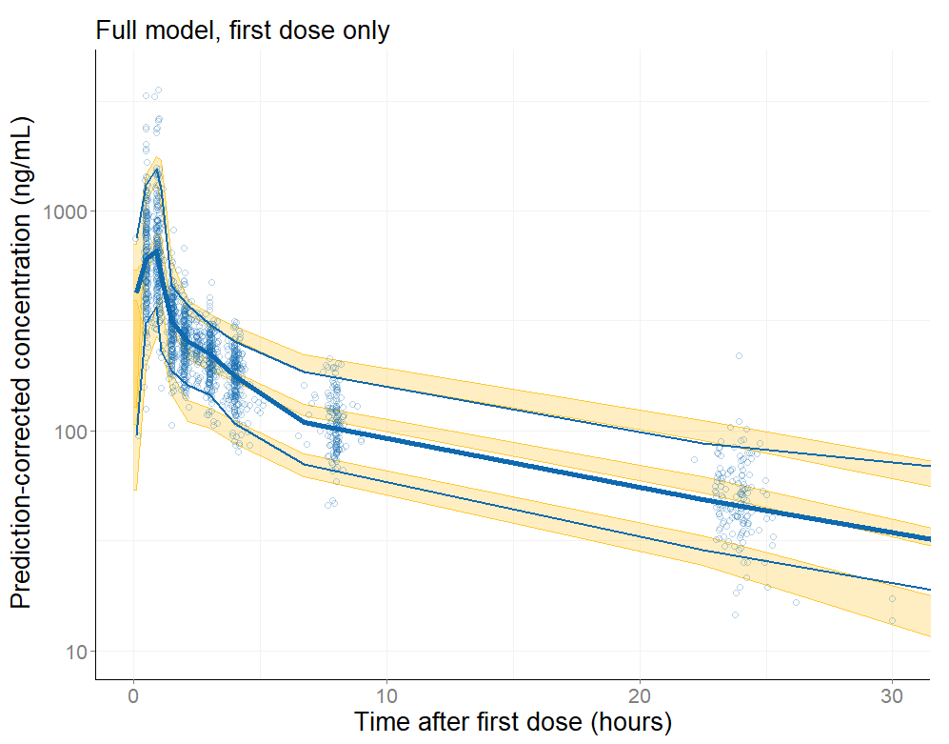
pcVPC prediction-corrected Visual Predictive Check
The pcVPC of the full covariate model is shown. Yellow shaded areas of the VPC represent 95% prediction intervals around the median and the 5th and 95th percentiles based on simulations (500 simulated datasets) following the first dose. Blue solid lines represent medians, 5th and 95th percentiles of the binned observed data. Points are individual observations

Fig. S5 Representative individual predicted concentration time profiles from the two phase I studies
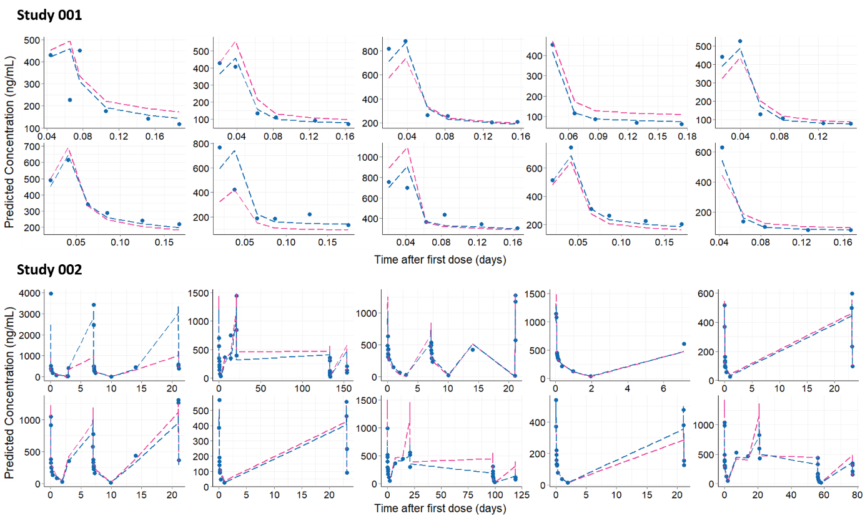Representative individual predicted concentration time profiles overlaid with the observed concentrations from the two phase I studies. Pink and blue lines represent population and individual predictions, respectively. Points are individual observations

Table S1 Demographics and baseline characteristics by study
Variable | Study MS201923-0001  Value (N = 170) | Study VX13-970-002  Value (N = 70)
Demographics
Age [years] | 59 {57.6} (26-79) [0] | 61.5 {60.4} (38-77) [0]
Bodyweight [kg] | 73 {75.2} (46-135) [0] | 72.3 {76} (48.2-150) [0]
BSA [kg/m²] | 1.82 {1.84} (1.4-2.52) [0] | 1.82 {1.84} (1.43-2.59) [0]
Lean body mass [kg] | 49.5 {52.4} (35.7-78.1) [1] | 50 {52} (36.9-78.9) [0]
Height [cm] | 168 {167} (99-191) [0] | 167 {167} (145-187) [0]
Sex [n (%)]  Male  Female | 68 (40%)  102 (60%) | 27 (38.6%)  43 (61.4%)
Race [n (%)]  White  Black  Asian  Other  Missing | 157 (92.4%)  3 (1.76%)  4 (2.35%)  4 (2.35%)  2 (1.18%) | 67 (95.7%)  0 (0%)  1 (1.43%)  2 (2.86%)  0 (0%)
Ethnicity [n (%)]  Hispanic/Latino  Not Hispanic/Latino  Missing | 7 (4.12%)  157 (92.4%)  6 (3.53%) | 0 (0%)  69 (98.6%)  1 (1.43%)
Lab values
Creatinine [µmol/L] | 66 {69.3} (32.7-148) [0] | 71 {71.2} (36-124) [0]
Creatinine clearance [mL/min] | 97.2 {102} (50-150) [0] | 89.2 {96.1} (57.2-150) [0]
Platelet count [10⁹ /L] | 264 {285} (93-816) [0] | 297 {298} (162-671) [0]
White cell count [cells /µL] | 7.2 {7.82} (1.37-25.2) [0] | 7.2 {7.24} (3.2-14.3) [0]
Albumin [g/L] | 39 {38.5} (23-49) [0] | 35.5 {35.4} (23-44) [0]
Bilirubin [µmol/L] | 6.84 {7.47} (0.5-20.5) [0] | 9 {9.84} (2-21) [0]
ALT [ U/L] | 19 {27.2} (4-178) [0] | 20.5 {26.3} (8-159) [0]
AST [U/L] | 24 {31.2} (10-159) [0] | 26 {30.8} (9-115) [0]
Renal impairment [n (%)]  None  Mild  Moderate  Severe | 104 (61.2%)  52 (30.6%)  14 (8.24%)  0 (0%) | 33 (47.1%)  36 (51.4%)  1 (1.43%)  0 (0%)
Hepatic impairment [n (%)]  None  Mild  Moderate  Severe  Missing | 109 (64.1%)  30 (17.6%)  0 (0%)  1 (0.588%)  30 (17.6%) | 57 (81.4%)  13 (18.6%)  0 (0%)  0 (0%)  0 (0%)
Disease status
Tumor burden [mm] | 80.5 {91.5} (10-312) [0] | 56 {66} (12-169) [0]
Tumor type [n (%)]  NSCLC  TNBC  SCLC  PrCa  Breast  H&N  CRC  Ovarian  Mesothelioma  Other | 46 (27.1%)  33 (19.4%)  14 (8.24%)  5 (2.94%)  6 (3.53%)  1 (0.588%)  26 (15.3%)  4 (2.35%)  8 (4.71%)  27 (15.9%) | 2 (2.86%)  0 (0%)  2 (2.86%)  2 (2.86%)  5 (7.14%)  0 (0%)  18 (25.7%)  5 (7.14%)  4 (5.71%)  32 (45.7%)
ECOG PS [n (%)]  0  1  2  3 | 46 (27.1%)  113 (66.5%)  5 (2.94%)  6 (3.53%) | 19 (27.1%)  51 (72.9%)  0 (0%)  0 (0%)
ALT alanine transaminase, AST aspartate transaminase, BSA body surface area, CRC colorectal cancer, ECOG PS Eastern Cooperative Oncology Group Performance Status H&N head & neck, NSCLC non-small cell lung cancer, PrCa prostate cancer, SCLC small cell lung cancer, TNBC triple negative breast cancer,
Continuous covariates are reported as median {geometric mean} (range) [missing]

Table S2 Population parameter estimates for the base model
Parameter | Estimate | RSE%ª | Asymptotic 95% CI | Shrinkage (%)^{b}
Clearance CL [L/h] | 56 | 2.5 | 54-59 | -
Central volume V1 [L] | 111 | 4.4 | 100-120 | -
Peripheral volume V2 [L] | 861 | 2.1 | 830-900 | -
Intercompartmental clearance Q [L/h] | 296 | 3.3 | 280-320 | -
IIV on CL [var] | 0.081 | 6.2 | 0.062-0.1 | 8.6
cov (CL, V1) | 0.067 | 13.0 | 0.032-0.1 | -
cov (CL, Q) | 0.048 | 14.0 | 0.021-0.075 | -
cov (CL, V2) | 0.057 | 6.5 | 0.042-0.071 | -
IIV on V1 [var] | 0.38 | 7.1 | 0.28-0.49 | 8
cov (V1, Q) | 0.26 | 8.3 | 0.18-0.35 | -
cov (V1, V2) | 0.093 | 9.5 | 0.058-0.13 | -
IIV on Q [var] | 0.24 | 8.9 | 0.15-0.32 | 5.8
cov (Q, V2) | 0.089 | 14.0 | 0.021-0.075 | -
IIV on Q [var] | 0.071 | 6.5 | 0.053-0.089 | 6.4
Proportional residual error [sd] | 0.22 | 4.1 | 0.21-0.24 | -
Additive residual error [ng/mL] | 1.9 | 13.0 | 1.4-2.4 | -
CI confidence interval, CL clearance, var variance, cov covariance, sd standard deviation, IIV inter-individual variability, Q intercompartmental clearance, RSE relative standard error, V1 central volume of distribution, V2 peripheral volume of distribution
ªObtained by NONMEM covariance step. The relative standard errors for individual variability parameters are reported on the approximate standard deviation scale (standard error/variance estimate)/2
^{b}The epsilon shrinkage was estimated to be 11%

