Supplementary Table 1 Study population demographics
Demographics | Results
Number of patients | 30
Age (years) | 41 ± 20
Gender, male | 19 (63%)
Weight (kg) | 75 ± 20
Indication for MRA
- Follow-up aortic dilatation | 15 (50%)
- Turner syndrome | 4 (13%)
- Follow-up coarctation | 2 (7%)
- Syndrome of Marfan | 1 (3%)
- Other | 8 (27%)

Data was expressed as mean ± standard deviation or as number (percentage).

Supplementary Table 2 Comparison of aortic diameters
 | Diameter |  |  | Difference |  | ICC
Landmark | CE-MRA† | SSFP-MRA† |  | Mean [LoA]* |  | r
Sinus of Valsalva | 34.2 ± 6.7 | 34.0 ± 6.8 |  | – 0.1 [-2.4; 2.2] |  | 0.99
Sinotubular junction | 30.3 ± 6.5 | 30.3 ± 6.5 |  | 0.0 [-2.0; 2.0] |  | 0.99
Mid-ascending aorta | 33.0 ± 6.2 | 33.1 ± 6.3 |  | 0.2 [-1.8; 2.2] |  | 0.99
Proximal aortic arch | 27.5 ± 5.4 | 27.3 ± 5.5 |  | – 0.2 [-2.1; 2.7] |  | 0.98
Mid-aortic arch | 21.5 ± 4.4 | 21.6 ± 4.5 |  | 0.1 [-2.1; 2.2] |  | 0.97
Proximal desc. aorta | 20.1 ± 4.7 | 20.1 ± 4.7 |  | 0.0 [-1.6; 1.6] |  | 0.99
Mid-descending aorta | 20.4 ± 4.1 | 20.6 ± 4.3 |  | 0.2 [-1.6; 1.9] |  | 0.98
Aorta at diaphragm | 19.1 ± 4.0 | 19.3 ± 4.1 |  | 0.1 [-1.3; 1.5] |  | 0.98
Abdominal aorta | 18.2 ± 3.7 | 18.1 ± 3.8 |  | -0.1 [-1.7; 1.6] |  | 0.98

Mean diameter per landmark for both sequences, the difference and the intraclass correlation coefficient.
†Data presented as mean ± standard deviation (mm)
*Difference presented as mean difference [limits of agreement] (mm)
CE contrast-enhanced; LoA limits of agreement; MRA magnetic resonance angiography; SSFP steady-state free precession; ICC intraclass correlation coefficient.

Supplementary Table 3 Intra- and inter-observer variability

†Data presented as the range of variability (mm) between reproducibility measurements and the maximum disagreement percentage (%).

CE contrast-enhanced; MRA magnetic resonance angiography; SSFP steady state free precession

Landmark | Intra-observer variability† |  |  | Inter-observer variability†
 | CE-MRA | SSFP-MRA |  | CE-MRA | SSFP-MRA
Sinus of Valsalva | – 1.9 – 2.3; 6% | – 1.1 – 1.0; 3% |  | – 2.1 – 2.4; 8% | – 1.8 – 1.1; 6%
Sinotubular junction | – 1.4 – 0.8; 5% | – 0.5 – 0.9; 4% |  | – 1.8 – 2.3; 10% | – 1.1 – 0.9; 5%
Mid-ascending aorta | – 0.4 – 1.3; 5% | – 0.7 – 1.3; 6% |  | – 1.1 – 1.0; 5% | – 0.8 – 1.3; 5%
Proximal aortic arch | – 0.6 – 0.7; 3% | – 0.4 – 1.2; 4% |  | – 0.9 – 0.9; 4% | – 0.8 – 0.6; 3%
Mid-aortic arch | – 0.8 – 0.9; 4% | – 0.5 – 1.4; 5% |  | – 1.9 – 0.9; 10% | – 1.2 – 1.3; 6%
Proximal desc. aorta | – 1.4 – 1.1; 6% | – 0.6 – 0.6; 4% |  | – 1.3 – 0.7; 7% | – 1.3 – 1.1; 6%
Mid-desc. aorta | – 0.4 – 1.2; 9% | – 0.7 – 1.1; 6% |  | – 1.4 – 1.0; 9% | – 1.4 – 0.6; 6%
Aorta at diaphragm | – 0.4 – 1.2; 8% | – 0.5 – 0.8; 4% |  | – 1.2 – 1.4; 9% | – 1.1 – 0.9; 6%
Abdominal aorta | – 0.5 – 0.9; 7% | – 0.9 – 0.6; 5% |  | – 0.9 – 0.7; 7% | – 1.6 – 1.3; 8%

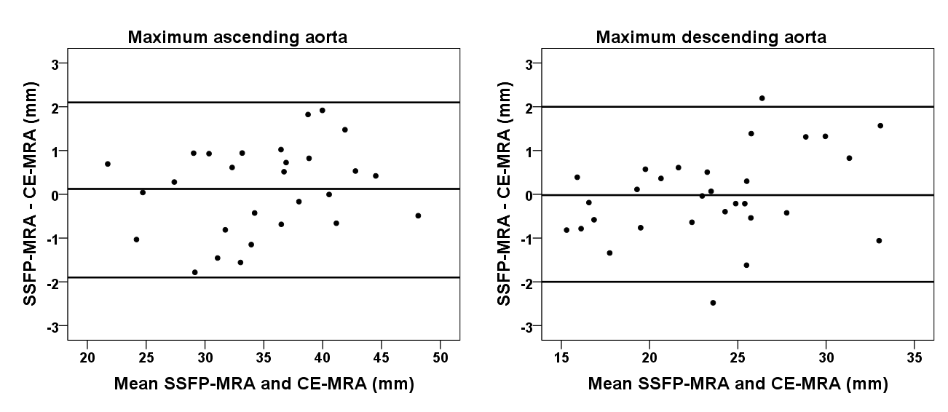
Supplementary Fig. 1 Bland-Altman analysis of the differences between CE-MRA and SSFP-MRA for maximum diameter assessment of the ascending aorta (left) and descending aorta (right).

CE contrast-enhanced; MRA magnetic resonance angiography; SSFP steady-state free precession

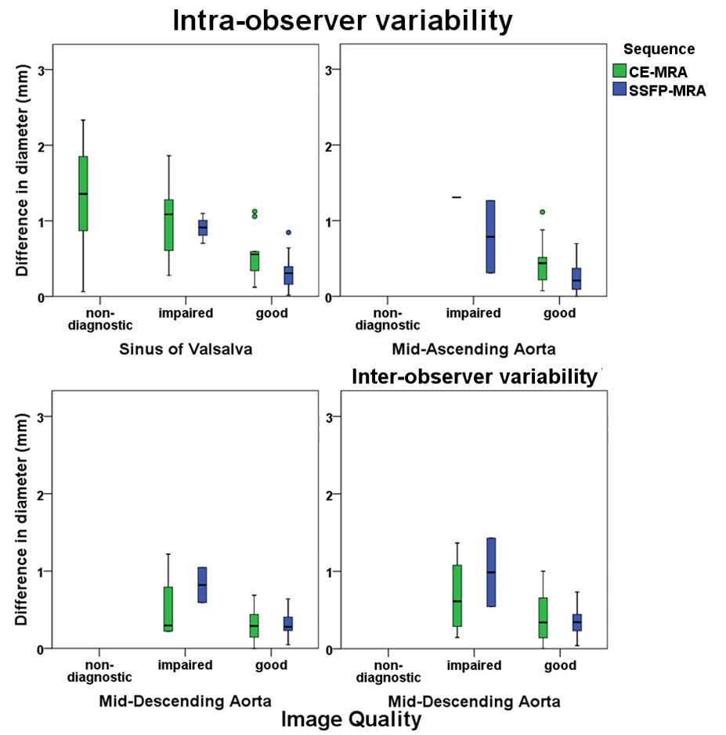

Supplementary Fig. 2 Boxplot of the observer variability for the different image quality scores. The four panels represent the intra-observer variability in the sinus of Valsalva (top left), the mid-ascending aorta (top right), the mid-descending aorta (bottom left) and the inter-observer variability in the mid-descending aorta (bottom right). On the x-axis, the image quality score of both CE-MRA and SSFP-MRA is presented. The y-axis shows the variability in mm of the observer measurements corresponding with the different image quality scores.

CE contrast-enhanced; MRA magnetic resonance angiography; SSFP steady state free precession

