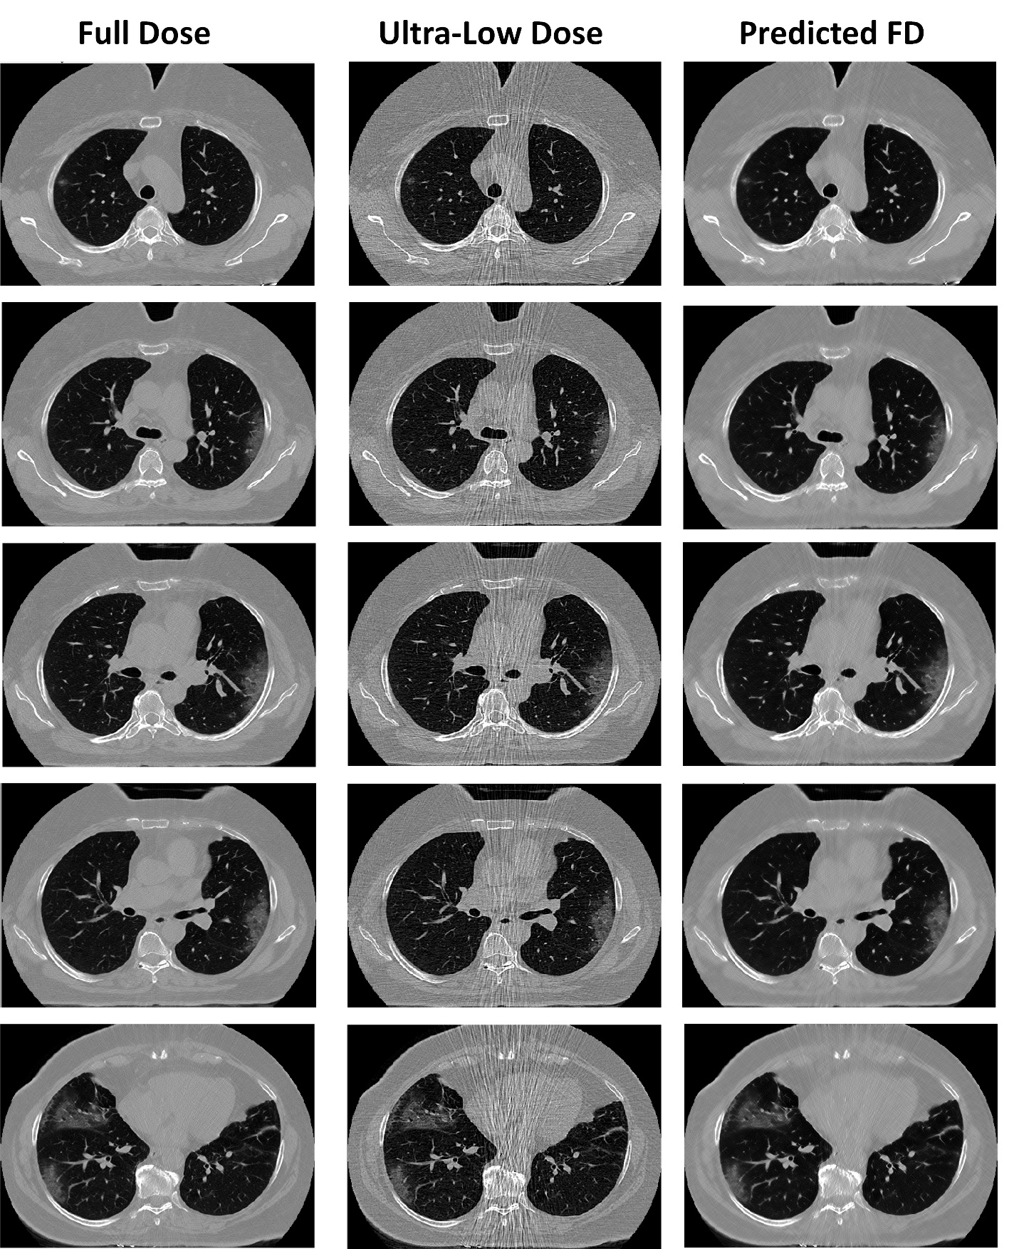
Supplemental Figure 1. Representative full-dose image and corresponding ultra-low-dose and predicted full-dose images case 2.
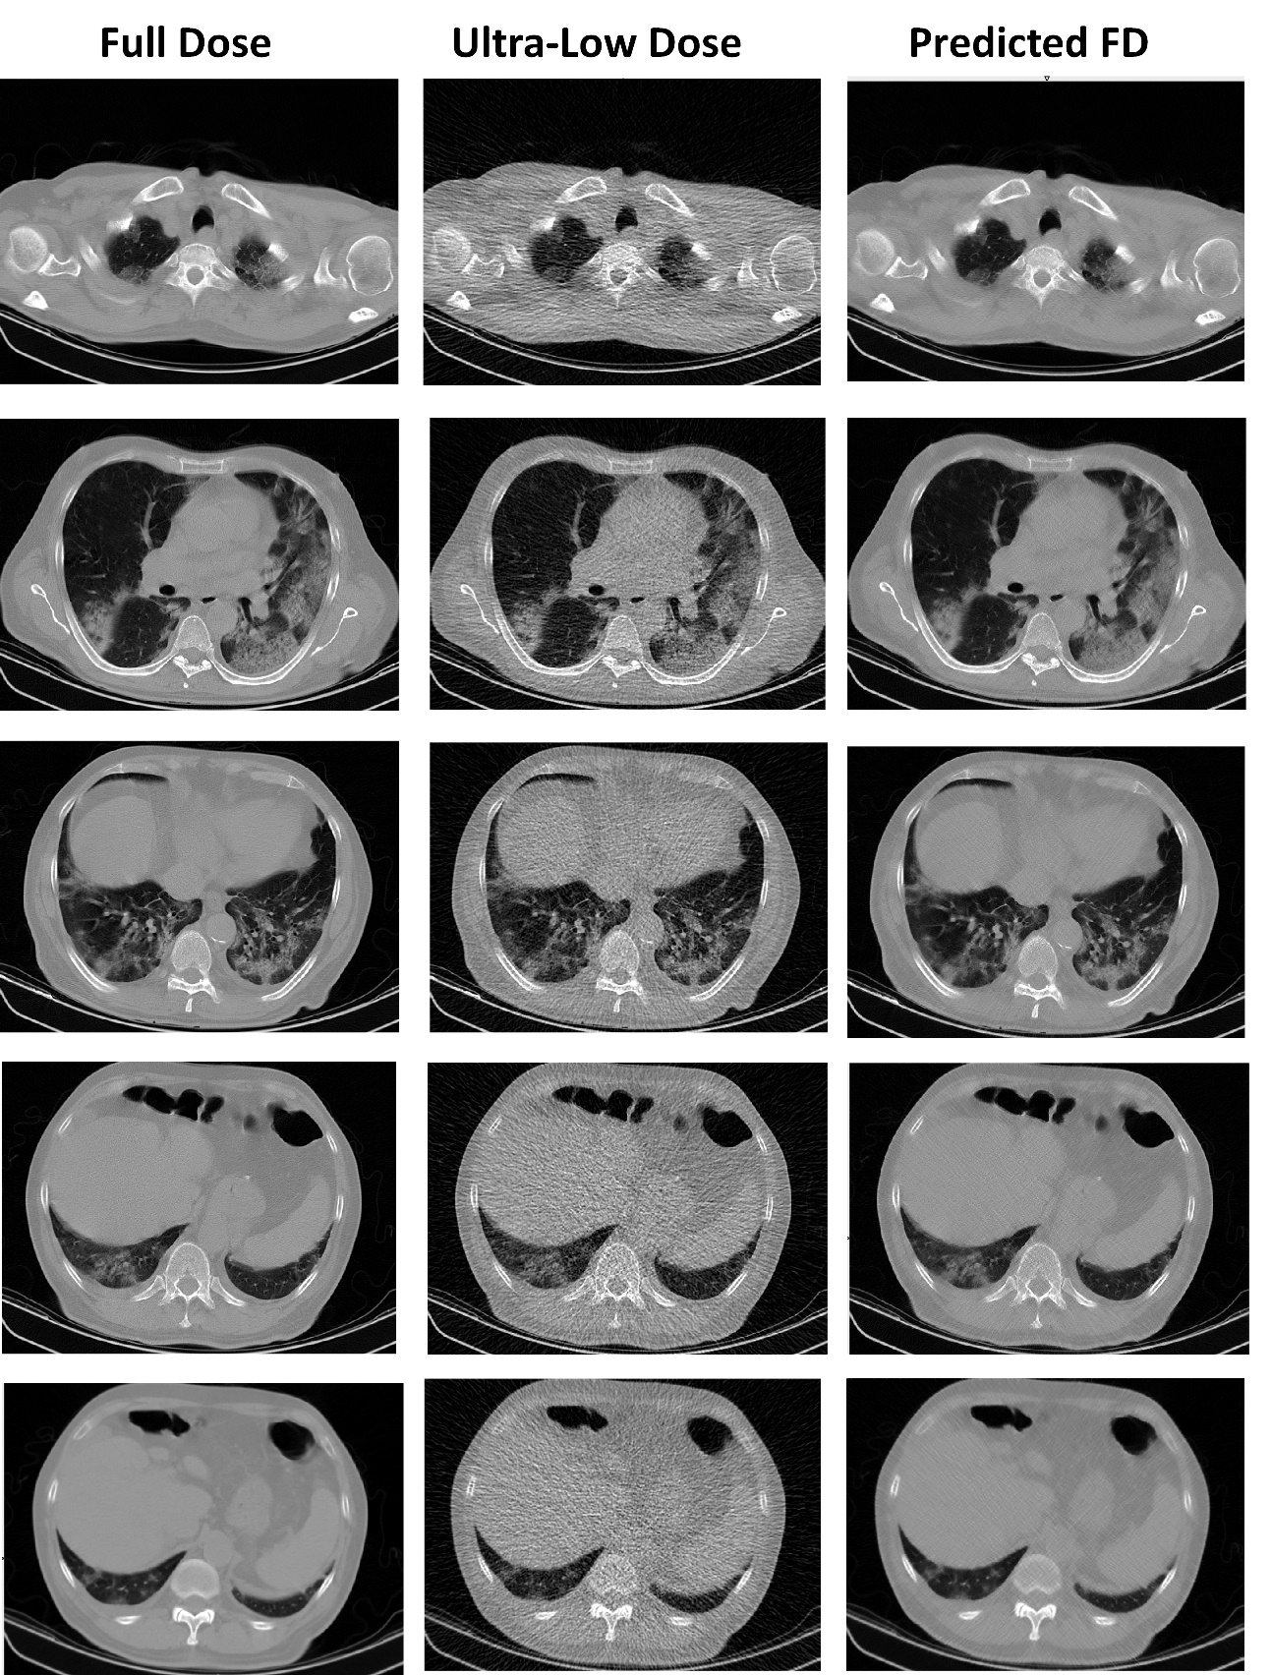
Supplemental Figure 2. Representative full-dose image and corresponding ultra-low-dose and predicted full-dose images case 3.

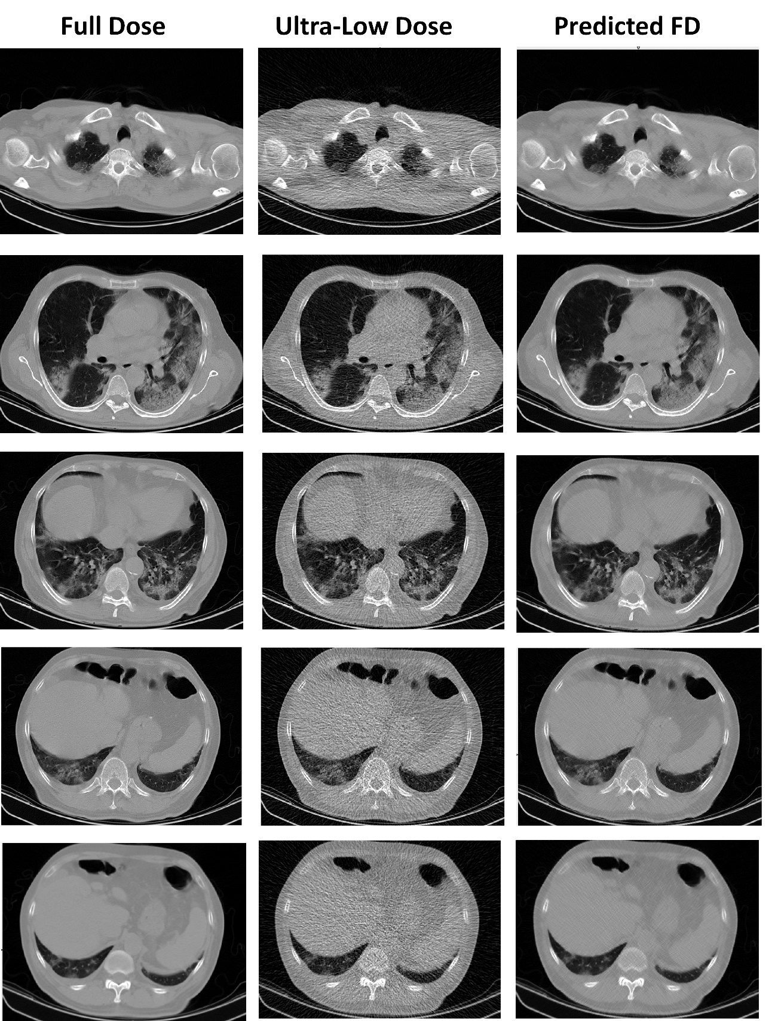
Supplemental Figure 3. Outlier report: CT images of a patient where the deep learning algorithm improved image quality but changed the patchy lesion to consolidation in predicted images case 2.
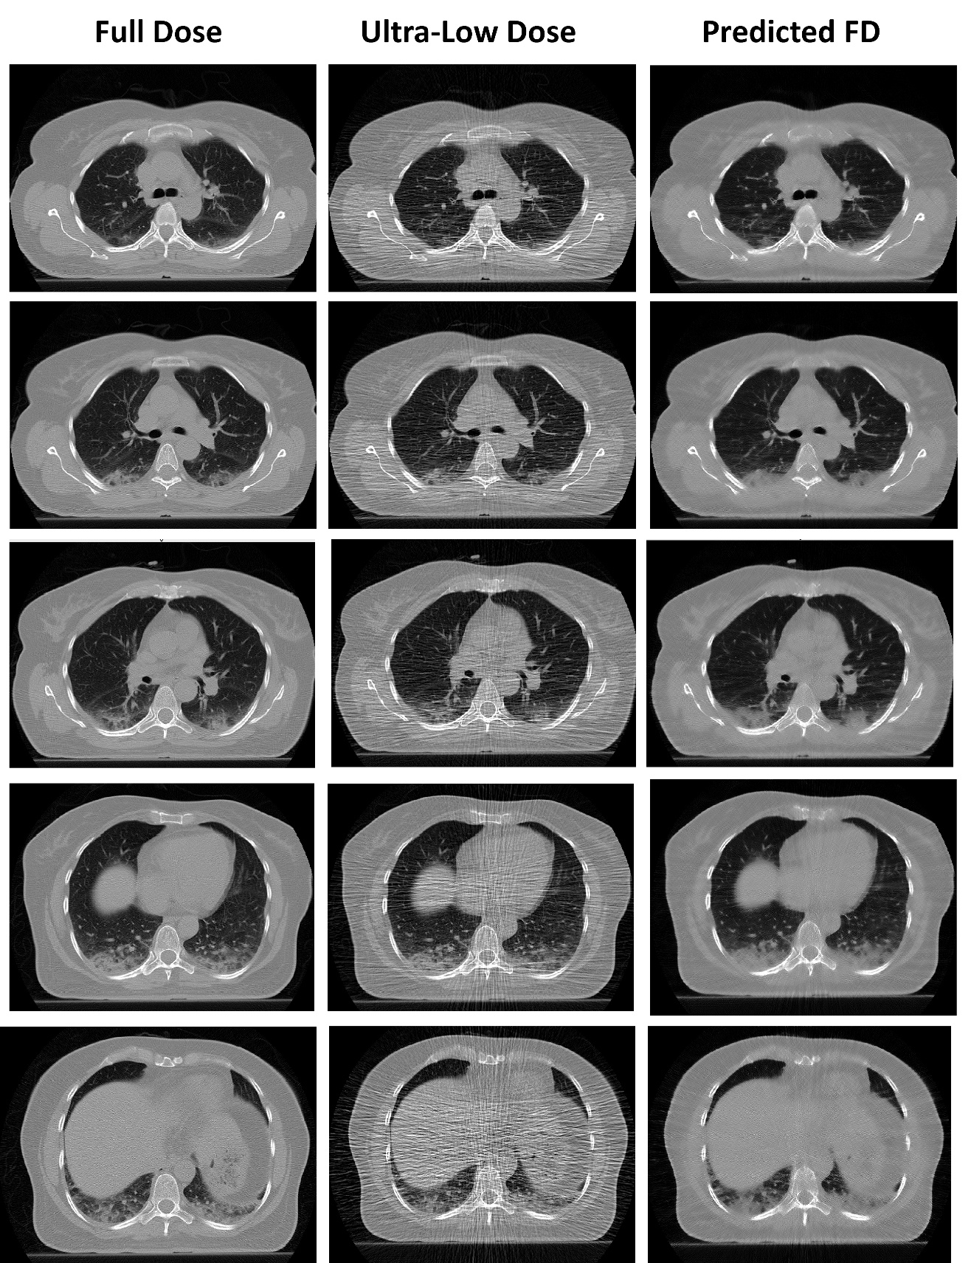
Supplemental Figure 4. Outlier report: CT images of a patient where the deep learning algorithm improved image quality but changed the patchy lesion to consolidation in predicted images case 3.

