Supplementary Figure 1: Funnel plot of pouch failure with follow up < 5 years (Eggers test = 0.1263506).

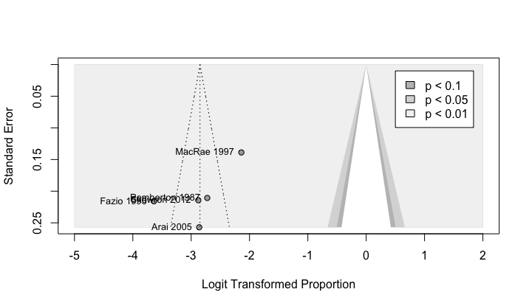

Supplementary Figure 2: Funnel plot of pouch failure with follow up ≥5 but <10 years (Eggers test = 0.9885051)
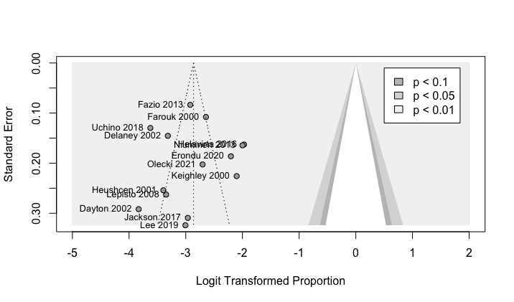

Supplementary Figure 3: Funnel plot of pouch failure with follow up ≥ 10 (Eggers test not possible due to insufficient data)

