Supplementary figures

Supplementary Figure 1. Proximal Isovelocity Surface Area (PISA) radius measurement

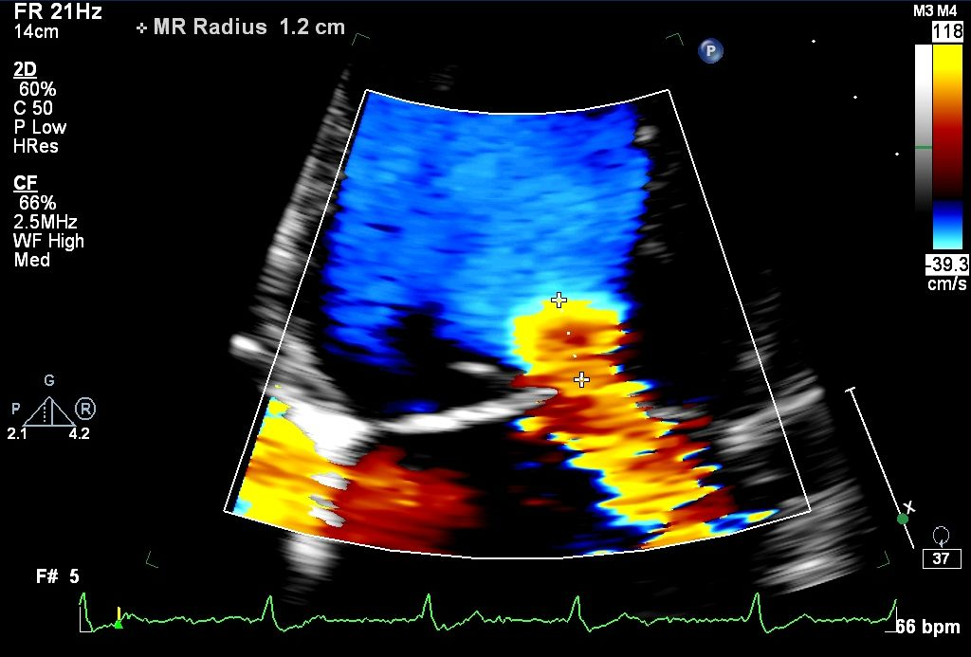
Aliasing line
PISA radius
Regurgitant orifice
Left atrium
Left ventricle
Supplementary Figure 2. Kaplan Meyer Curve for Survival Free according to Baseline ERO (ERO cut-off 0.4cm²).

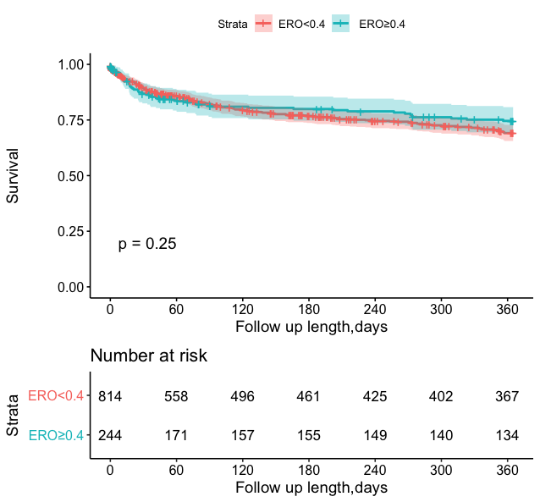
ERO: effective regurgitant orifice

Supplementary Figure 3. Kaplan Meyer Curve for Survival Free according to Baseline ERO (ERO cut-off 0.2cm²).

ERO: effective regurgitant orifice

Figure 4. Kaplan Meyer Curve for Survival Free according to Baseline ERO with the median used as cut-off.

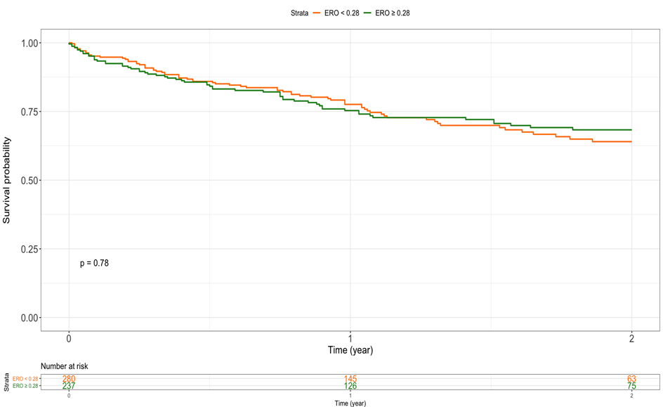

ERO: effective regurgitant orifice

Supplementary Figure 2. NYHA Functional Class at Baseline and 1-year Follow-up According to Baseline ERO (ERO cut-off 0.4cm²).

There was no difference in baseline NYHA class between the 2 ERO groups (P= 0.19). At last follow-up, patients in the higher ERO group were more frequently in NYHA class I or II (P=0.029). ERO: effective regurgitant orifice; NYHA: New York Heart Association

Supplementary Figure 3. NYHA Functional Class at Baseline and 1-year Follow-up According to Baseline ERO (ERO cut-off 0.2cm²).

There was a trend for more severe NYHA class in patients in the lower ERO group at baseline (P=0.007), while at last follow-up, there was no difference in NYHA between the 2 groups (P=0.98). ERO: effective regurgitant orifice; NYHA: New York Heart Association

