Supplemental file “Growth differentiation factor 15 predicts poor prognosis in heart failure patients with anemia-results from RED-HF”

Ueland et al.

Methods
Statistics

Trends across tertiles of GDF-15 were tested using Kruskal-Wallis H test, one-way ANOVA or chi-square depending on distribution and variable type (i.e. categorical or continuous). For comparing treatment effects on the GDF-15, the Mann-Whitney U test was used on change values while Wilcoxon matched pairs test was used to assess longitudinal changes within groups. Stepwise linear regression was used to identify the most important predictors of GDF-15. Kaplan-Meier curves were constructed to visualize and evaluate (log rank test) differences in survival. A restricted cubic spline analysis with three knots was undertaken on the primary outcome to assess linearity of risk. Survival analyses were performed using the Cox proportional hazard regression models to estimate hazard ratios (HRs) and 95% confidence intervals (CIs) for GDF-15 as a log-transformed continuous variables at baseline, which included mainly clinical variables at step one in addition to randomization (age, gender, NYHA class, hospitalization for HF within 6 months, log serum creatinine, LVEF, etiology, body mass index (BMI), left bundle-branch block, history of atrial fibrillation or flutter, systolic blood pressure). At step two, log-transformed serum concentrations of NT-proBNP, hsTnT and hsCRP were included. The adjustment model was prespecified. For the analysis of changes in GDF-15 concentrations from baseline to 6-month follow-up, a 15% relative change was used as cutoff, which is consistent with other studies (1). Harrel’s C-statistic and Net reclassification improvement (NRI) was calculated to evaluate the prognostic usefulness of biomarkers. We also compared the prognostic value of GDF-15 with NT-proBNP and hs-TnT in two ways: First, we evaluated C-statistics for the addition of GDF-15, NT-proBNP and TnT to a model including adjustment variables from step 1 as described above but including CRP. Second, we evaluated C-statistics the exclusion of GDF-15, NT-proBNP and TnT from the full model including all adjustment variables and GDF-15, NT-proBNP and TnT. Associations between GDF-15 and indices of iron deficiency were assessed by spearman correlation. Interactions between iron deficiency markers, GDF-15 and outcomes were evaluated by dividing the iron deficiency markers in tertiles and evaluating the association between GDF-15 and outcomes within each tertile in unadjusted and adjusted analysis as described above. ROC analysis and logistic regression was used to evaluate the association between GDF-15 levels and unresponsiveness to Darbepoetin alfa. A two-sided p-value <0.05 was considered to be significant. All statistical analyses were performed with the use of SAS software, version 9.2.

1. Masson S, Anand I, Favero C et al. Serial measurement of cardiac troponin T using a highly sensitive assay in patients with chronic heart failure: data from 2 large randomized clinical trials. Circulation 2012;125:280-8.

Supplementary Table 1. Comparison between participants in the biomarker sub-study population with the main RED-HF population.
Characteristic | Main trial | Sub-study | P-value | Placebo  N=792 | Darbepoetin alfa  N=790 | P-value
 | (n=2278) | (n=1582) |  | (n=792) | (n=790)
Age, yrs. | 70±11 | 70±12 | 0.468 | 69±12 | 70±12 | 0.371
Female sex | 41 | 43 | 0.250 | 44 | 42 | 0.202
Race (white/black) | 68/9 | 66/10 | 0.423 | 66/11 | 67/9 | 0.231
BMI (SD) kg/m² | 27.2±5.7 | 27.1±5.7 | 0.446 | 27±6 | 27±6 | 0.891
NYHA (III or IV) | 65 | 66 | 0.456 | 64 | 69 | 0.036
Ischemic HF | 73 | 72 | 0.353 | 71 | 72 | 0.842
Duration HF, yrs. | 5.3±5.3 | 5.4±5.4 | 0.759 | 5±5 | 5±5 | 0.456
LVEF,% | 30.3±6.8 | 30.3±6.8 | 1.000 | 30±7 | 30±7 | 0.698
Medical history
Hypertension | 74 | 74 | 0.733 | 73 | 75 | 0.546
Diabetes | 46 | 45 | 0.339 | 44 | 45 | 0.758
Atrial fibrillation or flutter | 33 | 32 | 0.463 | 32 | 31 | 0.720
MI last 6 mo. | 37 | 37 | 0.862 | 34 | 39 | 0.082
Medication
ACE or ARB | 89 | 90 | 0.216 | 89 | 92 | 0.034
Beta-blocker | 85 | 85 | 0.965 | 86 | 84 | 0.450
Diuretic | 92 | 91 | 0.930 | 91 | 92 | 0.237
Systolic BP | 120±18 | 120±18 | 0.889 | 121±18 | 119±18 | 0.103
Heart rate, bpm. | 72±11 | 72±11 | 0.635 | 72±11 | 72±11 | 0.418
Biochemistry
Creatinine, mg/dL | 1.5±0.6 | 1.5±0.6 | 0.451 | 1.5±0.6 | 1.5±0.6 | 0.703
eGFR, mL/min/1.73m² | 50±21 | 50±22 | 0.546 | 50±22 | 50±22 | 0.853
Hemoglobin, g/dL | 11.0±0.7 | 11.0±0.7 | 0.699 | 11.0±0.7 | 11.0±0.7 | 0.560
Transferrin saturation, % | 26.8 ±10.8 | 27.9±10.9 | 0.735 | 27.3±11.6 | 26.7±10.2 | 0.254
Iron, μg/dL | NA |  | NA | 75.7±34.4 | 78.0±39.2 | 0.227
Ferritin, μg/L | NA |  | NA | 149±153 | 158±184 | 0.267
Platelets, x10⁹/L | 232±79 | 232±79 | 0.842 | 228±78 | 236±81 | 0.050
WBC, x10⁹/L | 6.9±2.2 | 6.7±2.2 | 0.534 | 6.7±2.2 | 6.8±2.1 | 0.467
hsCRP, mg/dL | 2.7 (0.8,6.3) | 2.7 (0.8,6.6) | 0.444 | 2.6 [0.7, 6.5 | 2.7 [0.8, 6.8] | 0.122
NT-proBNP, pmol/L | 1823 (653,4244) | 1840 (592,4209) | 0.986 | 1832 [628,4189] | 1850 [557,4231] | 0.869
hsTnT, ng/ml | 26 (15,43) | 26 (15,41) | 0.826 | 25 [15,41] | 27 [16,41] | 0.383
Patient characteristics are given as mean ± SD for continuous variables and % of cases for categorical variables. ACE, angiotensin-converting enzyme; ARB, angiotensin receptor blocker; BMI, body mass index; BP, blood pressure; eGFR, estimated glomerular filtration rate; hsCRP, high-sensitivity C-reactive protein; hsTnT, high-sensitive troponin.

Supplemental Table 2. Baseline predictors of GDF-15
 | Coefficients (95% CI) | P value
(Intercept) | 7.48 (5.06‒9.92) | <0.001
hsTnT (Log), ng/mL | 0.53 (0.36‒0.69) | <0.001
Creatinine, mg/dL | 1.36 (1.11‒1.62) | <0.001
NT-proBNP (Log), pmol/L | 0.63 (0.47‒0.78) | <0.001
Hemoglobin, g/dL | -0.47 (-0.64‒-0.3) | <0.001
Systolic BP | -0.02 (-0.02‒-0.01) | <0.001
Age, yrs. | 0.03 (0.02‒0.04) | <0.001
History of Diabetes | 0.48 (0.23‒0.72) | <0.001
MI last 6 mo. | 0.44 (0.19‒0.69) | <0.001
Platelets | 0.00 (-0.01‒0.00) | <0.001
Heart rate, bpm. | 0.02 (0.01‒0.03) | <0.001
hsCRP (Log), mg/dL | 0.19 (0.06‒0.32) | 0.004
Race, other | 0.66 (0.22‒1.11) | 0.005
History of Atrial fibrillation or flutter | 0.27 (-0.04‒0.58) | 0.004
Diuretic | -0.50 (-0.92‒-0.08) | 0.040

Supplemental Table 3. Association of Change in GDF-15 with Outcomes evaluated as tertiles.
 | Univariable | Step 1 | Step 2
All-Cause Mortality or First Hospitalization for Worsening Heart Failure
T2 | 0.62 (0.50‒0.76) | 0.86 (0.69‒1.07) | 0.83 (0.66‒1.04)
T3 | 1.32 (1.09‒1.59) | 1.62 (1.33‒1.96) | 1.58 (1.30‒1.92)
p-trend | <0.001 | <0.001 | <0.001
Cardiovascular Mortality or First Hospitalization for Worsening Heart Failure
T2 | 0.57 (0.46‒0.72) | 0.81 (0.64‒1.03) | 0.78 (0.61‒1.00)
T3 | 1.32 (1.08‒1.60) | 1.62 (1.32‒1.98) | 1.57 (1.28‒1.93)
p-trend | <0.001 | <0.001 | <0.001
All-Cause Mortality
T2 | 0.61 (0.48‒0.78) | 0.79 (0.62‒1.02) | 0.77 (0.59‒0.98)
T3 | 1.21 (0.98‒1.49) | 1.34 (1.08‒1.66) | 1.28 (1.02‒1.58)
p-trend | <0.001 | <0.001 | <0.001
Cardiovascular Mortality
T2 | 0.59 (0.45‒0.77) | 0.76 (0.57‒1.00) | 0.74 (0.55‒0.97)
T3 | 1.25 (0.99‒1.58) | 1.39 (1.1‒1.76) | 1.31 (1.03‒1.65)
p-trend | <0.001 | <0.001 | <0.001

Hazard ratios and 95% confidence interval are shown for T2 change (-420 – 340 ng/L) and T3 change (>340 ng/mL) vs. T1 change (<420 ng/L) in univariate (UNI) analysis, when adjusted for clinical and biochemical variables (step 1), and lastly for CRP, TnT and NT-proBNP (Step 2). * comparing the fully adjusted models with and without inclusion of log GDF15.

Supplemental Table 4. Correlation (Spearman) between baseline, change and 6 month levels of GDF-15 and markers of iron deficiency and anemia in the RED-HF cohort.
 |  |  | Change |  | 6 months
 | Baseline | All | Placebo | Darb. | All | Placebo | Darb.
Iron | -0.06* | 0.01 | 0.01 | -0.02 | -0.14*** | -0.11** | -0.15***
Ferritin | 0.14*** | 0.00 | -0.02 | 0.03 | 0.14*** | 0.19*** | 0.11**
Transferrin | -0.06* | 0.00 | 0.00 | 0.01 | -0.10** | -0.07 | -0.11**
Hemoglobin | -0.21*** | 0.02 | -0.02 | -0.02 | -0.24*** | -0.30*** | -0.19***

*p<0.05, *p<0.01, ***p<0.001

Supplemental Table 5. Interactions between GDF-15 and iron status on outcome.
 | Univariate* | Full adjustement**
 | HR (95% CI) p-value | HR (95% CI) p-value
All-Cause Mortality or First Hospitalization for Worsening Heart Failure
Iron <60 μg/dL | 1.90 (1.67 - 2.17) <0.001 | 1.19 (1.00 - 1.42) 0.046
Iron 60-81 μg/dL | 1.86 (1.61 - 2.14) <0.001 | 1.20 (1.00 - 1.45) 0.055
Iron >81 μg/dL | 1.81 (1.57 - 2.09) <0.001 | 1.18 (0.96 - 1.45) 0.108
Ferritin <65 μg/L | 1.56 (1.36 - 1.78) <0.001 | 1.07 (0.88 - 1.29) 0.517
Ferritin 65-149 μg/L | 1.94 (1.69 - 2.23) <0.001 | 1.14 (0.95 - 1.38) 0.17
Ferritin >149 μg/L | 2.19 (1.90 - 2.52) <0.001 | 1.44 (1.18 - 1.75) <0.001
Transferrin saturation <21% | 1.75 (1.55 - 1.98) <0.001 | 1.09 (0.92 - 1.28) 0.311
Transferrin saturation 21-29% | 1.86 (1.62 - 2.14) <0.001 | 1.22 (1.00 - 1.48) 0.049
Transferrin saturation >29% | 2.06 (1.75 - 2.41) <0.001 | 1.41 (1.13 - 1.76) 0.002
Hemoglobin <10.8 g/dL | 1.94 (1.70 - 2.23) <0.001 | 1.20 (0.99 - 1.45) 0.059
Hemoglobin 10.8-11.45 g/dL | 2.13 (1.85 - 2.46) <0.001 | 1.34 (1.11 - 1.61) 0.002
Hemoglobin > 11.45 g/dL | 1.59 (1.38 - 1.85) <0.001 | 1.07 (0.87 - 1.31) 0.52
Cardiovascular Mortality or First Hospitalization for Worsening Heart Failure
Iron <60 μg/dL | 1.89 (1.64 - 2.17) <0.001 | 1.15 (0.95 - 1.38) 0.145
Iron 60-81 μg/dL | 1.84 (1.59 - 2.13) <0.001 | 1.19 (0.98 - 1.45) 0.082
Iron >81 μg/dL | 1.77 (1.52 - 2.05) <0.001 | 1.14 (0.92 - 1.41) 0.234
Ferritin <65 μg/L | 1.53 (1.33 - 1.75) <0.001 | 1.03 (0.85 - 1.26) 0.759
Ferritin 65-149 μg/L | 1.90 (1.64 - 2.20) <0.001 | 1.08 (0.89 - 1.32) 0.439
Ferritin >149 μg/L | 2.19 (1.88 - 2.55) <0.001 | 1.42 (1.16 - 1.74) 0.001
Transferrin saturation <21% | 1.75 (1.54 - 1.99) <0.001 | 1.06 (0.90 - 1.26) 0.479
Transferrin saturation 21-29% | 1.83 (1.58 - 2.13) <0.001 | 1.22 (1.00 - 1.51) 0.054
Transferrin saturation >29% | 1.95 (1.65 - 2.30) <0.001 | 1.29 (1.02 - 1.62) 0.031
Hemoglobin <10.8 g/dL | 1.97 (1.68 - 2.29) <0.001 | 1.21 (1.00 - 1.48) 0.052
Hemoglobin 10.8-11.45 g/dL | 2.03 (1.75 - 2.36) <0.001 | 1.36 (1.11 - 1.65) 0.003
Hemoglobin > 11.45 g/dL | 1.60 (1.38 - 1.85) <0.001 | 0.99 (0.80 - 1.23) 0.931
Death
Iron <60 μg/dL | 1.95 (1.68 - 2.27) <0.001 | 1.30 (1.06 - 1.58) 0.011
Iron 60-81 μg/dL | 2.06 (1.75 - 2.42) <0.001 | 1.50 (1.21 - 1.86) <0.001
Iron >81 μg/dL | 1.63 (1.39 - 1.90) <0.001 | 1.06 (0.84 - 1.33) 0.616
Ferritin <65 μg/L | 1.59 (1.36 - 1.85) <0.001 | 1.10 (0.89 - 1.35) 0.396
Ferritin 65-149 μg/L | 1.96 (1.67 - 2.30) <0.001 | 1.19 (0.96 - 1.48) 0.106
Ferritin >149 μg/L | 2.14 (1.83 - 2.50) <0.001 | 1.51 (1.21 - 1.88) <0.001
Transferrin saturation <21% | 1.85 (1.61 - 2.13) <0.001 | 1.19 (0.98 - 1.44) 0.075
Transferrin saturation 21-29% | 1.87 (1.60 - 2.20) <0.001 | 1.37 (1.10 - 1.70) 0.004
Transferrin saturation >29% | 1.91 (1.61 - 2.26) <0.001 | 1.34 (1.04 - 1.71) 0.021
Hemoglobin <10.8 g/dL | 1.96 (1.68 - 2.29) <0.001 | 1.22 (0.98 - 1.52) 0.071
Hemoglobin 10.8-11.45 g/dL | 2.17 (1.85 - 2.54) <0.001 | 1.41 (1.14 - 1.74) 0.002
Hemoglobin > 11.45 g/dL | 1.55 (1.32 - 1.81) <0.001 | 1.22 (0.98 - 1.53) 0.074
CV death
Iron <60 μg/dL | 1.93 (1.63 - 2.27) <0.001 | 1.24 (1.00 - 1.56) 0.055
Iron 60-81 μg/dL | 2.08 (1.74 - 2.47) <0.001 | 1.48 (1.17 - 1.85) 0.001
Iron >81 μg/dL | 1.55 (1.31 - 1.83) <0.001 | 0.98 (0.77 - 1.25) 0.878
Ferritin <65 μg/L | 1.55 (1.31 - 1.83) <0.001 | 1.05 (0.84 - 1.32) 0.678
Ferritin 65-149 μg/L | 1.89 (1.59 - 2.25) <0.001 | 1.09 (0.86 - 1.37) 0.49
Ferritin >149 μg/L | 2.14 (1.81 - 2.54) <0.001 | 1.48 (1.16 - 1.88) 0.002
Transferrin saturation <21% | 1.87 (1.60 - 2.18) <0.001 | 1.15 (0.94 - 1.42) 0.177
Transferrin saturation 21-29% | 1.82 (1.53 - 2.17) <0.001 | 1.38 (1.09 - 1.75) 0.008
Transferrin saturation >29% | 1.79 (1.49 - 2.15) <0.001 | 1.16 (0.89 - 1.52) 0.26
Hemoglobin <10.8 g/dL | 2.06 (1.73 - 2.45) <0.001 | 1.18 (0.93 - 1.50) 0.163
Hemoglobin 10.8-11.45 g/dL | 2.03 (1.71 - 2.42) <0.001 | 1.49 (1.18 - 1.88) 0.001
Hemoglobin > 11.45 g/dL | 1.54 (1.30 - 1.81) <0.001 | 1.09 (0.85 - 1.39) 0.486

*adjusting for randomized treatment, ** Full multivariable adjustment (age, gender, NYHA class, hospitalization for HF within 6 months, log serum creatinine, LVEF, etiology, body mass index, left bundle-branch block, history of atrial fibrillation or flutter, systolic blood pressure, log-transformed serum concentrations of NT-proBNP, hsTnT and hsCRP.

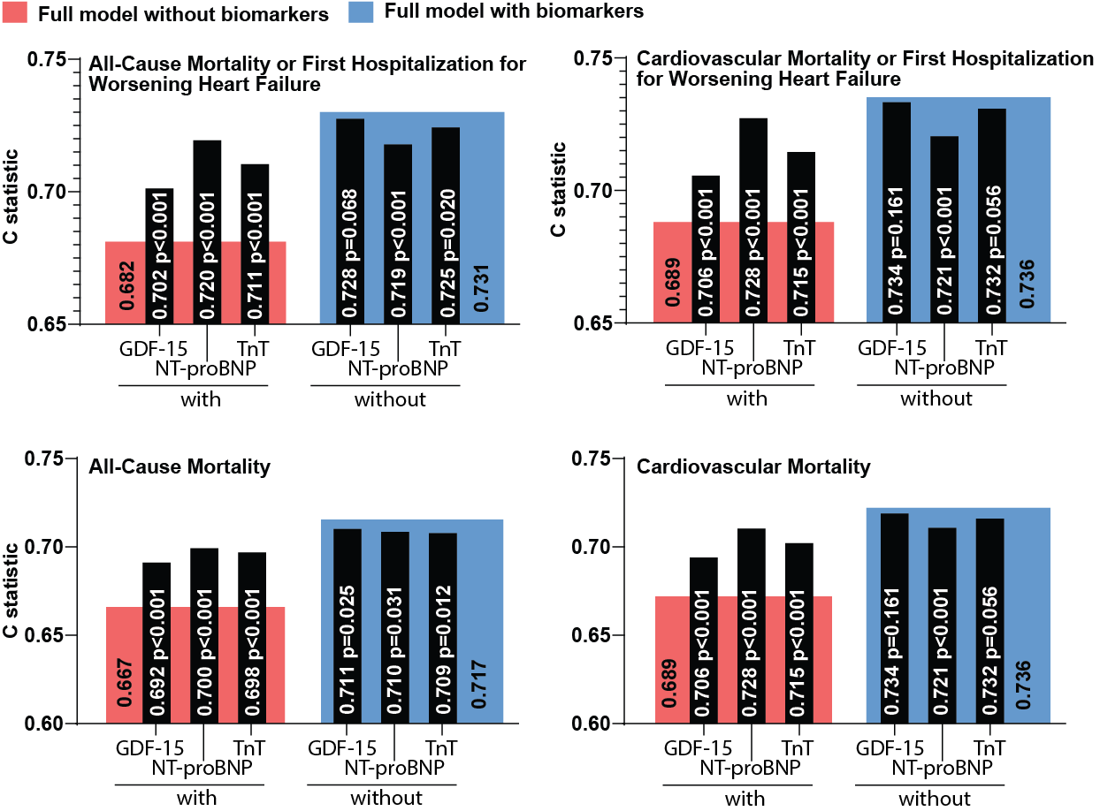
Supplemental Figure 1. Comparison of the prognostic value of GDF-15, NT-proBNP and TnT on outcomes in RED-HF. The graphs show c-statistics for GDF-15, NT-proBNP and TnT in two ways: on the left side of each graph, we show the c statistics for the addition of each biomarker on a model including all adjustment variables as described under statistics and CRP in addition (marked in pink) but excluding GDF-15, NT-proBNP and TnT and on the right side, the exclusion of GDF-15, NT-proBNP and TnT from the full model including all adjustment variables and GDF-15, NT-proBNP and TnT (marked in blue). Data given in graphs are the c statistic and corresponding p-value

