Dietary intervention using (1,3)/ (1,6)-β-glucan, a fungus-derived soluble prebiotic ameliorates high-fat diet-induced metabolic distress and alters beneficially the gut microbiota in mice model
Karthika Muthuramalingam¹, Vineet Singh², Changmin Choi¹, Seung In Choi³, Young Mee Kim¹, Tatsuya Unno^{2,4, *}, Moonjae Cho^{1,5,6, *}

¹ Department of Biochemistry, School of Medicine, Jeju National University, Jeju 63243, Republic of Korea
² Faculty of Biotechnology, School of Life Sciences, SARI, Jeju National University, Jeju 63243, Republic of Korea
³ Department of Pharmaceutical Research Institute, Quegen Biotech Co. Ltd., Seoul 429931, Republic of Korea
⁴ Subtropical/Tropical Organism Gene Bank, Jeju National University, Jeju 63243, Republic of Korea
⁵ Institute of Medical Science, Jeju National University, Jeju 63241, Republic of Korea
⁶ Interdisciplinary Graduate Program in Advanced Convergence Technology & Science, Jeju National University, Jeju 63241, Republic of Korea

* Authors to whom correspondence should be addressed
E-mail: tatsu@jejunu.ac.kr (T.U)
moonjcho@jejunu.ac.kr (M.J.C)

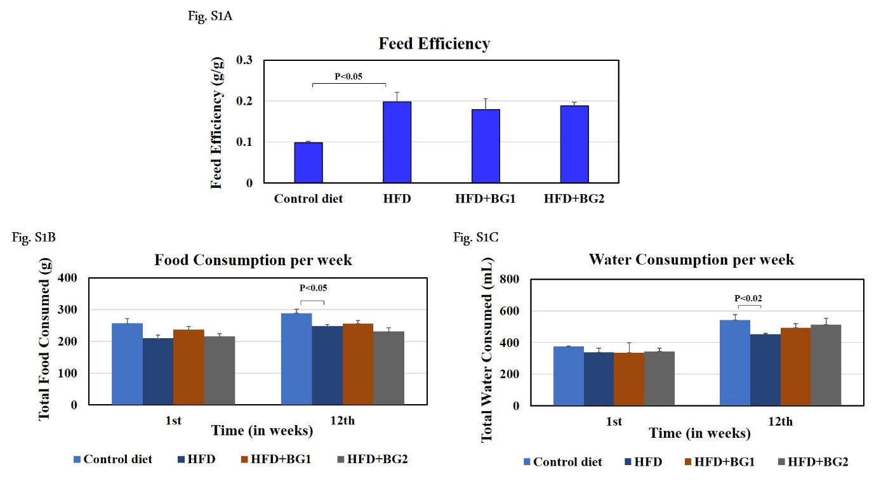
Online Resource Fig.S1: Effect of dietary β-glucan on energy intake. a: Feed efficiency, b: Food consumption, and c: Water consumption.

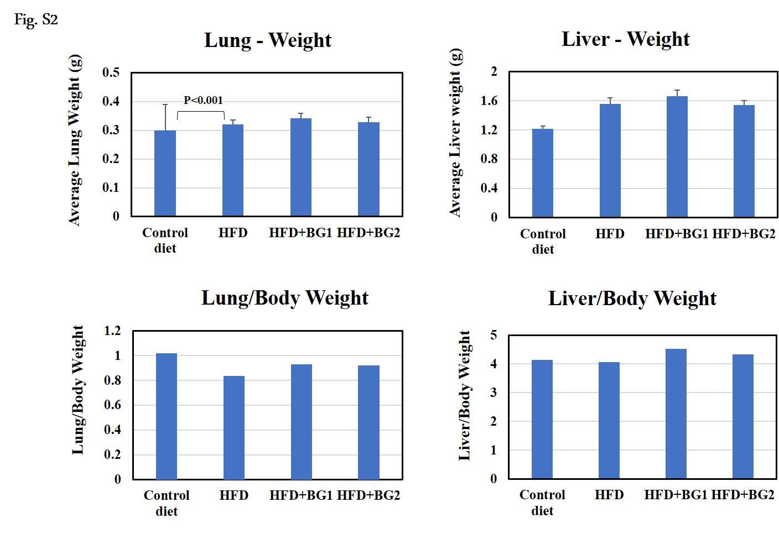
Online Resource Fig.S2: Effect of dietary β-glucan on pathophysiology of mice. A: Lung weight and lung/body weight and B: Liver weight and liver/body weight.
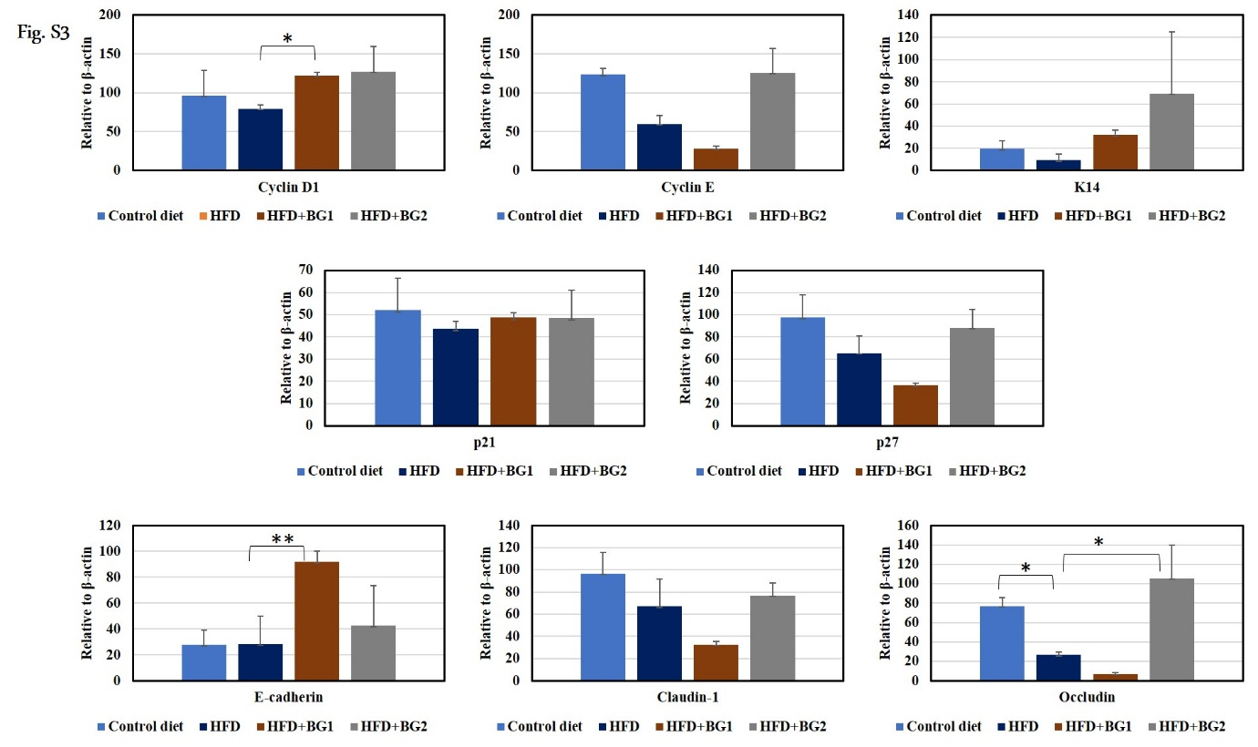 Online Resource Fig.S3: Assessment of expression of intestinal proteins involved in colon cell proliferation, differentiation, and tight junction markers in HFD, HFD + BG1, and HFD + BG2 groups.

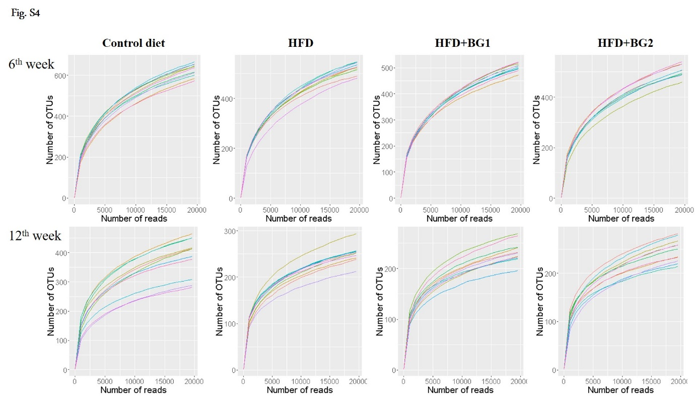 Online Resource Fig.S4: Evaluation of sequence depth by rarefaction curve analysis.
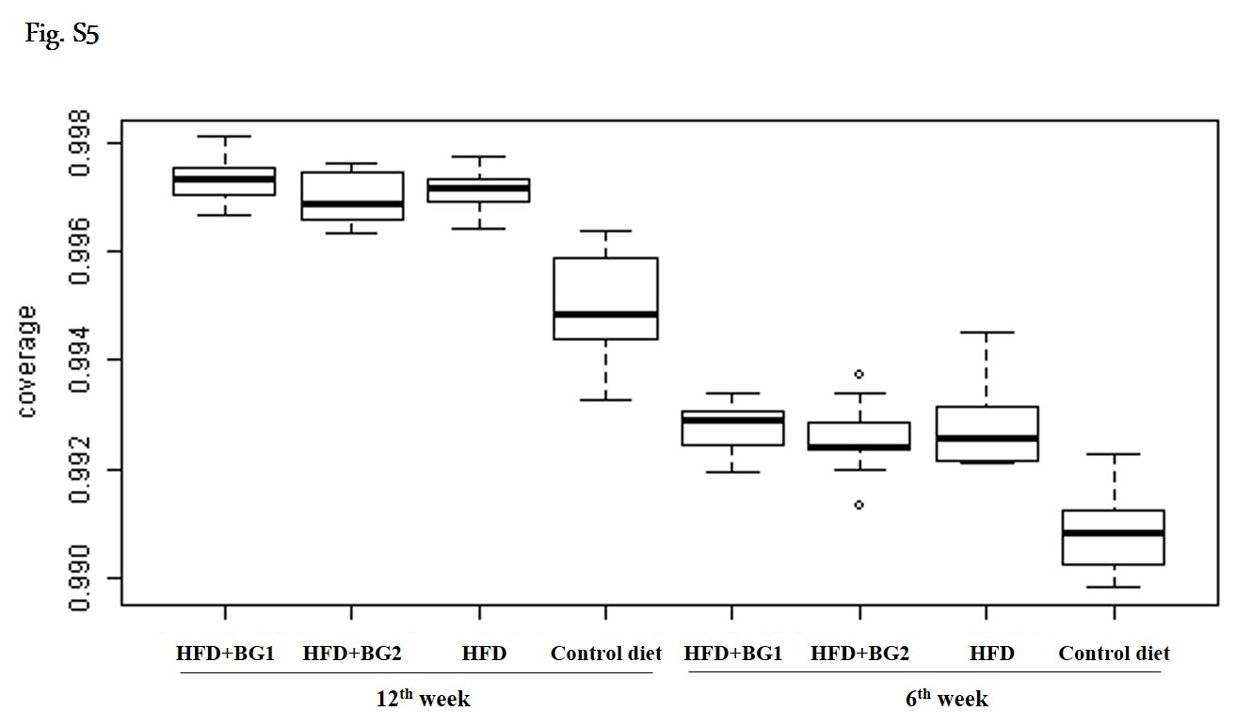 Online Resource Fig.S5: Good’s coverage obtained for each sample in this study.
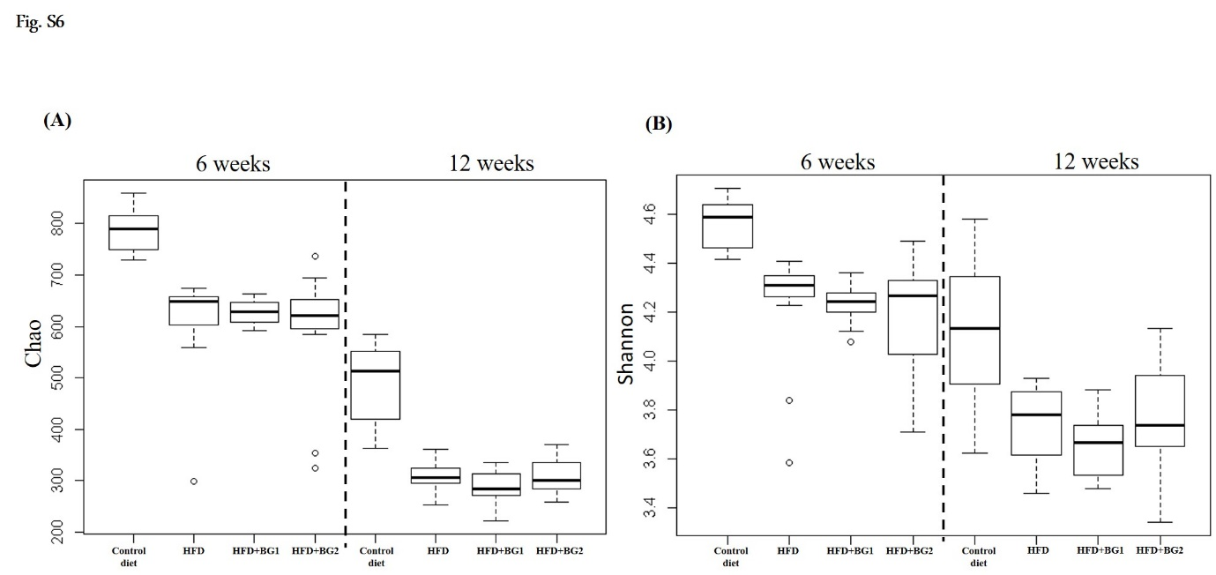 Online Resource Fig.S6: Effects of feeding duration and diets on species richness (A) and evenness (B) in the mouse gut microbiota.
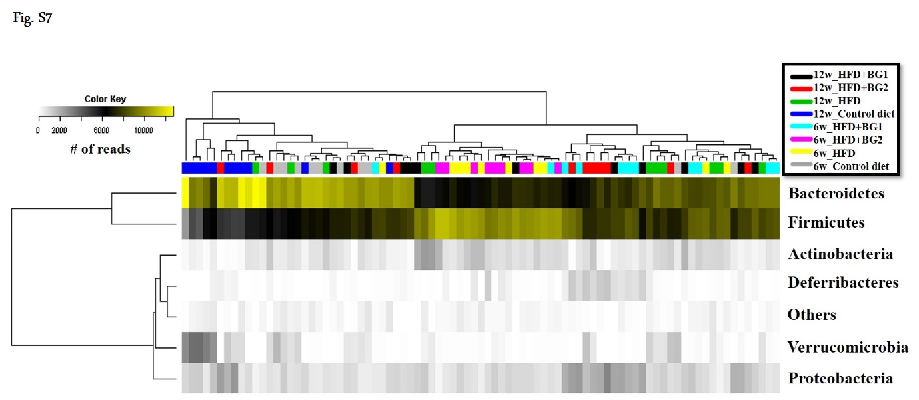 Online Resource Fig.S7: Bacterial composition analysis at the phylum level.

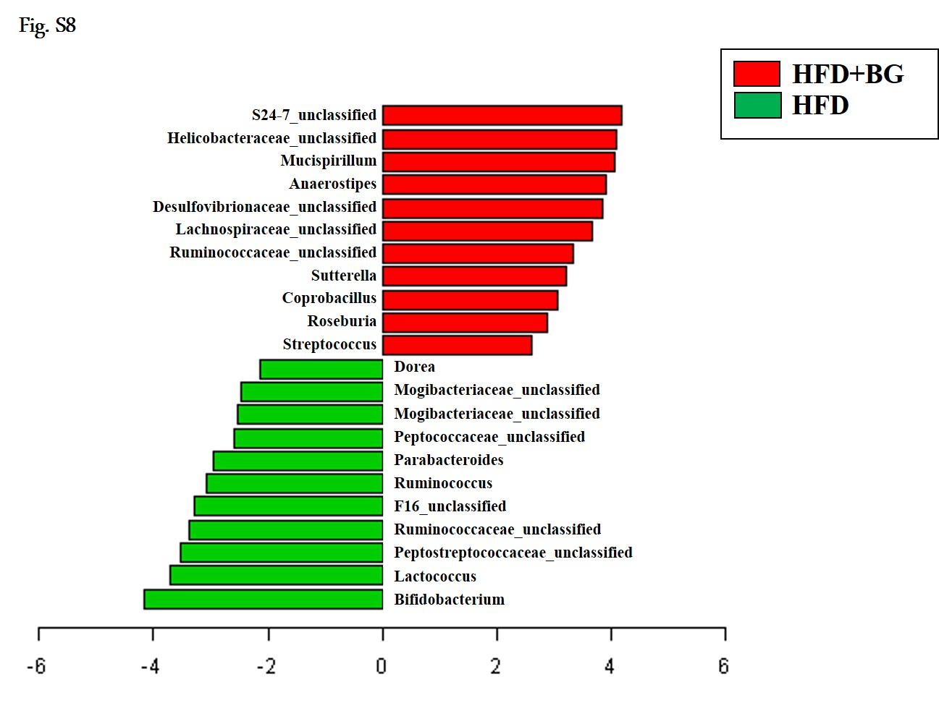 Online Resource Fig.S8: Differentially abundant genera at the 12th week in control and β-glucan groups.
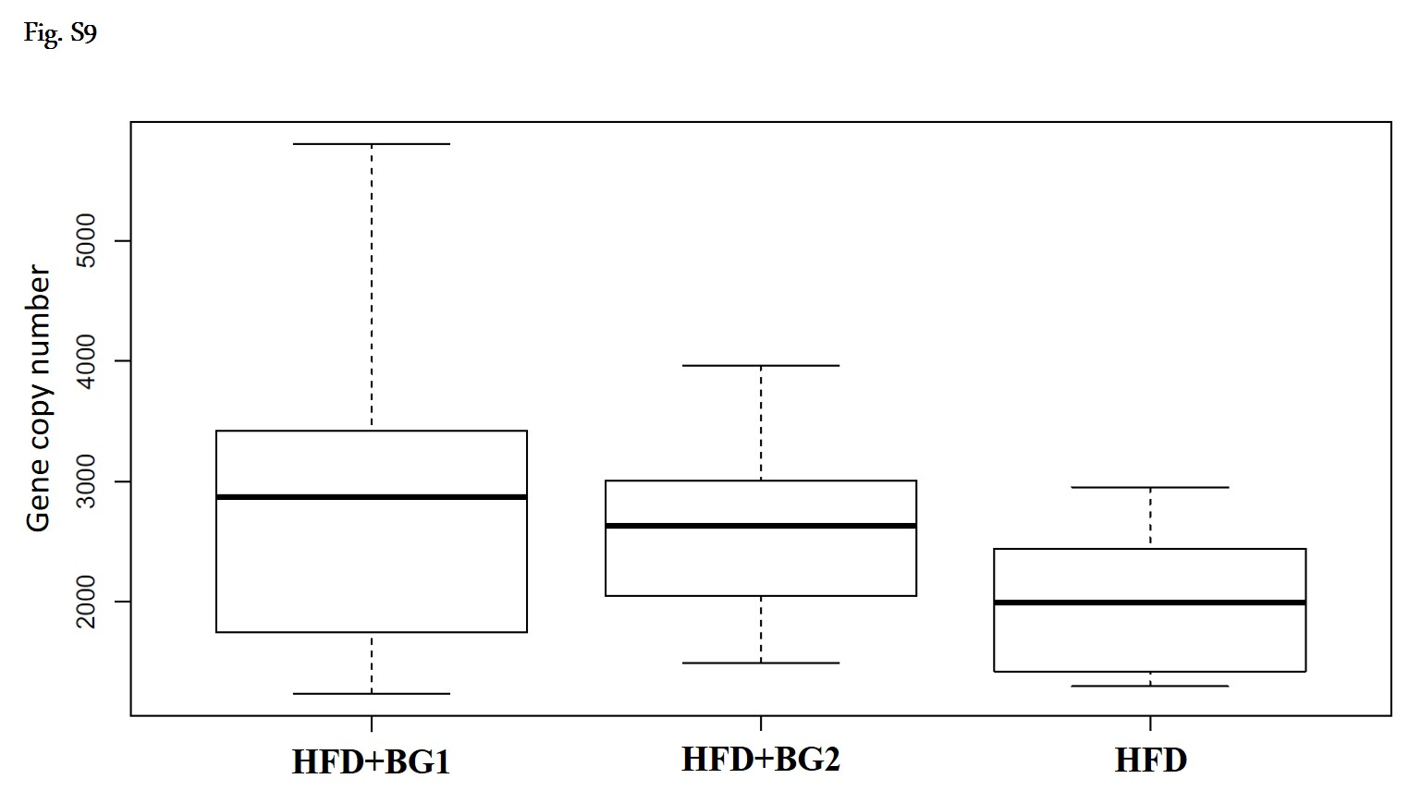 Online Resource Fig.S9: Enumeration of Bifidobacterium based on qPCR for HFD group samples at the 12th week.
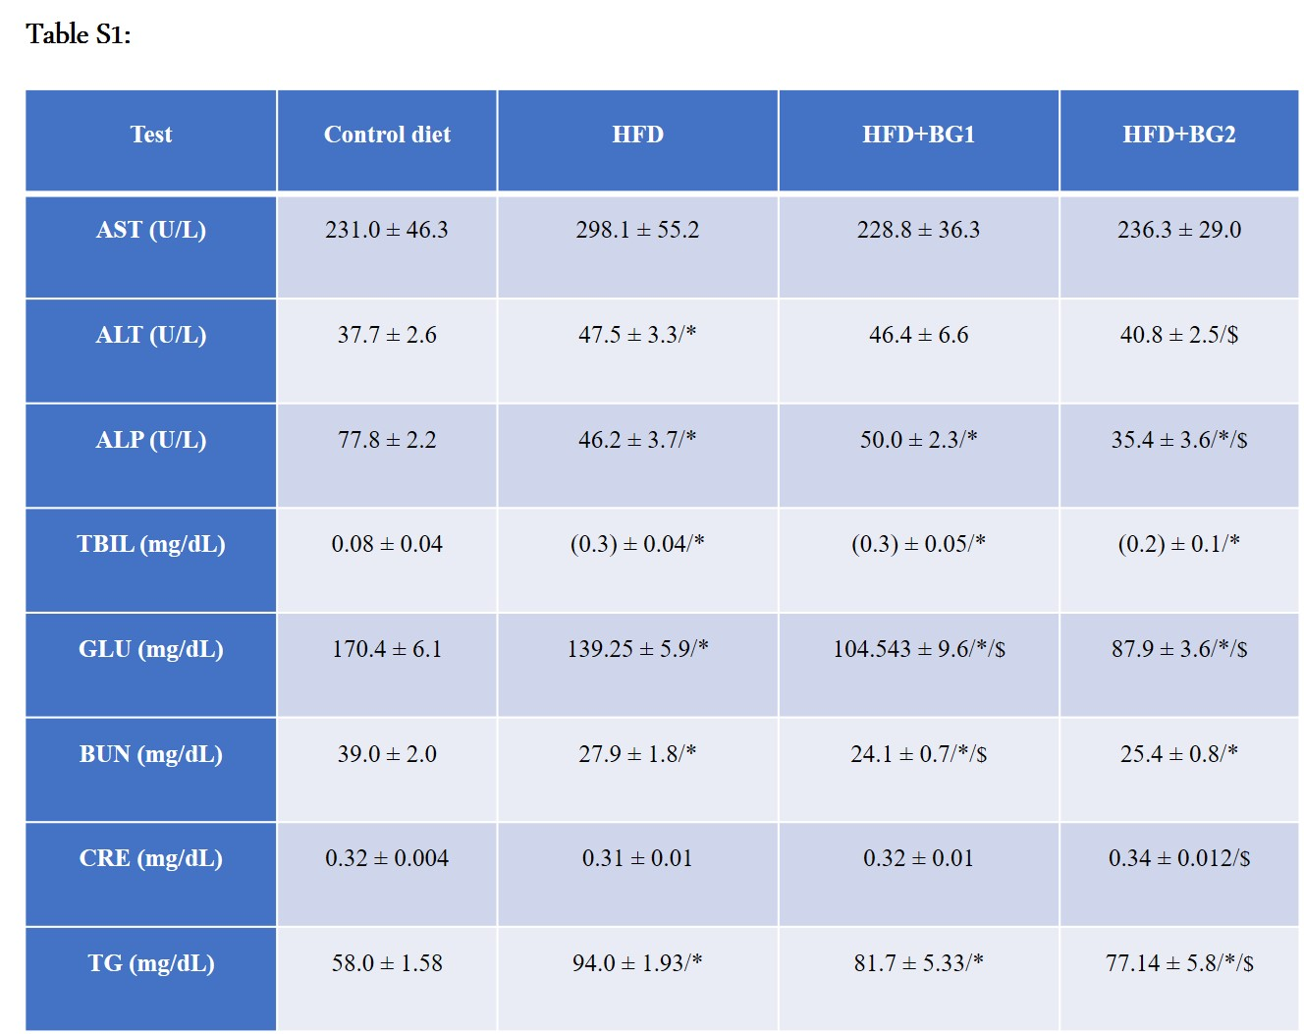
Online Resource Table S1: Blood biochemical markers profiling At the end of 12 weeks, mice were sacrificed using the cardiac puncture method, and blood was drawn using a sterilized syringe and needles. The collected blood samples were sent to ChemOn Inc. for the analysis of different biochemical markers as indicated in the table. AST-aspartate transaminase, ALT-alanine transaminase, ALP- alkaline phosphatase, TBIL- total bilirubin, GLU- blood glucose level, TG-triglyceride, BUN- blood urea nitrogen and CRE- creatinine. (*-compared to that of control diet; $-compared to that of HFD)

