Figure S1. Plasmids used to generate recombinant adeno-associated virus (rAAV).

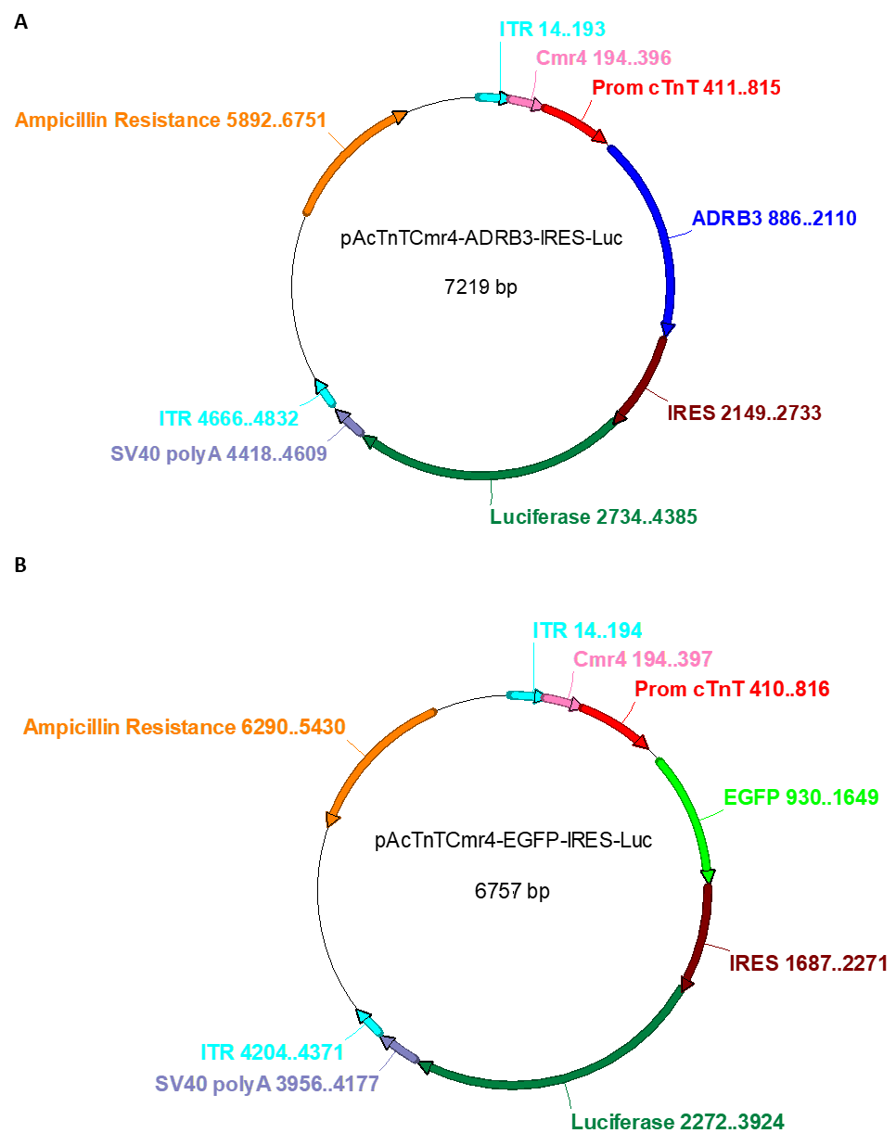

(A) Plasmid for hβ3AR-rAAV production. (B) Plasmid used for control EGFP-rAAV production. ITR, recognition site for AVV packaging; Cmr4, enhancer sequence; Prom cTnT, troponin T promoter sequence for cardiomyocyte-specific expression; ADRB3, c-DNA sequence of the human β3AR receptor; EGFP, enhanced green fluorescent protein sequence; IRES, internal ribosome entry site.

Figure S2. Beta3-adrenergic receptor overexpression protects neonatal rat ventricular myocytes from isoproterenol-induced hypertrophy.

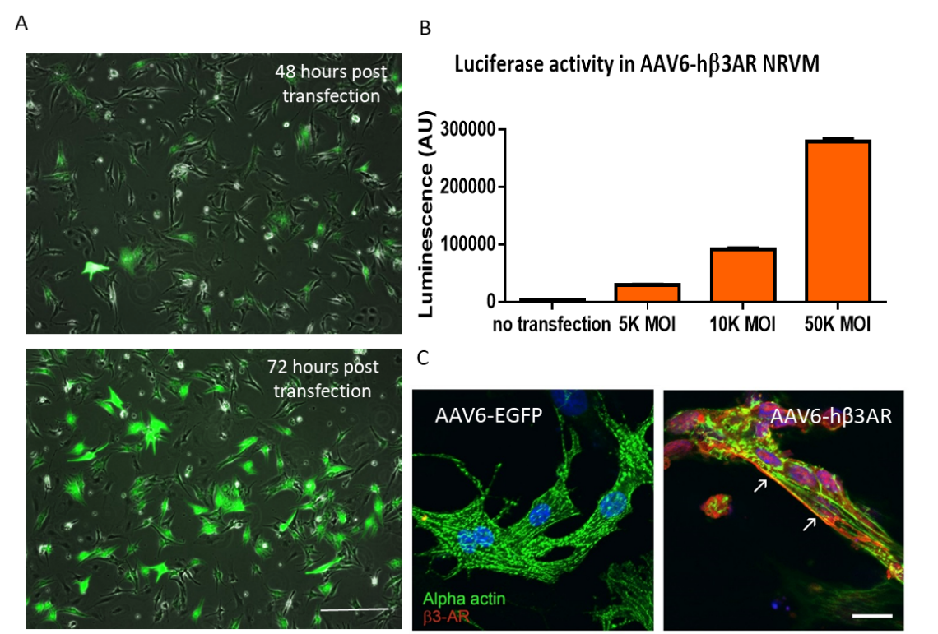

(A) Representative images of neonatal rat ventricular myocytes (NRVM) transfected with EGFP adeno-associated virus serotype 6 at 10K MOI for 48 hours (top) and 72 hours (bottom). EGFP signal is evident in most cells after 72 hours of transduction. Scale bar, 100µm. (B) Luciferase activity quantification in NRVMs transduced for 72 hours with hβ3AR-luciferase adeno-associated virus serotype 6 at 5K, 10K, and 50K MOI. A 10K MOI sufficiently transduces NRVMs. Data are means ± SEM from two independent experiments. (C) Immunostaining for α-actin (green) and hβ3AR (red) in NRVMs transduced for 72 hours with control (AAV6-EGFP) or human β3AR adeno-associated virus (AAV6-hβ3AR), showing membrane localization of hβ3AR and no signal in control cells. Scale bar, 20 µm. Data are means ± SEM.

Figure S3. In vivo assessment of LV function in c-hβ3tg mβ3KO mice and mβ3KO control littermates

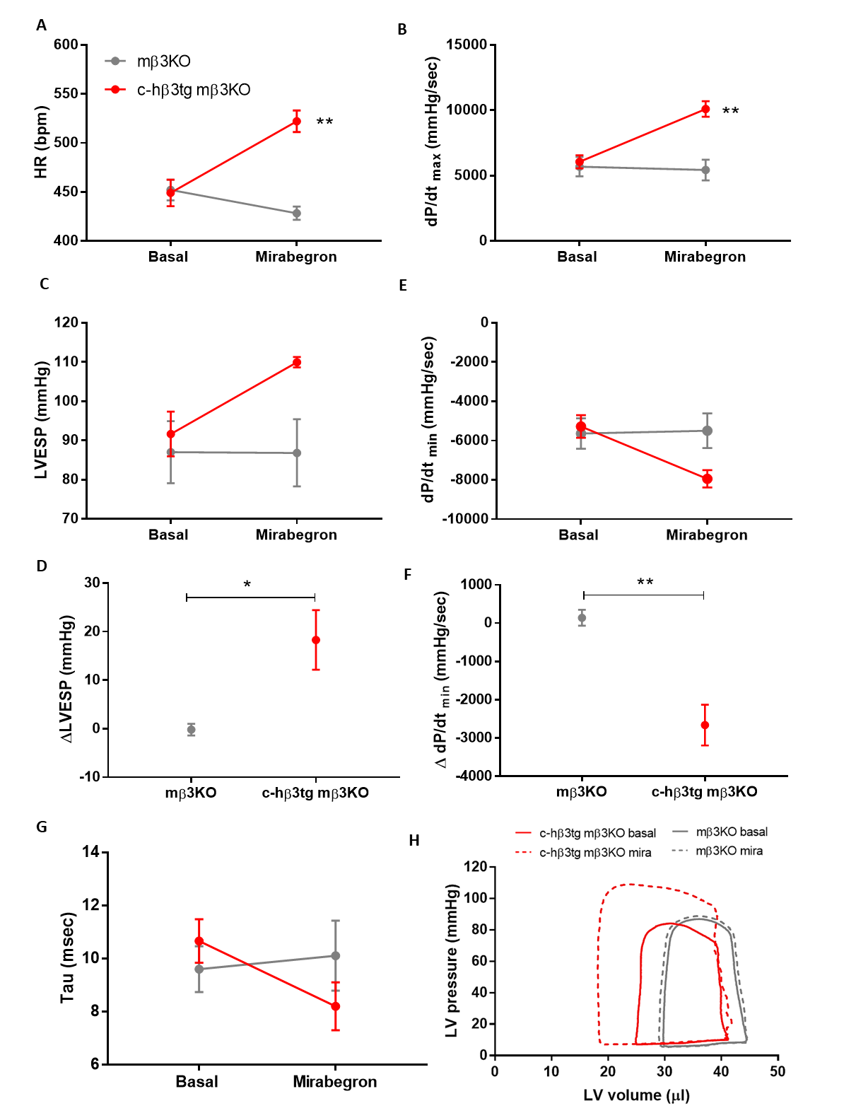

(A) Increased chronotropic response to mirabegron in c-hβ3tg mβ3KO mice indicated by the effect on heart rate (HR). (B-D) Increased in systolic function in c-hβ3tg mβ3KO mice: (B) maximal derivative of LV pressure (dP/dt_{max}); (C, D) left ventricular end-systolic pressure (LVESP). (E, G) Increased diastolic function in c-hβ3tg mβ3KO mice: (E, F) minimal derivative of LV pressure (dP/dt_{min}); (G) time constant of isovolumic relaxation (Tau). (H) Representative pressure-volume loops showing an upward and leftward shift after mirabegron administration in c-hβ3tg vs. mβ3KO mice, indicating enhanced contractility. c-hβ3tg mβ3KO mice (red, n=3) and mβ3KO control littermates (gray, n=3) at baseline and in response to the β3AR agonist mirabegron (1µg/kg). Data are means ± SEM. Two-way ANOVA, **p<0.01 and Student t-test (for increase plots), *p<0.05, **p<0.01.

Figure S4. Assessment of βAR transcripts in adult cardiomyocytes.

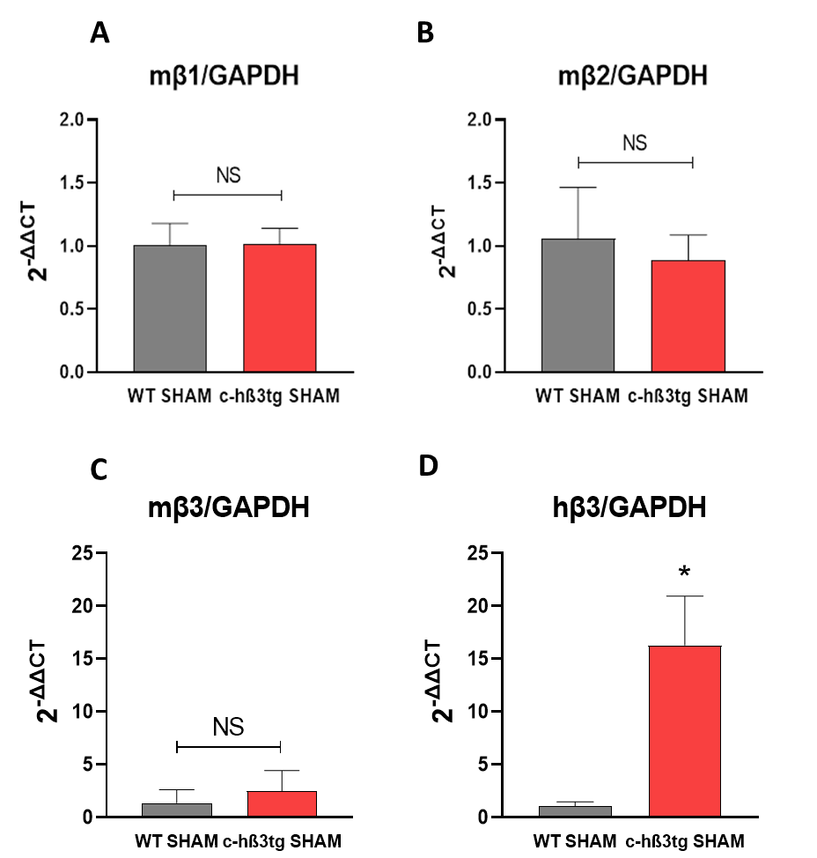

Evaluation of endogenous mouse Adrb1 (A), Adrb2 (B) and Adrb3 (C) transcripts in the context of transgenic human β3AR overexpression (c-hβ3tg mice) by qPCR. (D) Levels of the human Adrb3 transcript were also assessed. Data are means ± SEM. Student t-test or Mann-Whitney test were used to compare differences between WT (n=4) and c-hβ3tg mice (n=3). NS, not significant; *p<0.05.

Figure S5. Adult mouse hearts perfusion and cNMPs evaluation.

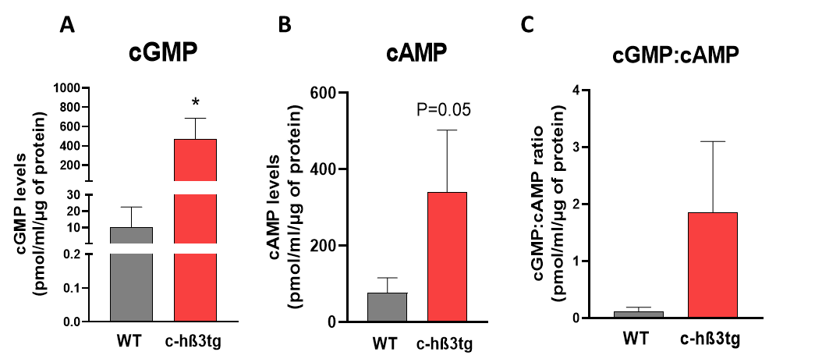

Hearts from c-hβ3tg and WT mice were explanted and ex vivo perfused with the β3AR agonist mirabegron. Upon exposure to β3AR agonist, the predominant effect was a massive increase in cGMP levels (A); however, there was a concurrent modest increase in cAMP levels (B). Therefore, cGMP:cAMP ratio was increased. Data are means ± SEM. Student t-test or Mann-Whitney test were used to compare differences between WT (n=4) and c-hβ3tg mice (n=3). *p<0.05.

Figure S6. Pre-treatment with L-NAME in c-hβ3tg mice before TAC induction.

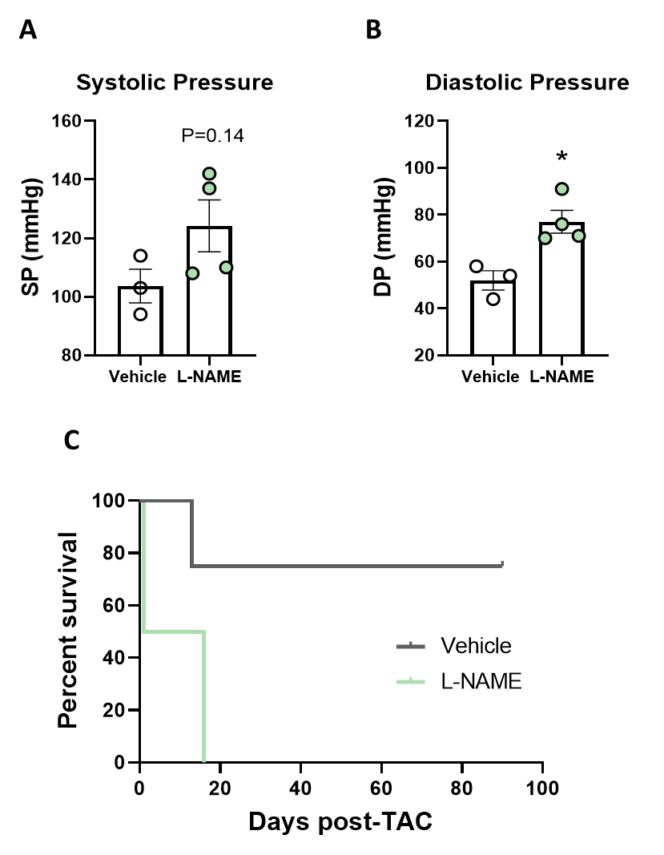

c-hβ3tg mice previously pre-treated with the nitric oxide synthase inhibitor L-NAME (1mg/mL) for 15d or vehicle were subjected to TAC and followed up. 15d treatment with L-NAME in c-hβ3AR mice resulted in an increase of systolic (A) and diastolic pressures (B). Data are means ± SEM. Student t-test was used to compare differences between vehicle (n=3) and L-NAME-treated mice (n=4). Additionally, c-hβ3tg mice under L-NAME had significantly less survival treatment than c-hβ3AR not receiving L-NAME (C). Data are shown as a Kaplan-Meier Curve. *p<0.05.

Figure S7. Cardiomyocyte free fatty-acid and glucose utilization.

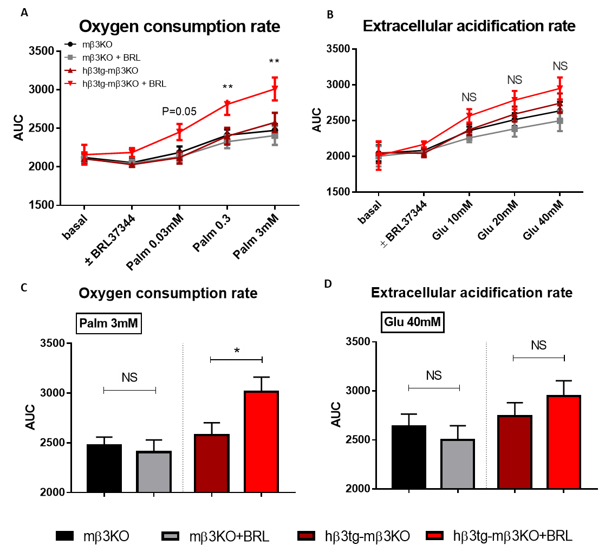

(A, B) Cardiomyocyte free fatty-acid utilization. (A) Oxygen consumption rates in cardiomyocytes isolated from healthy adult mβ3KO mice and c-hβ3tg mβ3KO mice. Cardiomyocytes were exposed to increasing doses of the free fatty acid palmitate (Palm) in the presence or absence of the β3AR agonist BRL37344 (1μM, n=8). Two-way ANOVA, **p<0.01 for c-hβ3tg mβ3KO in the presence or absence of BRL37344. (B) Oxygen consumption rates at the highest palmitate concentration (3mM). The elevated BRL-activated oxygen consumption rate in c-hβ3tg mβ3KO cardiomyocytes indicates increased fatty-acid utilization Student’s t test, *p<0.05. (C, D) Cardiomyocyte glucose utilization. (C) Extracellular acidification rate (an index of lactic acid production) in cardiomyocytes isolated from healthy adult mβ3KO mice and c-hβ3tg mβ3KO mice; cardiomyocytes were exposed to increasing doses of glucose (Glu) in the presence or absence of 1μM BRL37344 (n=8). Two-way ANOVA, NS, not significant, for c-hβ3tg mβ3KO in the presence or absence of BRL37344. (D) Extracellular acidification rates at the highest glucose concentration (40mM). Cellular metabolic parameters were measured using a Seahorse Bioscience XF96 Extracellular Flux Analyzer. Data are means ± SEM.

Figure S8. OPA1 and MFN2 evaluation in sham-operated mice.

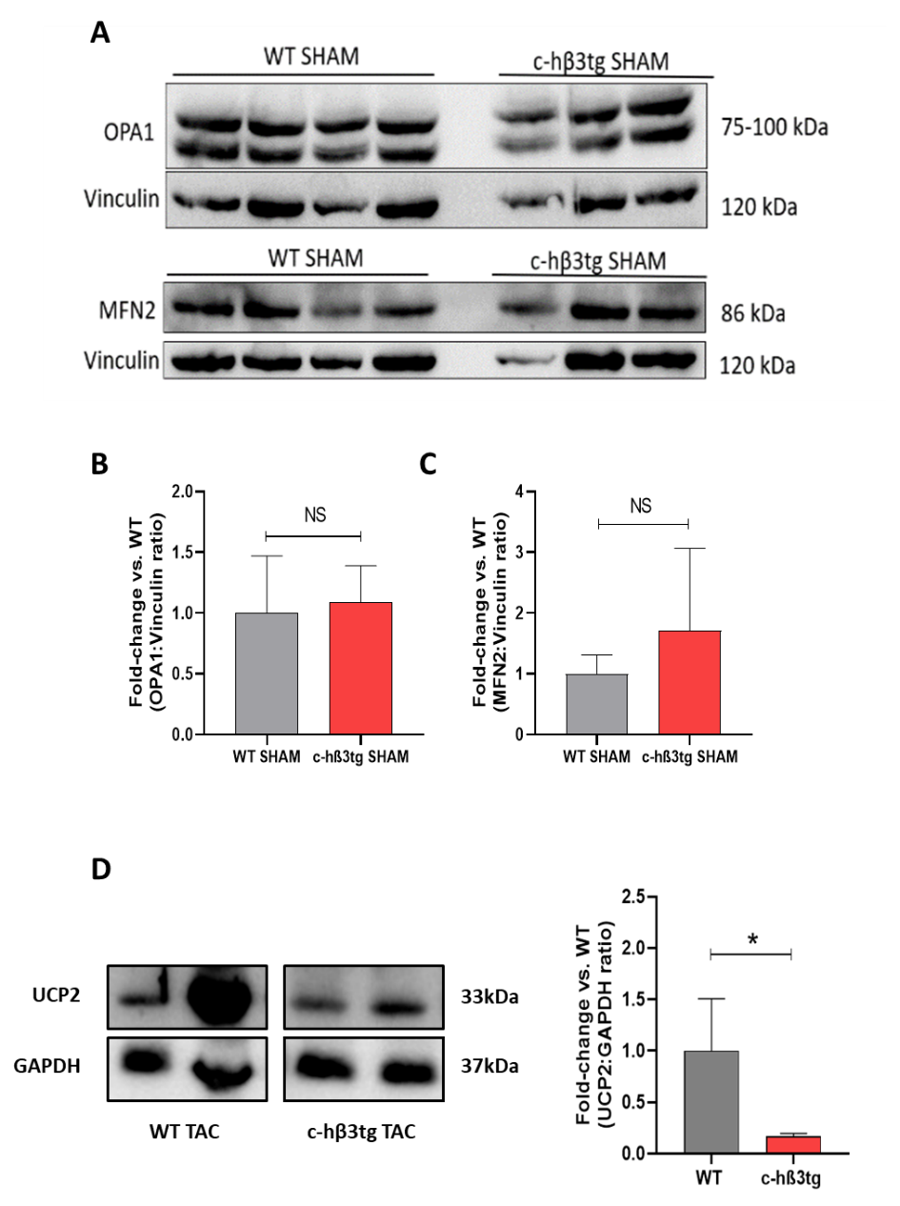

Protein expression of OPA1 (A, B) and MFN2 (A, C) in mice overexpressing hβ3AR (n=3) or WT (n=4) without TAC (sham) were evaluated, with no differences observed between genotypes. Expression of UCP-2 was also assessed in c-hβ3tg (n=5) or WT (n=4) 12 weeks after TAC induction. Data are means ± SEM. Student t-test was used to compare differences between genotypes. NS, not significant; *p<0.05.

Figure S9. Adeno-associated virus serotype 9 (AAV9) efficiently transduces cardiac tissue in mice.

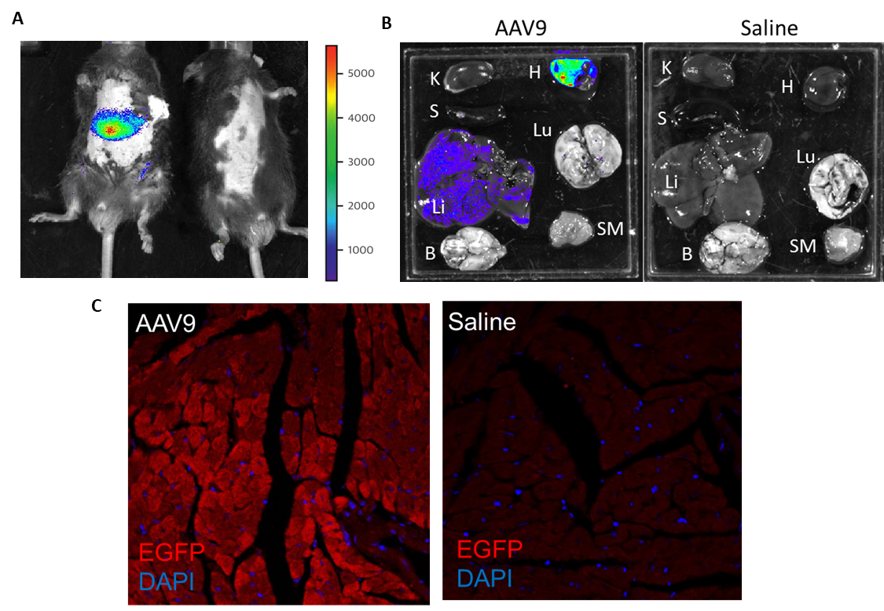

(A) In vivo bioluminescence images showing luciferase activity in C57Bl6J mice 2 weeks after intravenous (femoral vein) injection of AAV9 (3x10¹¹ viral genomes/mouse) (left) or saline (right). (B) Ex vivo bioluminescence images from D-luciferin–organs from mice transduced with AAV9 (left) or saline (right). K, kidney; S, spleen; Li, liver; B, brain; H, heart; Lu, lungs; SM, skeletal muscle. Luciferase activity was predominantly observed the heart and activity was low in the liver. (C) Fluorescence microscopy of heart cryosections from mice transduced with AAV9-EGFP (left) or saline (right), showing the mosaic cell distribution of transgene expression.

Figure S10. Mice transduced with AAV9-hβ3AR express functional beta3-adrenergic receptors in cardiomyocytes.

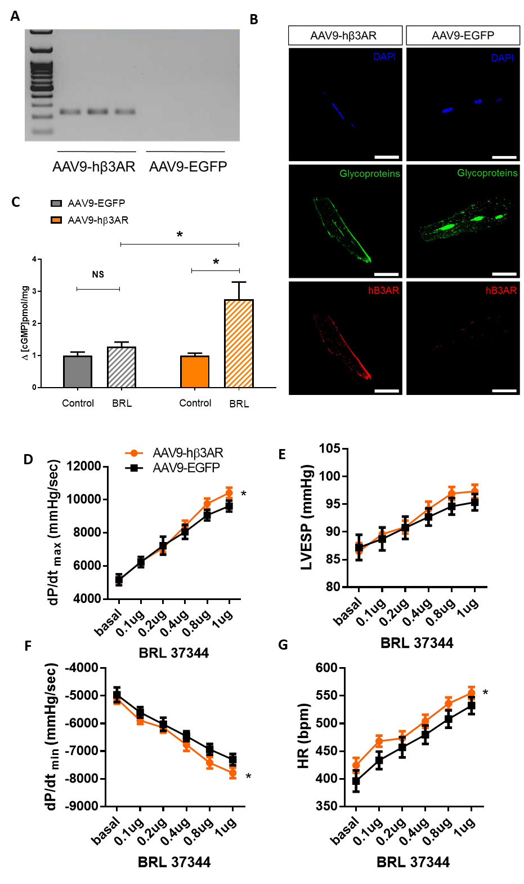

(A) RT-PCR analysis showing ADRB3 gene expression in cardiomyocytes from mice transduced with AAV9-hβ3AR but not AAV9-EGFP. The probe was designed to target only the human β3AR cDNA sequence. (B) Representative immunostaining in adult mouse ventricular myocytes from mice injected with AAV9-hβ3AR (left) or control AAV9-EGFP (right). hβ3AR (red) is found at the sarcolemma of AAV9-hβ3AR-transduced cardiomyocytes. Lectin staining of membrane glycoproteins (green) is shown for comparison. Scale bar, 50µm. (C) β3AR-driven cGMP production in hearts from mβ3KO mice transduced with AAV9-hβ3AR or AAV9-EGFP. Hearts were perfused ex vivo with the β3AR agonist BRL37344 (BRL, 0.1μM) or vehicle (Control). (D-G) Analysis of left ventricular function in mice transduced with AAV9-hβ3AR (orange, n=9) or AAV9-EGFP (black, n=10) at baseline and in response to increasing doses of BRL 37344, with AAV9-hβ3AR-transduced mice showing an increased chronotropic response (heart rate, HR), increased systolic function indicated by maximal derivative of LV pressure (dP/dt_{max}) and left ventricular end-systolic pressure (LVESP), and increased diastolic function indicated by the minimal derivative of LV pressure (dP/dt_{min}). Data are means ± SEM. Two-way ANOVA, *p<0.05

Figure S11. Gene-therapy– mediated beta3-adrenergic receptor overexpression in cardiomyocytes does not revert the cardiac metabolic switch in heart failure.

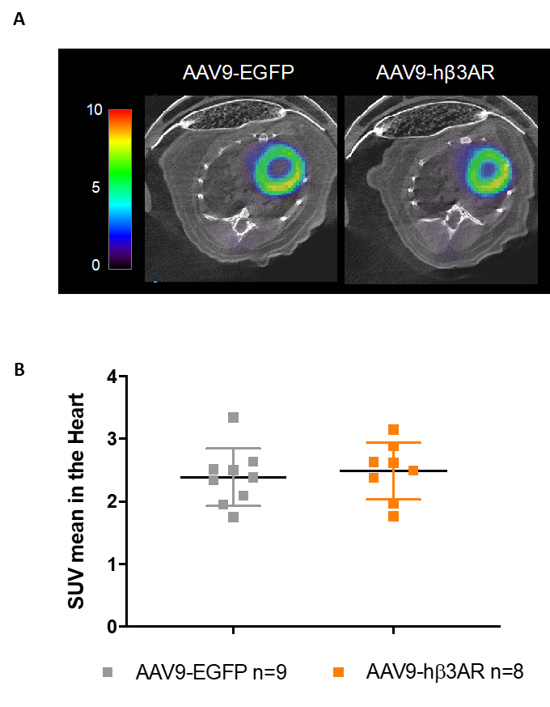

C57Bl6J WT mice were subjected to transaortic constriction surgery (TAC) to induce supravalvular AS. Eight weeks later, mice were transduced with AAV9-hβ3AR or control AAV9-EGFP. PET-CT scans were performed 12 weeks after surgery. (A) Representative PET-CT thoracic scan images after [¹⁸F]FDG injection. (B) Mean standardized uptake value (SUV). Data are means ± SEM. No significant differences were found by Student t-test.

