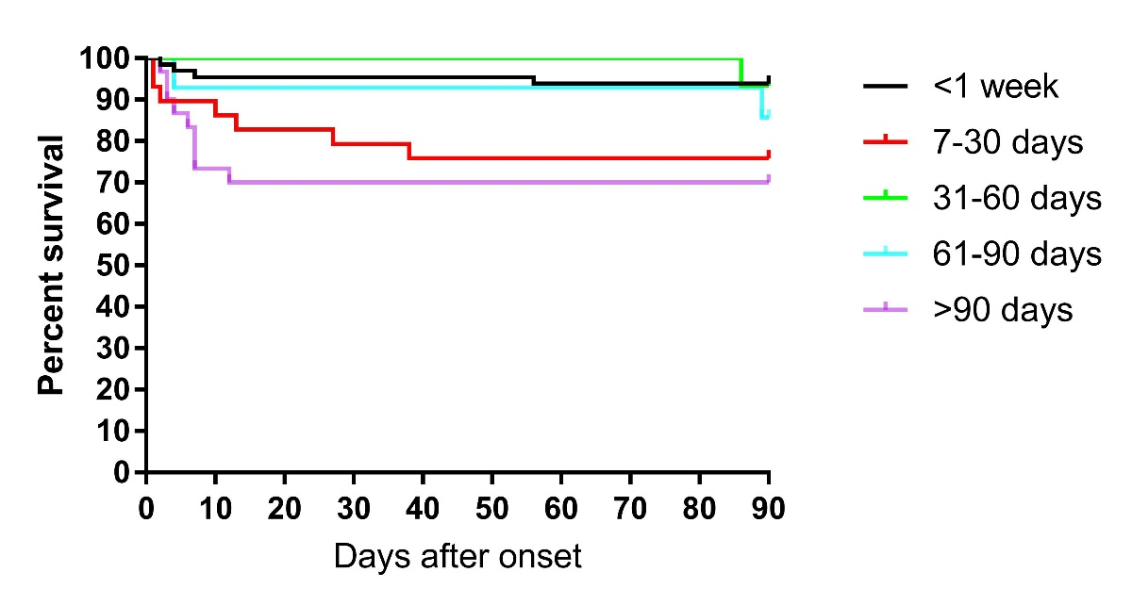
Figure S2 Kaplan–Meier survival curves estimated survival rates between 5 time-point after transplantation.
Statistical significance (Log Rank test):
- <1 week vs. >90 days (93.8% vs 70%), P=0.001
- <1 week vs. 7-30 days (93.8% vs. 75.9%), P=0.011

