**Supplemental Materials**

**Population pharmacokinetics of alemtuzumab (Campath) in pediatric hematopoietic cell transplantation: towards individualized dosing to improve outcome**

R. Admiraal, C.M. Jol-van der Zijde, J.M. Furtado Silva,C.A.J. Knibbe, A.C. Lankester, J.J. Boelens, G. Hale, S. Adams, P. Veys, C. van Kesteren,R.G.M. Bredius

**Figure S1: Validation of ELISA**

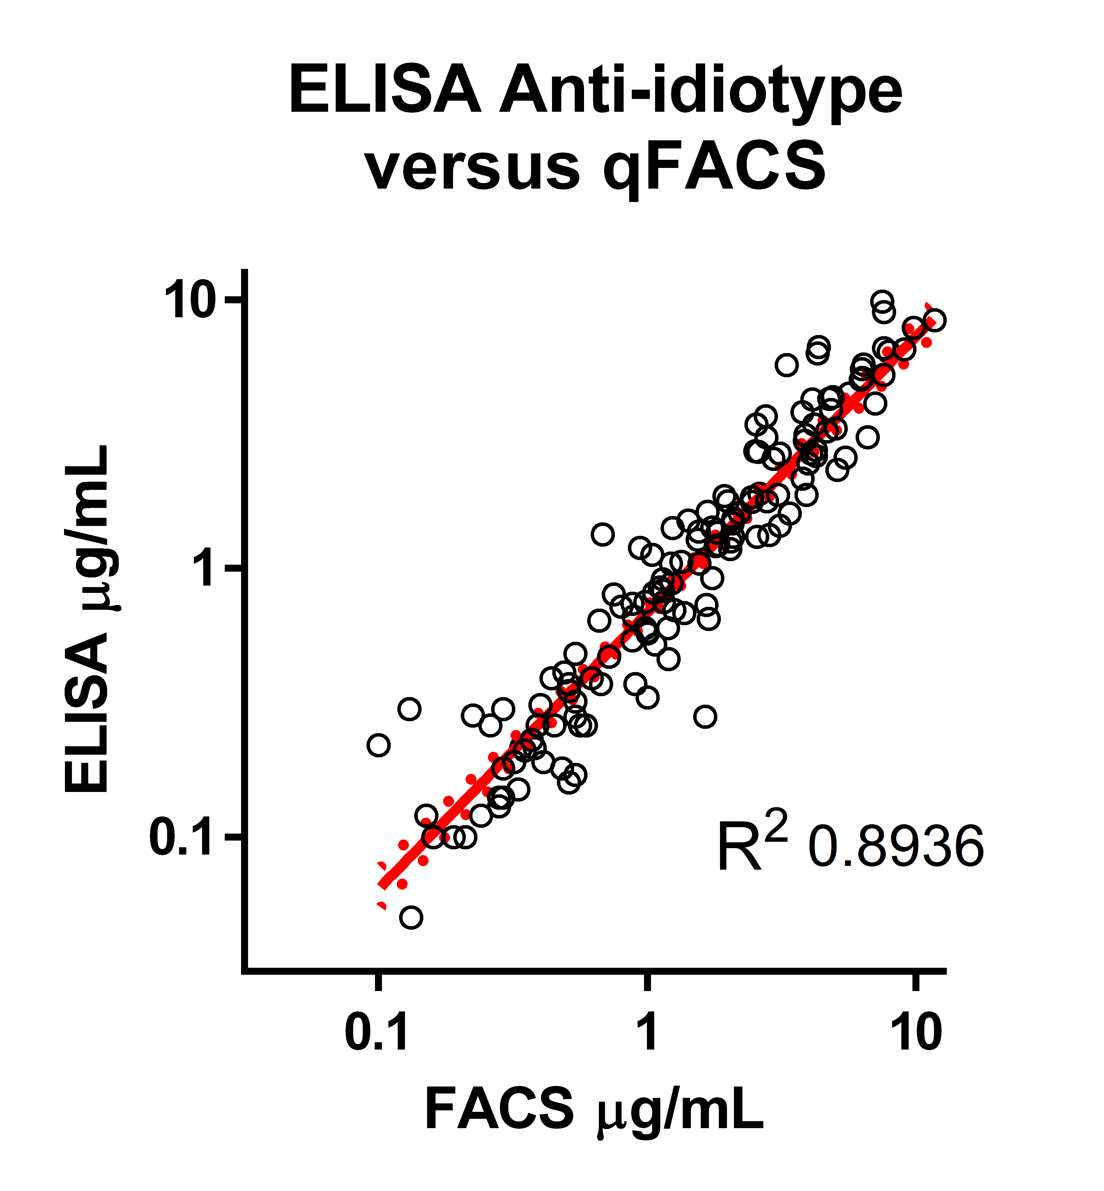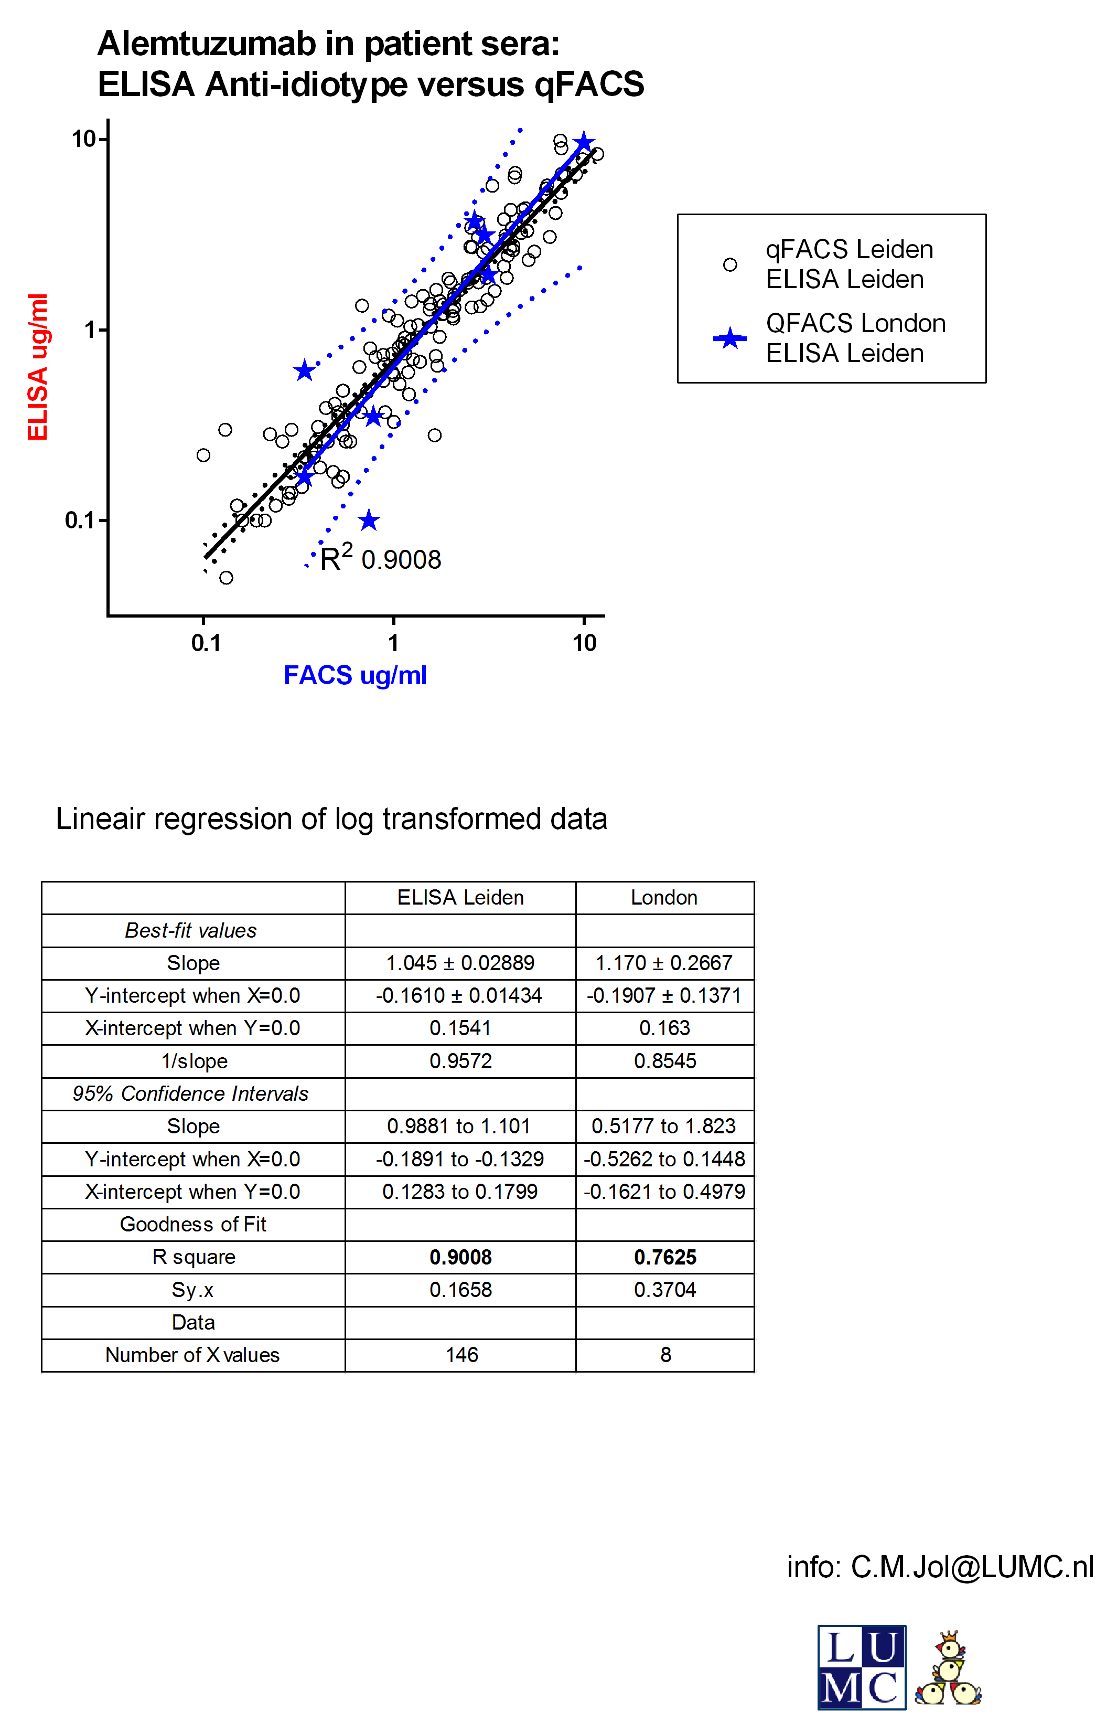

Figure S1: Validation of the ELISA-method as compared to the FACS-method for quantifying alemtuzumab concentrations. Panel A: Only samples measured in LUMC. Panel B: Samples measured in LUMC (all ELISA samples) versus FACS measured in the LUMC (open circles) and GOSH (blue stars).

Figure S2: Clearance according to alemtuzumab concentration

Macintosh HD:Users:rickadmiraal:Documents:ATG:Campath:plots:voor publicatie:Fig Sx relatieve bijdrage aan klaring.eps

Figure S2: Total clearance (solid line) according to serum alemtuzumab concentrations. Dot-dashed line: linear clearance; dashed line: saturable clearance.

Figure S3: Clearance according to body weight

Macintosh HD:Users:rickadmiraal:Documents:ATG:Campath:plots:voor publicatie:Fig S3/ Clearance according to WT.eps

Figure S3: Scaling exponent on clearance (panel A) and individual clearance (panel B) according to body weight

Figure S4: Interindividual variability versus baseline lymphocyte counts

Macintosh HD:Users:rickadmiraal:Documents:ATG:Campath:plots:voor publicatie:Fig S4 IIV versus lymphocytes.pdf

Figure S4: Interindividual variability (IIV) on clearance (panel A), central volume of distribution (panel B) and Michaelis-Menten constant (panel C) versus baseline lymphocyte counts. Dashed line: IIV=0

Fig S5: Baseline lymphocyte counts versus clearance and day 0 alemtuzumab concentrations.

Macintosh HD:Users:rickadmiraal:Documents:ATG:Campath:plots:voor publicatie:Fig S5 ALC vs CL en dag 0.eps

Figure S5: Day 0 alemtuzumab concentrations versus baseline lymphocyte count (panel A), clearance versus baseline lymphocyte count (panel B).

Figure S6: GOF-plots in 1-compartment and 2-compartment base model

Macintosh HD:Users:rickadmiraal:Documents:ATG:Campath:plots:voor publicatie:Fig Sx pred-dv 1 vs 2 comp.eps

Legend: Goodness-of-fit plots of the 1-compartment (upper panels) and 2-compartment (lower panels) base models: population predicted versus observed concentrations of alemtuzumab in all patients, split by medians of body weight (left panels body weight <17.3 kg; right panels body weight > 17.3kg. Lines: line of unity (x=y)

Figure S7: Population predicted versus observed concentrations

Macintosh HD:Users:rickadmiraal:Documents:ATG:Campath:plots:voor publicatie:Fig 2 pred-dv_age_groups.eps

**Figure S7**: Goodness-of-fit plots of the final model: population predicted (x-axes) versus observed concentrations (y-axes) of alemtuzumab in all patients, split by quartiles of body weight. Panel A: < 11kg; Panel B: 11-17.3kg; Panel C: 17.3-32kg; Panel D: >32kg. Lines: line of unity (x=y).

**Supplemental data file**

$PROBLEM Alemtuzumab PK ;

$INPUT ID TIME NDV=DROP DV AMT=DOSE RATE EVID MDV WT BSA AGE SEX LYMNUL DIAG FERT SCTT SCTNR CENT MEAS ;

$DATA campath.csv IGNORE=@ ;

$SUBROUTINES ADVAN6 TOL=9 ;

$MODEL

NCOMP=2

COMP=(CENTRAL DEFOBS DEFDOSE)

COMP=(PERIPH) ;

$PK

MWT = WT/17.25

MLYM = LYMNUL/0.78 ;

TVCL = THETA(1) \* (MWT\*\*((THETA(7)\*WT)\*\*THETA(8)))

CL = TVCL \* EXP(ETA(1))

TVV1 = THETA(2) \* MWT\*\*THETA(9)

V1 = TVV1 \* EXP(ETA(2))

V2 = V1 \* THETA(3)

TVQ = THETA(4) \* MWT\*\*THETA(10)

Q = TVQ

TVVMAX= THETA(5)

VMAX = TVVMAX

TVKM = THETA(6)

KM = TVKM \* EXP(ETA(3))

K10 = CL/V1

K12 = Q/V1

K21 = Q/V2

S1 = V1

ET1 = ETA(1)

ET2 = ETA(2)

ET3 = ETA(3)

;-------------------------------------------------------------------------

$DES

C1 = A(1)/V1

DADT(1)= -K10\*A(1) -(VMAX\*C1)/(KM+C1) - K12\*A(1) + K21\*A(2)

DADT(2)= K12\*A(1) - K21\*A(2)

;-------------------------------------------------------------------------

$ERROR

IPRED = 0

IF(F.GT.0) IPRED = LOG(F)

W=1

IRES=DV-IPRED

IWRES= IRES/W

Y = IPRED + ERR(1)

A1 = A(1)

;-------------------------------------------------------------------------

$THETA

(0, 0.2) ;CL

(0, 1.9) ;V1

(0, 0.8) ;V2

(0, 0.3) ;Q

(0, 0.8) ;Vmax

(0, 3) ;Km

0.05 ;Exp1WT on CL

-1 ;Exp2WT on CL

(0, 1) ;WT op V1

(0, 1) ; WT op Q

;-------------------------------------------------------------------------

$OMEGA

2 ;CL

1 ;V1

2 ;Km

;-------------------------------------------------------------------------

$SIGMA

0.1 ; error

;-------------------------------------------------------------------------

$EST NOABORT PRINT=5 MAXEVAL=9999 METHOD=1 POSTHOC NSIG=3 SIGL=9 INTERACTION $COV $TABLE ID TIME DV AMT RATE EVID MDV CWRES PRED IPRED ET1 ET2 ET3 WT AGE SEX LYMNUL DIAG FERT SCTT CL V1 V2 Q KM VMAX NOPRINT ONEHEADER FILE=run28.tab NOAPPEND