Electronic Supplementary Material

Clinical Pharmacokinetics

Pharmacokinetics of Ampreloxetine, a Norepinephrine Reuptake Inhibitor, in Healthy Subjects and Adults with Attention-Deficit/Hyperactive Disorder or Fibromyalgia Pain

Jitendra Kanodia^{1*}, Arthur Lo^{1*}, R. Michael Baldwin^{1,2}, Richard A. Graham¹, David L. Bourdet¹

¹ Clinical & Translational Pharmacology, Theravance Biopharma US, Inc., South San Francisco, CA, USA
² Former employee of Theravance Biopharma US, Inc.

* These authors contributed equally to this article.

Corresponding author:
Jitendra Kanodia, PhD
Director, Clinical and Translational Pharmacology
Theravance Biopharma US, Inc.
901 Gateway Boulevard
South San Francisco, CA 94080
jkanodia@theravance.com

Compliance with Ethical Standards
Funding: This study was funded by Theravance Biopharma, Inc. Kirsty Nahm MD of The Curry Rockefeller Group, LLC provided assistance with writing/formatting/proofreading/collation of the author comments and this assistance was funded by Theravance Biopharma, Inc. Open access publication of this manuscript was sponsored by Theravance Biopharma, Inc.

Conflicts of interest: Drs. Kanodia, Lo, Baldwin, Graham, and Bourdet are current or former employees of Theravance Biopharma US, Inc.

Supplementary Table 1. Summary of Plasma PK Parameters for Ampreloxetine: Day 1 (MAD Study)

Dose Level  (mg) |  | C_{max}  (ng/mL) | T_{max}ª  (hr) | AUC₀₋₂₄  (ng*hr/mL)
4 (Fasted) | Mean | 2.54 | 10 | 40.4
 | SD | 0.86 | 8.00,14.0 | 11.2
 | n | 6 | 6 | 6
4 (Fed) | Mean | 2.09 | 8.00 | 35.2
 | SD | 0.61 | 6.00, 14.0 | 10.4
 | n | 5 | 5 | 5
10 | Mean | 5.82 | 10 | 104
 | SD | 2.22 | 8.00, 14.0 | 41
 | n | 6 | 6 | 6
20 | Mean | 9.57 | 11 | 167
 | SD | 3.58 | 6.00, 14.0 | 63
 | n | 6 | 6 | 6
20 | Mean | 12.9 | 8 | 225
(Older age group) | SD | 1.9 | 6.00, 10.0 | 39
 | n | 6 | 6 | 6
40 | Mean | 31.9 | 8 | 573
 | SD | 11.4 | 6.00, 8.00 | 206
 | n | 6 | 6 | 6

ª Median (min, max).
AUC₀₋₂₄ area under the curve 0-24 hours, C_{max} maximum concentration, MAD multiple-ascending dose, max maximum, min minimum, PK pharmacokinetic, T_{max} time at maximum concentration.

Descriptor – Mean (min, max) | All subjects | SAD/MAD | Phase 2  (ADHD) | Phase 2  (FM)
Number of subjects (n) | 499 | 68 | 192 | 239
Age (years) | 38.7 (18, 65) | 36.8 (18, 64) | 30.8 (18, 45) | 45.5 (19, 65)
Body weight (kg) | 80.6 (43.1, 157) | 74.4 (51.6, 96.0) | 81.5 (48.5, 136) | 81.6 (43.1, 158)
Height (cm) | 168.3 (137, 199) | 167.3 (149, 184) | 173.5 (150, 199) | 164.5 (137, 191)
Baseline creatinine clearance (ml/min) | 100.5 (45.2, 201) | 123.2 (69.8, 200) | 113.0 (67.3, 201) | 83.9 (45.2, 154)
Body mass index (kg/m²) | 28.4 (18.6, 44.6) | 26.6 (19.9, 32.8) | 27.0 (18.7, 34.9) | 30.1 (18.6, 44.6)
Sex (M, F), n | 175 M, 324 F | 40 M, 28 F | 119 M, 73 F | 16 M, 223 F
Smoker/Non-smoker, n | 82 S, 417 NS | 0 S, 68 NS | 36 S, 156 NS | 46 S,193 NS

Supplementary Table 2: Summary of Covariates for Population PK Analysis

ADHD attention-deficit/hyperactivity disorder, F female, FM fibromyalgia, M male, MAD multiple-ascending dose, NS non-smoker, S smoker, SAD single-ascending dose.

Supplementary Fig. 1: a. Model-predicted ampreloxetine plasma concentrations; b. Individual predicted plasma concentrations plotted versus observed plasma concentrations; c. Weighted residuals.

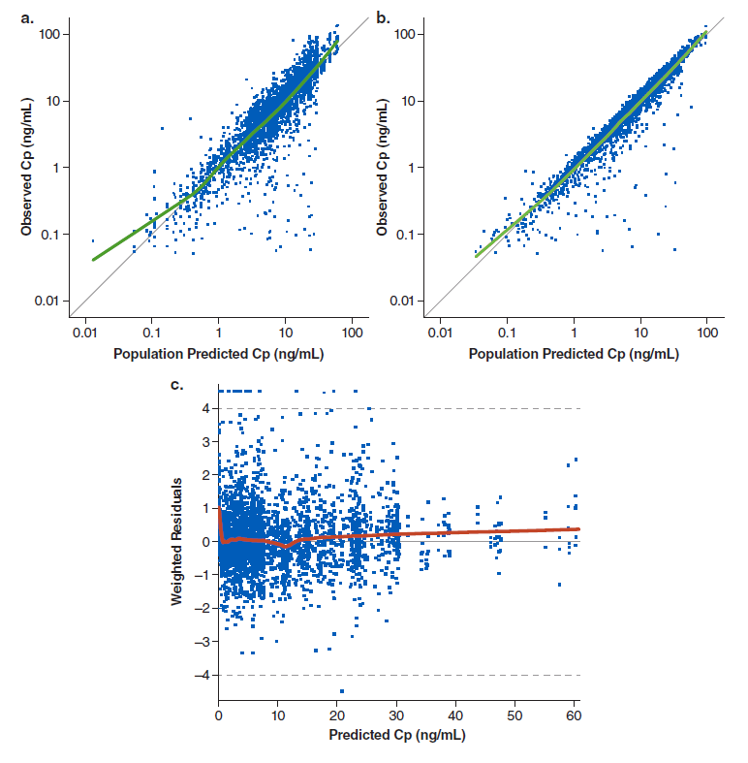
Cp plasma concentrations.

