ELECTRONIC SUPPLEMENTARY MATERIAL

Article Title: Risk of Acute Liver Injury in Agomelatine and Other Antidepressant Users in Four European Countries

Journal: CNS Drugs
Authors:
Manel Pladevall, MD, MSc; Anton Pottegård, MSc, PhD; Tania Schink, MPH, PhD; Johan Reutfors, MD, PhD; Rosa Morros, MD, PhD; Beatriz Poblador-Plou, MPH, PhD; Antje Timmer, MD, MS; Joan Forns, MPH, PhD; Maja Hellfritzsch, MD; Tammo Reinders, MSc; David Hägg, PhD; Maria Giner-Soriano PharmD, PhD; Alexandra Prados-Torres MD, PhD; Miguel Cainzos-Achirica, MD, MPH; Jesper Hallas, MD, DMSc; Lena Brandt, MSc; Jordi Cortés, MSc; Jaume Aguado, MSc; Gabriel Perlemuter, MD, PhD; Bruno Falissard, MD, PhD; Jordi Castellsagué MD, MPH; Emmanuelle Jacquot, MD; Nicolas Deltour, MSc; and Susana Perez-Gutthann, MD, MPH, PhD
Correspoding author:
Manel Pladevall-Vila, MD MSc
RTI Health Solutions, Av. Diagonal 605, 9-1 08028 Barcelona, Spain
Telephone: + 3493.241.7768
Mobile phone: +34.626.896.394
Fax: + 3493.414.2610
E-mail: mpladevall@rti.org

Online Resource 1. Characteristics of the Databases
Database feature | EpiChron, Aragon, Spain | SIDIAP, Catalonia, Spain (Information System for Research in Primary Care) | GePaRD (German Pharmacoepidemiological Research Database) | Danish National Health Registers | Swedish National Prescription and Inpatient Databases
Population of country | Spain: 46,512,199 | Spain: 46,512,199 | Germany:  80,767,463 | Denmark: 5,627,235 | Sweden: 9,644,864
Database population (Million) | 1.3 | 2.0 | 23.9 | 5.6 | 9.6
Database type | Primary health care electronic medical record database; link to hospital discharge data and pharmacy data | Primary health care electronic medical record database, link to hospital discharge data, pharmacy data, and mortality data | Claims database, four statutory health insurance providers | National health record databases, link to other national databases through the unique Civil Personal Registration Number | National health record databases, link to other national databases through the unique Civil Personal Registration Number
Data on medications and type of prescriptions | Reimbursed, pharmacy-filled prescriptions | Reimbursed, pharmacy-filled prescriptions and electronically prescribed drugs | Reimbursed, pharmacy-filled prescriptions | All (reimbursed and non-reimbursed) pharmacy-filled prescriptions; in one database, only reimbursed prescriptions | All (reimbursed and non-reimbursed) pharmacy-filled prescriptions
Drug dictionary codes/ therapeutic classification | ATC | ATC | ATC | ATC | ATC
Disease and procedure coding system(s) | Primary health care, ICPC; hospital, ICD-9-CM | ICD-10-CM for primary care diagnoses; ICD-9-CM for hospital diagnoses | ICD-10-GM for diagnoses; OPS for surgical and diagnostic procedures; EBM for types of treatments and diagnostic procedures | ICD-10 | ICD-10
Primary care data available | Yes | Yes | Yes | No | No
Specialist outpatient visits available | Yes | Only referrals from primary care physician to hospital specialist; only the date of the first visit is recorded | Yes | Only hospital clinic visits | Yes
Hospital discharge data available | Yes | Yes | Yes | Yes | Yes
Laboratory (requests, results) | Yes (only primary care results, hospital results available via abstraction of medical records) | Yes (only primary care results) | Requests are available, but not results | No (results available only via abstraction of medical records) | No
Data availability | Partial since 2005; complete 2010 through 2014 | 2006 through Dec 2014 | Since 2004 | Patient register, since 1977; prescription registers, since 1995;  last year included in this report, 2014 | Since July 2005 (patient register data available since 1987)  Last year included in this report, 2014
Approximate time lag (updates per year) | 1 year (1 per year) | 1 year (1 per year) | 1.5-1.8 year (at least 1 per year) | 1 year (1 per year) | 12 months (monthly updates for the prescribed drugs register)
Access to hospital medical records | Yes | No | No | Yes | No
ICD-10 = International Statistical Classification of Diseases and Related Health Problems, 10th Revision; ICD-10-CM = International Statistical Classification of Diseases and Related Health Problems, 10th Revision, Clinical Modification; ICD-10-GM = International Statistical Classification of Diseases and Related Health Problems, 10th Revision, German Modification; ICD-9-CM = International Classification of Diseases, Ninth Revision, Clinical Modification; ICPC = International Classification of Primary Care; OPS = Operationen- und Prozedurenschlüssel.
Note: The term “filled prescriptions” is equivalent to dispensed medications.

Online Resource 2. List of Study Exclusion Criteria

To control for potential confounding factors, the study cohort was restricted to patients without a history of liver disease or risk factors for liver disease. Therefore, patients with any of the listed conditions recorded as primary or secondary discharge diagnoses at any time before the start date were excluded from the study:

- Acute and subacute liver disease including viral and other infectious or toxic hepatitis
- Chronic liver diseases, such as cirrhosis or fibrosis of the liver, alcoholic liver disease, chronic toxic liver disease, hemochromatosis, Wilson disease, deficit of alpha-1-antitrypsin, and Budd-Chiari syndrome
- Disorders of bilirubin excretion such as Gilbert’s syndrome and Crigler-Najjar syndrome
- Chronic biliary or pancreatic disease
- Risk factors for liver disease: alcohol use disorder, heart failure
- Malignancy
- Human immunodeficiency virus (HIV) infection/AIDS
- Liver or other organ transplant
- Drug abuse and dependence
- History of paracetamol intoxication
- Jaundice (excluding neonatal jaundice)
- Hepatomegaly
- Other and unspecified disorders of the liver
- Non-specific elevation of levels of transaminase and lactic acid dehydrogenase (LDH)

Patients with a history of infectious liver injury or HIV/AIDS (who have a higher risk of viral hepatitis than the general population) were excluded from the study cohort because the focus of this study is non-infectious ALI.

Online Resource 3. List of Specific and Nonspecific Codes for Acute Liver Injury Used in the Three Study Endpoints
Code | Description
Specific codes
ICD-9-CM code
570.x | Acute and subacute necrosis of liver
572.2 | Hepatic coma
573.3 | Hepatitis unspecified
ICD-10-CM code
K71.0 | Toxic liver disease with cholestasis
K71.1 | Toxic liver disease with hepatic necrosis
K71.2 | Toxic liver disease with acute hepatitis
K71.6 | Toxic liver disease with hepatitis, not elsewhere classified
K71.9 | Toxic liver disease, unspecified
K72.0 | Acute and subacute hepatic failure
K72.9 | Hepatic failure, unspecified
K75.9 | Inflammatory liver disease, unspecified
K76.2 | Central haemorrhagic necrosis of liver
Nonspecific codes
ICD-9-CM code
573.8 | Other specified disorders of liver
573.9 | Unspecified disorders of liver
782.4 | Jaundice, unspecified, not of newborn
V42.7 | Liver transplant
790.4 | Nonspecific elevation of levels of transaminase or LDH
789.1 | Hepatomegaly
ICD-10-CM code
K76.8 | Other specified diseases of liver
K76.9 | Liver disease, unspecified
R17 | Unspecified jaundice, excludes neonatal
R16.0 | Hepatomegaly, not elsewhere classified
R16.2 | Hepatomegaly with splenomegaly, not elsewhere classified
R74.0 | Nonspecific elevation of levels of transaminase and LDH
Z94.4 | Liver transplant
ICD-9-CM = International Classification of Diseases, 9th Revision, Clinical Modification; ICD-10-CM = International Statistical Classification of Diseases and Related Health Problems, 10th Revision, Clinical Modification; LDH = lactic acid dehydrogenase.

Online resource 4. Drugs (Generic Name and ATC code) Considered as Concurrent Use of Hepatoxic Drugs, by Predominant Injury Pattern
Medication, by Type of Liver Injury | ATC Code
Hepatocellular (elevated ALT)
Acarbose | A10BF01, A10BD17
Acetaminophen | N02BE01, N02BE51, N02BE71
Allopurinol | M04AA01, M04AA51
Amiodarone | C01BD01
Baclofen | M03BX01
Bupropion | N06AX12, A08AA62
Ciprofloxacin ^{b} | J01MA02, J01RA10, J01RA12, J01RA11
Direct acting antivirals | J05A
Isoniazid | J04AM03, J04AC01, J04AC51, J04AM02, J04AM05, J04AM06, J04AM01, J04AM04
Interferon beta 1a/1b^{a,b} | L03AB02, L03AB07, L03AB08
Ketoconazole | J02AB02
Lisinopril | C09AA03, C09BB03, C09BA03
Lamotrigine^{b} | N03AX09
Levofloxacin^{a,b} | J01MA12, J01RA05 (with ornidazole), A02BD10 (with lansoprazole and amoxicillin)
Losartan | C09CA01, C09DB06, C09DA01
Methotrexate | L01BA01, L04AX03
NSAIDs | M01A
Omeprazole | A02BC01, A02BD05, A02BD01
Pyrazinamide | J04AK01, J04AM05, J04AM06
Rifampicin | J04AB02, J04AM02, J04AM05, J04AM06
Risperidone | N05AX08
Statins (HMG CoA reductase inhibitors) | C10AA
Tetracyclines | J01A
Telithromycinª | J01FA15
Trazodone | N06AX05
Trovafloxacin | J01MA13
Valproic acid | N03AG01
Cholestatic (elevated ALP and elevated TB)
Amlodipineª | C08CA01, C08GA02, C09BB03, C09BB04, C09BB07, C09BX01, C09DB01, C09DB02, C09DB04, C09DB05, C09DB06, C09DB07, C09DX01, C09DX03, C09XAA53, C09XA54, C10BX03, C10BX07, C10BX09, C10BX11
Anabolic steroids | A14A
Chlorpromazine | N05AA01
Clopidogrel | B01AC04
Oral contraceptives | G03A
Oxacillinª | J01CF04
Erythromycins | J01FA01
Estrogens | G03C, G03F, G03EA, L02AA
Irbesartan | C09CA04, C09DB05, C09DA04
Phenothiazines | N05AA, N05AB, N05AC
Terbinafine | D01BA02, D01AE15
Tricyclic/tetracyclic antidepressants | N06AA
Amoxicillin/clavulanic acid | J01CR01, J01CR02
Mixed (elevated AST and elevated ALT)
Azathioprine | L04AX01
Aripiprazole^{b,c} | N05AX12
Captopril | C09AA01, C09BA01
Carbamazepine | N03AF01
Clindamycin | J01FF01
Cyproheptadine | R06AX02
Enalapril | C09AA02, C09BA02, C09BB02, C09BB06
Flutamide | L02BB01
Nitrofurantoin | J01XE01, J01XE51
Phenobarbital | N03AA02
Phenytoin | N03AB02, N03AB52
Sulfonamides | J01E, J01RA02, A07AB, A10BC, C03BA, C03BB, C03BK, C03CA, C03CB
Trazodone | N06AX05
Trimethoprim-sulfamethoxazole | J01EE01
Verapamil | C08DA01, C08DA51, C09BB10
ALT = alanine aminotransferase; AST = aspartate aminotransferase; ATC = Anatomical Therapeutic Chemical (classification system); NSAIDs = non-steroidal anti-inflammatory drugs; TB = total bilirubin.
Sources: Navarro and Senior (2006).
ª Chalasani et al. (2008).
^{b} Shin et al. (2013).
^{c} FDA (2009)

Online Resource 5. Key Potential Confounders, Method of Control in the Analysis, and Time of Ascertainment
 | Case-Control Analyses
Variables (as Available in Data Sources) | Analysis method of control | Timing
Age | Matching | Index date
Sex | Matching | Index date
Calendar year of study start date | Matching | Start date
Index date (date of event) | Matching | —
Socioeconomic statusª | Adjustment | Start date
Liver diseases
Liver disease, study endpoints | Excluded | —
Liver disease, all liver disease other than study endpoints | Excluded | —
Haemochromatosis | Excluded | —
Wilson’s disease | Excluded | —
Deficit of alpha-1-antitrypsin | Excluded | —
Budd-Chiari syndrome | Excluded | —
Disorders of bilirubin excretion (Gilbert syndrome) | Excluded | —
Acute biliary and pancreatic disease | Adjustment | Any time before index date^{b}
Chronic biliary and pancreatic disease | Excluded | —
Risk factors for liver disease
Acute alcohol intoxication | Adjustment | Any time before index date^{b}
Alcohol use disorder | Excluded | —
Drug abuse and dependence | Excluded | —
Heart failure | Excluded | —
Obesity | Adjustment | Any time before index date^{b}
Hyperlipidaemia and hypertriglyceridaemia | Adjustment | Any time before index date^{b}
Diabetes | Adjustment | Any time before index date^{b}
Hypertension | Adjustment | Any time before index date^{b}
Occupational exposure^{c} | Adjustment | 12 months before index date
Malignancy | Excluded | —
Human immunodeficiency virus/AIDS | Excluded | —
Organ transplant | Excluded | —
Time during pregnancy^{d} | Excluded | —
Severe comorbidity: selected Charlson comorbidity index components^{e} | Excluded | —
Severe comorbidity: Charlson comorbidity index | Adjustment | Any time before index date^{b}
History of rheumatic diseases | Adjustment | Any time before index date^{b}
History of peptic ulcer disease | Adjustment | Any time before index date^{b}
Concurrent use of hepatotoxic drugs | Adjustment | 6 months before the index date
Use of other antidepressants
Number of different antidepressants used | Adjustment | Any time before index date^{b}
Concurrent use of other antidepressants | Adjustment | 6 months before the index date
Indication of treatment with antidepressants | Adjustment | Any time before index date^{b}
Time in days since first antidepressant prescription | Adjustment | Any time before index date^{b}
Number of liver tests performed^{f} | Adjustment | From study start date to index date^{f}
Health care resource utilisation measures | Adjustment | 6 months before the index date
— = not applicable.
ª Only some data sources will have variables appropriate to measure socioeconomic status. If a data source can provide information on socioeconomic status, the variable will be described in detail in the corresponding adaptation of the statistical analysis plan.
^{b} Includes all available time before the start date and up to but not including the index date.
^{c} Difficult to obtain in databases.
^{d} Only person-time during follow-up will be excluded.
^{e} Most components are already addressed through restriction and censoring.
^{f} Available only in SIDIAP and EpiChron, Spain, and in GePaRD, Germany. The timing of this variable includes available time beginning with the study start date and up to but not including the index date.

Online Resource 6. Summary of the Cohort Description Across the Five Data Sources in the Citalopram and Agomelatine Cohorts
 | EpiChron |  | SIDIAP |  | GePaRD |  | Denmark |  |  | Sweden
 | Citalopram  (N = 9,016) | Agomelatine  (N = 8,826) | Citalopram  (N = 41,295) | Agomelatine  (N = 3,243) | Citalopram  (N = 229,895) | Agomelatine  (N = 30,155) | Citalopram  (N = 199,887) | Agomelatine  (N = 18,032) |  | Citalopram  (N = 302,719) |  |  | Agomelatine  (N = 14,184)
Sex
Male | 28.8% | 28.4% | 26.5% | 28.9% | 30.7% | 29.3% | 36.8% | 33.3% |  | 33.1% |  |  | 35.6%
Female | 71.2% | 71.6% | 73.5% | 71.1% | 69.3% | 70.7% | 63.2% | 66.7% |  | 66.9% |  |  | 64.4%
Age (years)
Mean (SD) | 60.8  (19.3) | 54.3  (16.5) | 53.9  (18.4) | 51.2  (15.0) | 48.1  (15.9) | 47.5  (13.6) | 49.7  (20.2) | 45.6  (15.1) |  | 53.2  (20.7) |  |  | 44.2  (14.8)
Duration of follow-up (months)
Median (IQR) | 32.5  (16.3-46.5) | 33.3  (18-44) | 35.8  (18.8-49.2) | 46.0  (33.6-54.8) | 23.5  (10.6-35.8) | 20.7  (9.7-33.4) | 35.0  (18.7-52.9) | 37.9  (21.0-50.9) |  | 30.7  (14.1-47.3) |  |  | 27.9  (13.8-40.8)
Duration of first treatment episode of current use (months)
Median (IQR) | 3.2  (2.2-7.7) | 3.3  (2.2-7.5) | 7.5  (3.2-17.4) | 7.9  (3.3-18.8) | 4.6  (3.0-7.9) | 4.5  (2.2-7.0) | 6.9  (4.5-14.8) | 5.5  (2.5-12.7) |  | 6.0  (4.5-12.4) |  |  | 4.1  (2.2-7.9)
Duration of all treatment episodes of current use (months)
Median (IQR) | 5.2  (2.2-15) | 4.8  (2.2-12.4) | 9.0  (3.5-20.2) | 9.2  (3.8-20.7) | 5.2  (3.0-12.7) | 4.5  (2.2-8.9) | 9.4  (5.4-21.8) | 6.4  (2.5-15.4) |  | 9.0  (4.6-20.5) |  |  | 4.6  (2.2-10.9)
Percentage of the duration of all treatment episodes (current use) with multiple use of any other antidepressant
Median (IQR) | 0  (0-12.5) | 26.5  (0-74.9) | 0.0  (0.0-9.2) | 18.8  (0.0-100.0) | 0.0  (0.0-43.8) | 37.8  (0.0-100.0) | 0.0  (0.0-28.3) | 68.8  (6.8-100.0) |  | 0.0  (0.0-10.7) |  |  | 27.5  (4.3-67.0)
Obesity or overweight | 20.5% | 22.0% | 17.3% | 17.2% | 18.4% | 20.6% | 7.3% | 11.6% |  | 2.7% |  |  | 4.9%
Hyperlipidaemia and hypertriglyceridaemia | 36.4% | 36.1% | 29.0% | 27.6% | 30.8% | 31.4% | 18.8% | 16.9% |  | 18.7% |  |  | 12.6%
Diabetes | 13.8% | 10.3% | 10.2% | 7.9% | 9.3% | 8.4% | 6.7% | 6.1% |  | 7.5% |  |  | 5.4%
Hypertension | 48.6% | 40.1% | 30.4% | 23.4% | 40.9% | 42.3% | 28.1% | 23.9% |  | 38.9% |  |  | 33.2%
Charlson Comorbidity Index score
0 | 85.2% | 87.5% | 82.7% | 86.3% | 47.2% | 46.4% | 86.7% | 88.8% |  | 85.4% |  |  | 90.4%
1 | 10.4% | 10.1% | 13.9% | 11.9% | 41.9% | 44.7% | 9.9% | 9.9% |  | 9.1% |  |  | 8.2%
2+ | 4.4% | 2.4% | 3.4% | 1.7% | 10.9% | 8.9% | 2.8% | 1.1% |  | 5.5% |  |  | 1.4%
Number of liver tests performed
0 | 65.8% | 64.2% | 47.1% | 47.8% | 47.5% | 42.7% | N.A. | N.A. |  | N.A. |  |  | N.A.
1 | 26.5% | 27.3% | 39.4% | 37.3% | 34.1% | 34.9% | N.A. | N.A. |  | N.A. |  |  | N.A.
2+ | 7.7% | 8.5% | 13.4% | 14.9% | 18.4% | 22.4% | N.A. | N.A. |  | N.A. |  |  | N.A.
Number of antidepressants
0 | 91.3% | 84.2% | 77.7% | 54.6% | 65.4% | 36.8% | 75.9% |  | 23.1% |  | 51.0% | 9.0%
1 | 7.9% | 13.5% | 17.6% | 29.8% | 26.6% | 34.1% | 19.7% |  | 42.8% |  | 30.0% | 18.5%
2+ | 0.7% | 2.3% | 4.7% | 15.6% | 7.9% | 29.1% | 4.4% |  | 34.1% |  | 19.0% | 72.4%
Number of hepatotoxic drugs used
0 | 15.5% | 15.2% | 33.9% | 75.7% | 33.0% | 27.5% | 33.9% |  | 27.5% |  | 26.0% | 26.3%
1 | 18.3% | 18% | 20.0% | 7.4% | 32.0% | 31.7% | 28.8% |  | 29.2% |  | 34.1% | 26.7%
2+ | 66.3% | 66.8% | 46.1% | 16.9% | 34.9% | 40.8% | 37.4% |  | 43.3% |  | 39.9% | 47.1%
IQR = interquartile range; SD = standard deviation N.A. = not available.

Online Resource 7. Case-Control Analysis: Cases of ALI Hospitalisation in the Five Data Sources (Primary Endpoint) and Adjusted Odds Ratios, by Potential Confounding Factors
 | EpiChron  OR (95% CI) | SIDIAP  OR (95% CI) | GePaRD  OR (95% CI) | Danish National Health Registers OR (95% CI) | Swedish National Registers OR (95% CI)
Cases, n | 27 | 19 | 101 | 170 | 155
Controls, n | 538 | 380 | 2,020 | 3,400 | 3,100
Obesity or overweight
No | 1.0 (Reference) | – | 1.0 (Reference) | 1.0 (Reference) | 1.00 (Reference)
Yes | 1.28 (0.45-3.61) | – | 0.79 (0.45-1.39) | 1.82 (1.10-3.01) | 2.21 (1.11-4.41)
Acute biliary and pancreatic diseaseª | – | – | – | – | 2.35 (1.40-3.94)
Acute alcohol intoxicationª | – | – | – | – | –
Hyperlipidaemia and hypertriglyceridaemiaª | 0.37 (0.11-1.24) | – | 1.18 (0.72-1.94) | 0.90 (0.59-1.36) | 1.04 (0.64-1.69)
Diabetesª | 1.69 (0.25-11.27) | – | 0.39 (0.18-0.85) | 0.56 (0.30-1.04) | 0.99 (0.53-1.85)
Hypertensionª | 1.09 (0.38-3.12) | – | 2.04 (1.18-3.53) | 1.11 (0.74-1.67) | 1.20 (0.79-1.81)
History of peptic ulcer diseaseª | – | – | 2.13 (1.00-4.54) | – | –
History of rheumatic diseasesª | – | – | – | – | 8.93 (2.38-33.48)
Indication for major depressionª | 0.37 (0.12-1.15) | – | 1.14 (0.62-2.10) | 1.74 (1.07-2.82) | 0.93 (0.56-1.55)
Indication for anxiety disordersª | 0.56 (0.07-4.49) | – | 0.80 (0.47-1.34) | 0.66 (0.09-4.96) | 1.88 (1.01-3.51)
Indication for other mental and behavioural disordersª | 0.95 (0.12-7.83) | – | 0.84 (0.53-1.33) | 2.69 (1.10-6.55) | 1.16 (0.63-2.16)
Indication for neuropathic painª | – | – | – | 1.97 (0.54-7.13) | –
Charlson Comorbidity Index score
0 | 1.0 (Reference) | 1.0 (Reference) | 1.0 (Reference) | 1.0 (Reference) | 1.00 (Reference)
1 | 0.53 (0.1-2.9) | 0.98 (0.26-3.69) | 0.64 (0.38-1.08) | 1.15 (0.74-1.80) | 0.95 (0.54-1.70)
2+ | 0.61 (0.08-4.46) |  | 1.01 (0.55-1.86) | 1.43 (0.78-2.63) | 0.79 (0.34-1.82)
Number of outpatient visits (to GP or outpatient hospital clinic)
0 | – | – | 1.0 (Reference)^{b} | – | NA
1 | – | – | 1.18 (0.48-2.93)^{b} | – | NA
2-3 | – | – | 1.90 (0.79-4.55)^{b} | – | NA
4+ | – | – | 4.46 (1.83-10.85)^{b} | – | NA
Number of hospitalisations
0 | – | – | 1.0 (Reference)^{c} | – | 1.00 (Reference)
1 | – | – | 3.56 (2.25-5.64)^{c} | – | 1.08 (0.64-1.81)
2-3 | – | – | NA | – | 1.81 (1.00-3.30)
4+ | – | – | NA | – | 2.48 (1.10-5.59)
Number of emergency department visits
0 | – | – | NA | – | NA
1 | – | – | NA | – | NA
2-3 | – | – | NA | – | NA
4+ | – | – | NA | – | NA
Number of liver tests performed
0 | 1.0 (Reference) | – | 1.0 (Reference) | NA | NA
1 | 1.17 (0.35-3.89) | – | 2.06 (1.07-3.94) | NA | NA
2+ | 1.47 (0.36-5.93) | – | 5.28 (2.83-9.84) | NA | NA
Concurrent use of hepatotoxic drugs
None | 1.0 (Reference) | – | 1.0 (Reference) | 1.0 (Reference) | 1.00 (Reference)
1 | 1.9 (0.48-7.5) | – | 0.87 (0.49-1.57) | 1.22 (0.78-1.91) | 0.92 (0.57-1.48)
2+ | 1.68 (0.47-6.05) | – | 1.20 (0.65-2.19) | 1.57 (0.99-2.47) | 0.84 (0.53-1.34)
Concurrent use of other drugs for depression
No | 1.0 (Reference) | – | – | 1.0 (Reference) | 1.00 (Reference)
Yes | 1.68 (0.60-4.73) | – | – | 0.67 (0.43-1.05) | 0.93 (0.56-1.54)
Concurrent use of other drugs for depression
None | – | – | 1.0 (Reference) | – | –
1 | – | – | 0.96 (0.49-1.85) | – | –
2+ | – | – | 0.90 (0.37-2.19) | – | –
ALI = acute liver injury; CI = confidence interval; GP = general practitioner; NA = not applicable; OR = odds ratio.
"-" indicates that the variable was not included in the final multivariable model.
NOTE: Confounders included in the final multivariable model were those with reported adjusted ORs in this table. Age, sex, and calendar year are not reported for either the crude or the adjusted analysis because these variables were used for matching. Prespecified variables that were not included in the final multivariable model in any of the five data sources are not presented.
ª Binary variable (yes/no). Only the presence of the condition is presented. The reference category was not having the condition.
^{b} Categories for number of outpatient visits: 0-4, 5-9, 10-19, and 20+.
^{c} Categories for number of hospitalisations: 0 and 1 or more.

Online Resource 8. Age- and Sex-Standardised Incidence Rates of ALI (Primary Endpoint) for Current Use of Each Drug for Depression in the Five Data Sources
Data Source | Citalopram IR (95% CI) | Agomelatine  IR  (95% CI) | Fluoxetine  IR (95% CI) | Paroxetine  IR (95% CI) | Sertraline  IR (95% CI) | Escitalopram  IR  (95% CI) | Mirtazapine  IR  (95% CI) | Venlafaxine  IR  (95% CI) | Duloxetine  IR (95% CI) | Amitriptyline  IR  (95% CI)
EpiChron | 16.13  (0-38.6) | 27.14  (0-80.3) | 21.15  (0-62.6) | 10.88  (0-26.3) | 14.42  (0-42.7) | 13.76  (0.3-24.8) | 16.29  (0-41.4) | - | 9.26  (0-22.1) | 13.34  (0-32.1)
SIDIAP | 5.56  (0.0-12.0) | - | - | 5.95  (0.0-14.2) | 5.94  (0.0-17.6) | 9.77  (0.0-20.9) | 11.59  (0.0-34.3) | 8.35  (0.0-24.7) | - | 6.36  (0.0-18.8)
GePaRD | 9.63  (6.5-12.8) | 5.87  (0.0-13.4) | 8.12  (2.1-14.1) | 19.22  (3.6-34.9) | 11.47  (3.0-19.9) | 3.61  (0.0-8.2) | 4.58  (2.0-7.1) | 2.74  (0.0-5.9) | 8.51  (0.0-17.4) | 22.98  (12.9-33.1)
Denmark | 14.63  (11.3-21.6) | 4.80  (0.1-30.7) | 18.15  (6.1-57.8) | 23.91  (8.8-63.3) | 11.77  (5.9-18.2) | 16.60  (5.8-30.0) | 17.19  (12.3-29.7) | 22.67  (11.3-30.2) | 17.41  (4.5-32.3) | 18.55  (7.0-50.6)
Sweden | 8.95 (4.7-13.2) | - | 6.40 (0.0-15.7) | - | 7.27 (2.9-11.7) | 7.57 (0.2-14.9) | 10.42 (4.6-16.2) | 8.49 (0.8-16.2) | 11.12 (0.0-23.4) | 5.37 (0.0-11.4)
ALI = acute liver injury; CI = confidence interval; IR = incidence rate.
ª Incidence rates are calculated per 100,000 person-years.
“-” indicates that no cases of ALI were captured, and therefore, the IR could not be calculated.

Online Resource 9. Forest Plot of Adjusted Odds Ratios for ALI
(Primary Endpoint) for Current Use of Each Study Drug for Depression Compared With Current Use of Citalopram (Individual OR Results by Data Source and Combined OR Estimates)
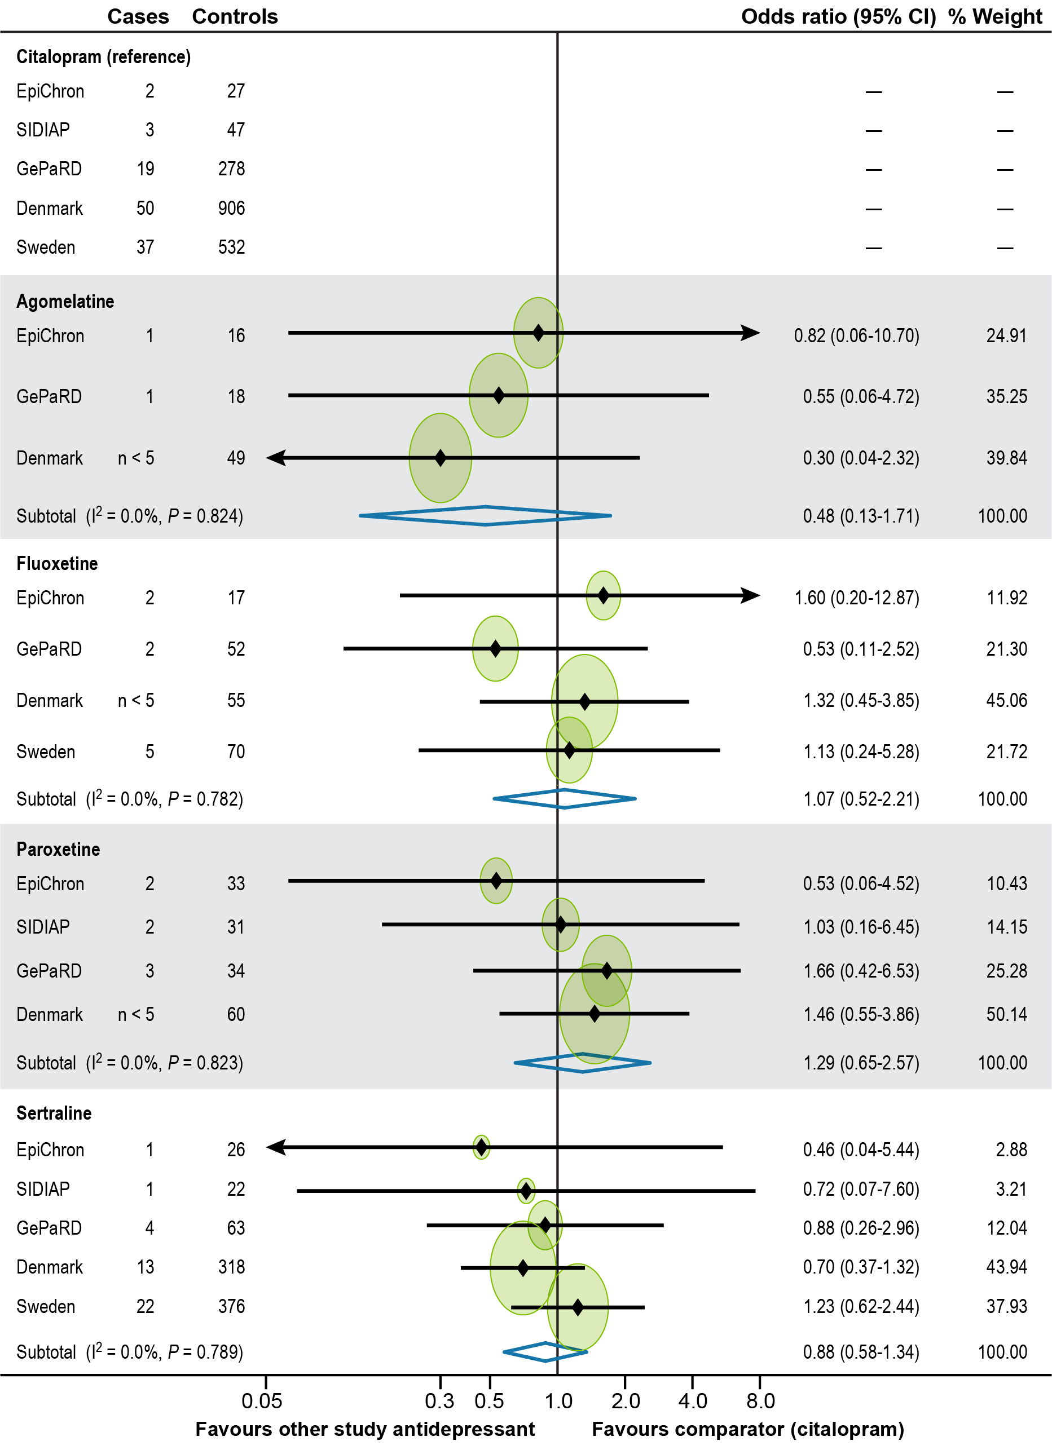

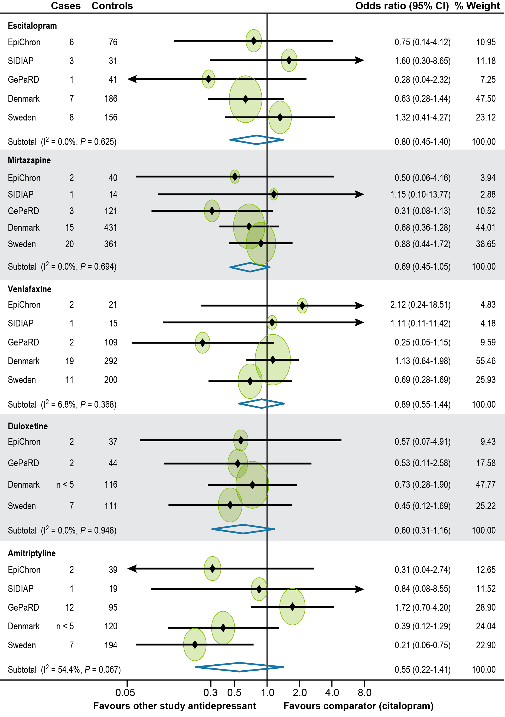
ALI = acute liver injury; CI = confidence interval; OR = odds ratio.
Note: Homogeneity was assessed with the I² statistic, and the results were combined using random-effects models. For those drugs for depression with an I² ≤ 30%, the estimates obtained by using fixed-effects models were similar.
Note: The analysis included 472 cases of the primary endpoint and 9,438 controls. Cases and controls displayed in the forest plot are only those identified among current users. Due to data protection policies, the exact number of cases could not be provided when the number of cases was less than 5. Subtotal refers to the combined OR estimates obtained by the meta-analysis. The size of the circles around the point estimates in the plot is proportional to the weight of each data source.

Online Resource 10. Forest Plot of Adjusted Odds Ratios for ALI
(Secondary Endpoint) for Current Use of Each Study Drug for Depression Compared With Current Use of Citalopram (Individual OR Results by Data Source and Combined OR Estimates)
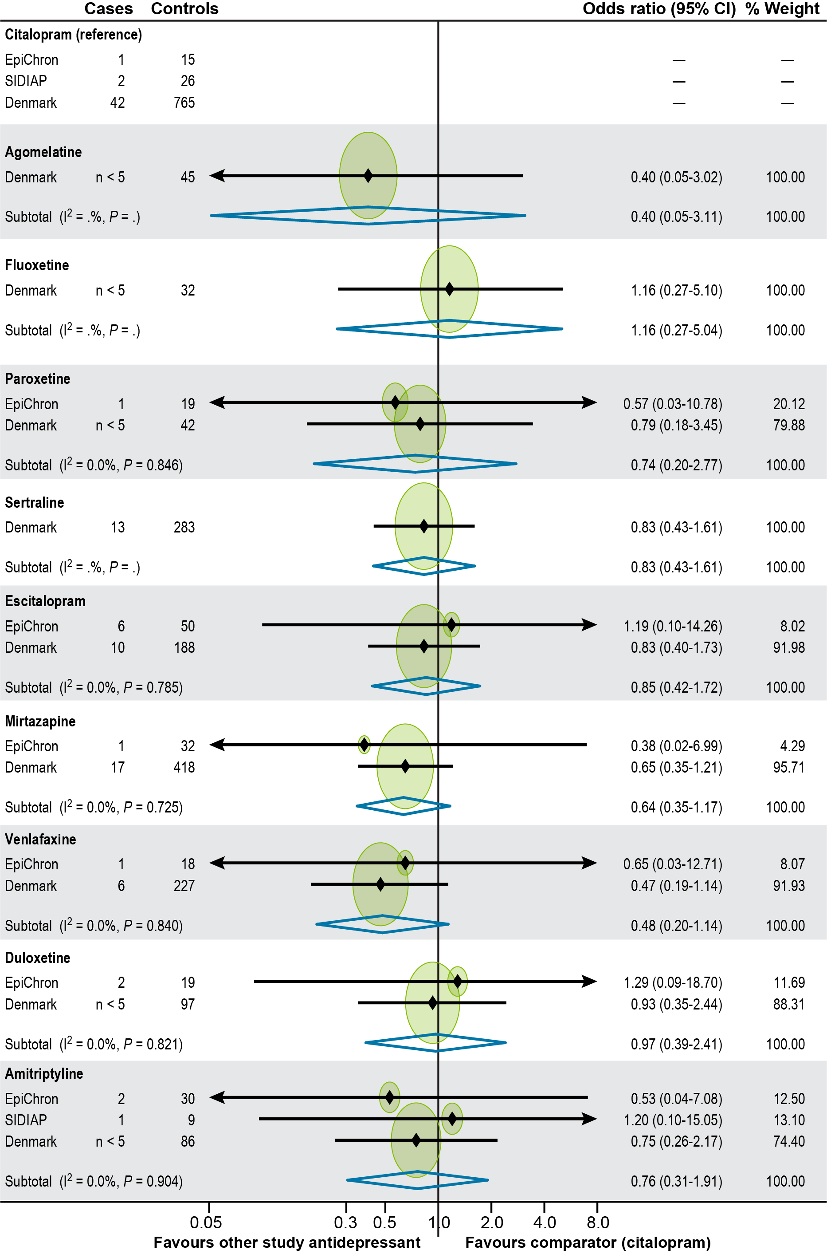
ALI = acute liver injury; CI = confidence interval; OR = odds ratio.
Note: Homogeneity was assessed with the I² statistic, and the results were combined using fixed-effects models. The analysis included 178 cases of the validated secondary endpoint and 3,540 controls. Cases and controls displayed in the forest plot are only those identified among current users. For agomelatine, fluoxetine, and sertraline, cases of the validated secondary endpoint were found only in the Danish National Health Registers. Due to data protection policies, the exact number of cases could not be provided when the number of cases was less than five. Subtotal refers to the combined OR estimates obtained by the meta-analysis. The size of the circles around the point estimates in the plot is proportional to the weight of each data source.

Online Resource 11. Forest Plot of Adjusted Odds Ratios for ALI
(Tertiary Endpoint) for Current Use of Each Study Drug for Depression Compared With Current Use of Citalopram (Individual OR Results by Data Source and Combined OR Estimates)
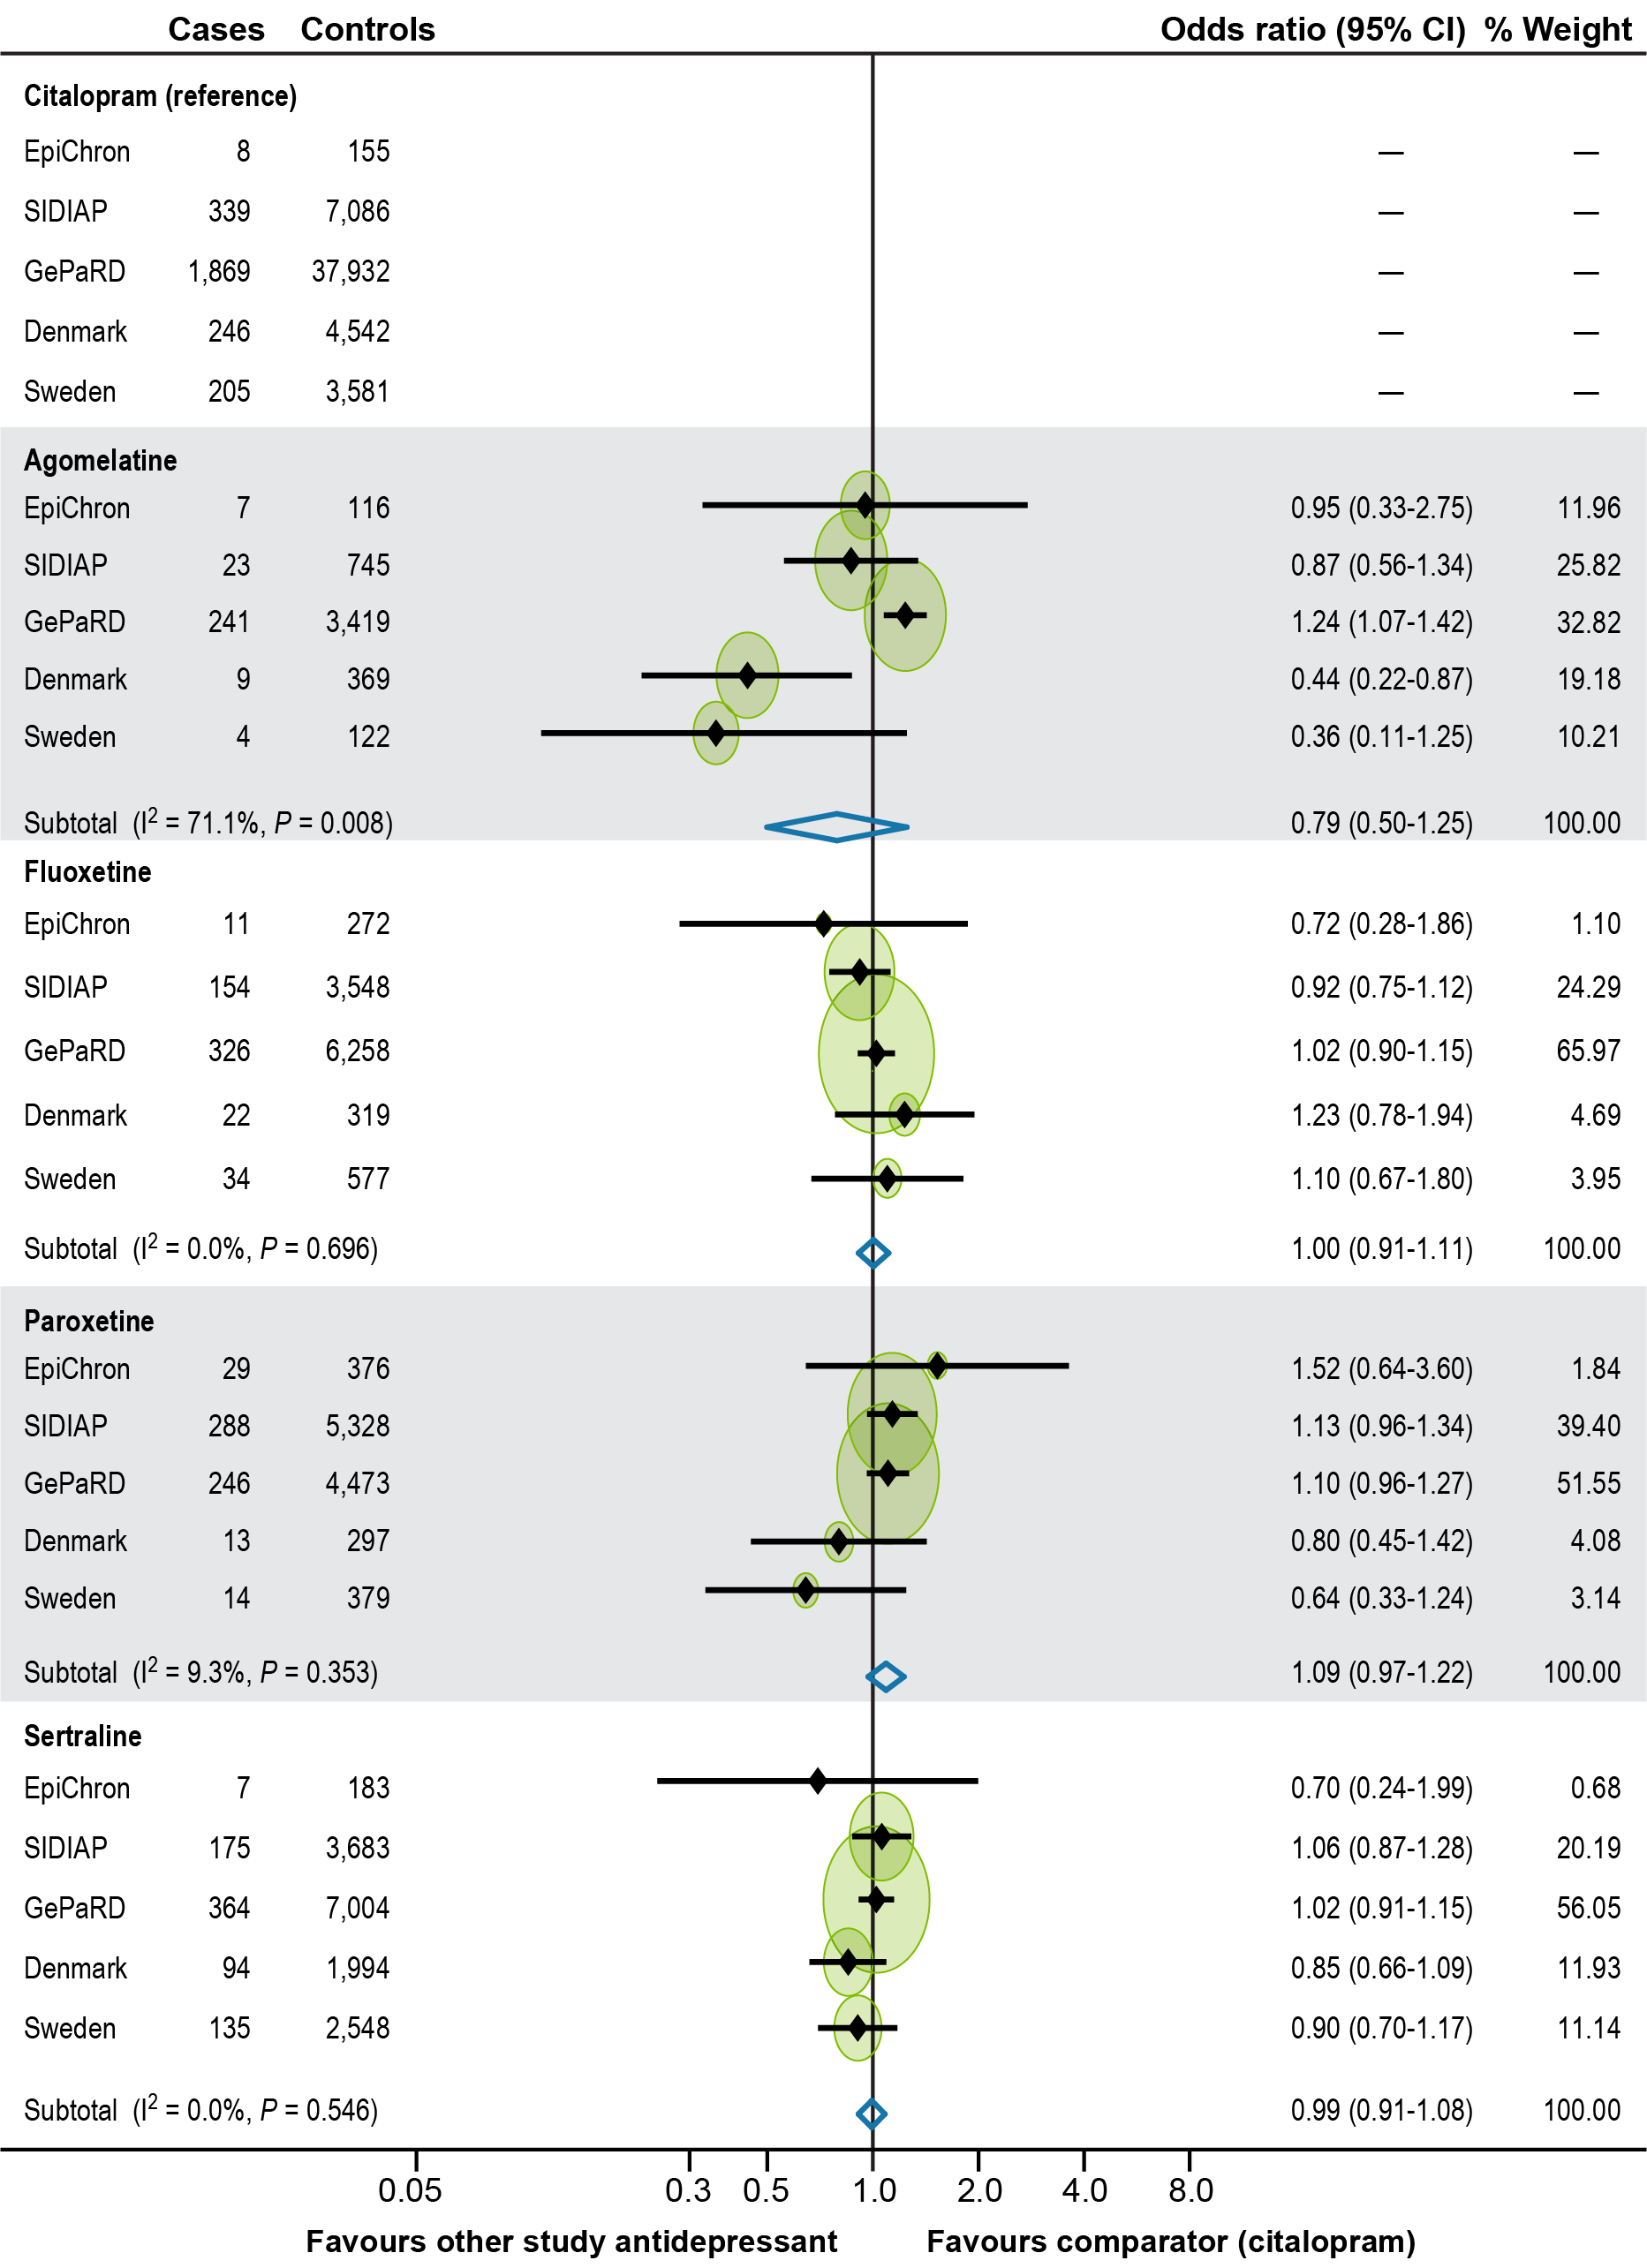
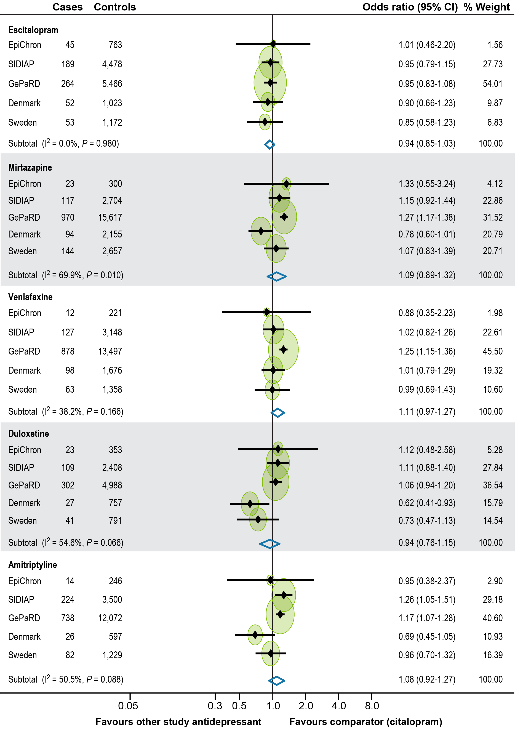
ALI = acute liver injury; CI = confidence interval; OR = odds ratio.
Note: Homogeneity was assessed with the I² statistic, and the results were combined using random-effects models. For those drugs for depression with an I² ≤ 30%, the estimates obtained by using fixed-effects models were similar.
Note: The analysis included 17,118 cases of the tertiary endpoint and 342,070 controls. Cases and controls displayed in the forest plot are only those identified among current users. Subtotal refers to the combined OR estimates obtained by the meta-analysis. The size of the circles around the point estimates in the plot is proportional to the weight of each data source.

Online Resource 12. Agomelatine Results Overall and by Data Source for Tertiary Endpoint
 | EpiChron  OR (95% CI) | SIDIAP  OR (95% CI) | GePaRD  OR (95% CI) | Danish National Health Registers  OR (95% CI) | Swedish National Registers  OR (95% CI) | Combined  OR (95% CI)
Main analysis | 0.95  (0.33-2.75) | 0.87  (0.56-1.34) | 1.24  (1.07-1.42) | 0.44  (0.22-0.87) | 0.36  (0.11-1.25) | 0.79  (0.50-1.25)
Sensitivity analyses
Only confirmed cases | – | – | NA | 0.75  (0.17-3.22) | NA | –
ALI = acute liver injury; CI = confidence interval; NA = Not applicable; OR = odds ratio.
"-" indicates that the model did not converge.
Note: Adjusted for confounding factors; the list of confounders differed by data source.

Online Resource 13. Forest Plot of Adjusted Odds Ratios for ALI (Tertiary Endpoint Including Only Validated Cases) for Current Use of Each Study Drug for Depression Compared With Current Use of Citalopram (Individual OR Results by Data Source and Combined OR Estimates)
