Supplemental material Figure 1: Flow diagram of participants completing the survey and samples included in the C-TTO and DC data analysis

Total number of interviews completed (n=1,014)

Final sample included in the C-TTO analysis

(n=999)

**Exclusion criteria for C-TTO**

Criteria 1 (n=3)

Criteria 2 (n=12)

All states valued zero (n=1)

All states valued -1 (n=11)

Total excluded (n=15)

Final sample included in the DC analysis

(n=1,014)

Total number of interviews conducted (n=1,033)

19 participants with incomplete responses excluded

C-TTO: composite time trade-off

DC: discrete choice

Supplemental material Table 1: Self-reported health using the EQ-5D-5L descriptive system and EQ Visual Analogue Scale (VAS) by age group for all participants (n=1,014)

|  |  |  |  |  |  |  |  |  |  |
| --- | --- | --- | --- | --- | --- | --- | --- | --- | --- |
|  | **Age Group** | **18-24** | **25-34** | **35-44** | **45-54** | **55-64** | **65-74** | **75+** | **Total** |
| **Domain** |  | **n (%)** | **n (%)** | **n (%)** | **n (%)** | **n (%)** | **n (%)** | **n (%)** | **n (%)** |
| **Mobility** | **No problems** | 160 (96%) | 165 (95%) | 165 (95%) | 107 (90%) | 177 (79%) | 82 (79%) | 39 (70%) | 895 (88%) |
| **Slight problems** | 6 (4%) | 6 (3%) | 8 (5%) | 11 (9%) | 37 (17%) | 17 (16%) | 9 (16%) | 94 (9%) |
| **Moderate problems** | 0 (0%) | 1 (1%) | 0 (0%) | 1 (1%) | 8 (4%) | 5 (5%) | 5 (9%) | 20 (2%) |
| **Severe problems** | 0 (0%) | 0 (0%) | 0 (0%) | 0 (0%) | 1 (0%) | 0 (0%) | 3 (5%) | 4 (0%) |
| **Unable to walk** | 0 (0%) | 1 (1%) | 0 (0%) | 0 (0%) | 0 (0%) | 0 (0%) | 0 (0%) | 1 (0%) |
| **Self-Care** | **No problems** | 166 (100%) | 172 (99%) | 172 (99%) | 118 (99%) | 218 (98%) | 101 (97%) | 52 (93%) | 999 (99%) |
| **Slight problems** | 0 (0%) | 0 (0%) | 1 (1%) | 1 (1%) | 4 (2%) | 3 (3%) | 1 (2%) | 10 (1%) |
| **Moderate problems** | 0 (0%) | 1 (1%) | 0 (0%) | 0 (0%) | 1 (0%) | 0 (0%) | 3 (5%) | 5 (0%) |
| **Severe problems** | 0 (0%) | 0 (0%) | 0 (0%) | 0 (0%) | 0 (0%) | 0 (0%) | 0 (0%) | 0 (0%) |
| **Unable to** | 0 (0%) | 0 (0%) | 0 (0%) | 0 (0%) | 0 (0%) | 0 (0%) | 0 (0%) | 0 (0%) |
| **Usual**  **activities** | **No problems** | 156 (94%) | 168 (97%) | 165 (95%) | 110 (92%) | 186 (83%) | 96 (92%) | 46 (82%) | 927 (91%) |
| **Slight problems** | 10 (6%) | 3 (2%) | 7 (4%) | 9 (8%) | 27 (12%) | 6 (6%) | 4 (7%) | 66 (7%) |
| **Moderate problems** | 0 (0%) | 2 (1%) | 1 (1%) | 0 (0%) | 9 (4%) | 2 (2%) | 5 (9%) | 19 (2%) |
| **Severe problems** | 0 (0%) | 0 (0%) | 0 (0%) | 0 (0%) | 0 (0%) | 0 (0%) | 1 (2%) | 1 (0%) |
| **Unable to** | 0 (0%) | 0 (0%) | 0 (0%) | 0 (0%) | 1 (0%) | 0 (0%) | 0 (0%) | 1 (0%) |
| **Pain/**  **Discomfort** | **No problems** | 104 (63%) | 113 (65%) | 110 (64%) | 70 (59%) | 117 (52%) | 56 (54%) | 33 (59%) | 603 (59%) |
| **Slight problems** | 61 (37%) | 59 (34%) | 59 (34%) | 46 (39%) | 92 (41%) | 38 (37%) | 16 (29%) | 371 (37%) |
| **Moderate problems** | 1 (1%) | 1 (1%) | 3 (2%) | 3 (3%) | 13 (6%) | 9 (9%) | 5 (9%) | 35 (3%) |
| **Severe problems** | 0 (0%) | 0 (0%) | 1 (1%) | 0 (0%) | 0 (0%) | 1 (1%) | 2 (4%) | 4 (0%) |
| **Extreme problems** | 0 (0%) | 0 (0%) | 0 (0%) | 0 (0%) | 1 (0%) | 0 (0%) | 0 (0%) | 1 (0%) |
| **Anxiety/**  **Depression** | **No problems** | 116 (70%) | 118 (68%) | 134 (77%) | 86 (72%) | 170 (76%) | 86 (83%) | 40 (71%) | 750 (74%) |
| **Slight problems** | 47 (28%) | 51 (29%) | 36 (21%) | 28 (24%) | 46 (21%) | 13 (13%) | 11 (20%) | 232 (23%) |
| **Moderate problems** | 3 (2%) | 3 (2%) | 3 (2%) | 5 (4%) | 5 (2%) | 5 (5%) | 4 (7%) | 28 (3%) |
| **Severe problems** | 0 (0%) | 1 (1%) | 0 (0%) | 0 (0%) | 1 (0%) | 0 (0%) | 0 (0%) | 2 (0%) |
| **Extreme problems** | 0 (0%) | 0 (0%) | 0 (0%) | 0 (0%) | 1 (0%) | 0 (0%) | 1 (2%) | 2 (0%) |
|  |  |  |  |  |  |  |  |  |  |
| **Visual**  **Analogue**  **Scale** | **Mean** | 80.81 | 82.31 | 83.65 | 84.88 | 82.64 | 83.39 | 81.02 | 82.72 |
| **Standard error** | 10.51 | 10.62 | 10.48 | 11.36 | 13.06 | 11.67 | 16.95 | 11.77 |
| **25th Percentile** | 75 | 75 | 80 | 80 | 80 | 80 | 73 | 80 |
| **50th Percentile (median)** | 80 | 80 | 85 | 88 | 80 | 80 | 90 | 82 |
| **75th Percentile** | 90 | 90 | 90 | 90 | 90 | 90 | 90 | 90 |

Supplemental material Figure 2: Distribution of observed composite time trade-off (C-TTO) utility values across respondents



Supplemental material Figure 3: Distribution of observed C-TTO utility values by severity index [severity index is defined as the sum of the levels for all dimensions in a particular state, e.g. state 25431 has a severity index of 2+5+4+3+1 = 15]



Supplemental material Table 2: Interview times of composite time trade-off and feedback module across study samples

|  |  |  |  |  |
| --- | --- | --- | --- | --- |
|  | **Study Sample**  **(n=1,014)** | **Participants not excluding states during FM**  **(n = 674)** | **Participants excluding states during FM**  **(n = 340)** | **Mean difference (parametric 95% confidence interval)**  **[participants not excluding versus participants excluding]** |
| **C-TTO time in minutes, mean (standard deviation), median** | 12 (7),11 | 13 (7),11 | 12 (6), 10 | 1 (0.30 to 2.07)* |
| **FM time in minutes, mean (standard deviation), median** | 3 (2), 3 | 2 (1), 2 | 4 (2), 3 | -2 (-2.08 to -1.65)* |
| **Overall C-TTO+FM time in minutes, mean (standard deviation), median** | 15 (7), 14 | 15 (7) ,13 | 16 (7), 14 | -1 (-1.61 to 0.25) |
|  |  |  |  |  |

FM: Feedback module; C-TTO: composite time trade-off; *Significant at 5% significance level

Supplemental Material Table 3: Using the EQ-5D-5L value for Hong Kong in practice

|  |  |  |  |  |
| --- | --- | --- | --- | --- |
|  | **Utility decrement** | **Health state**  **55555** | **Health state**  **21211** | **Health State**  **23445** |
| **Mobility** |  |  |  |  |
| Slight | 0.109 |  | 0.109 | 0.109 |
| Moderate | 0.182 |  |  |  |
| Severe | 0.371 |  |  |  |
| Unable | 0.529 | 0.529 |  |  |
|  |  |  |  |  |
| **Self-care** |  |  |  |  |
| Slight | 0.087 |  |  |  |
| Moderate | 0.113 |  |  | 0.113 |
| Severe | 0.271 |  |  |  |
| Unable | 0.352 | 0.352 |  |  |
|  |  |  |  |  |
| **Usual Activities** |  |  |  |  |
| Slight | 0.067 |  | 0.067 |  |
| Moderate | 0.094 |  |  |  |
| Severe | 0.234 |  |  | 0.234 |
| Unable | 0.282 | 0.282 |  |  |
|  |  |  |  |  |
| **Pain/discomfort** |  |  |  |  |
| Slight | 0.076 |  |  |  |
| Moderate | 0.147 |  |  |  |
| Severe | 0.307 |  |  | 0.307 |
| Unable | 0.354 | 0.354 |  |  |
|  |  |  |  |  |
| **Anxiety/depression** |  |  |  |  |
| Slight | 0.080 |  |  |  |
| Moderate | 0.140 |  |  |  |
| Severe | 0.293 |  |  |  |
| Unable | 0.348 | 0.348 |  | 0.348 |
|  |  |  |  |  |
|  |  |  |  |  |
| Value for health state |  | 1-(0.529+0.352+0.282+0.354+0.348) =  -0.865 | 1-(0.109+0.067) = 0.824 | 1-(0.109+0.113+0.234+0.307+0.348) = -0.111 |

Supplemental material Figure 4: Observed mean and model predicted values without and with feedback module for the 86 C-TTO health states included in interview ordered from high to low

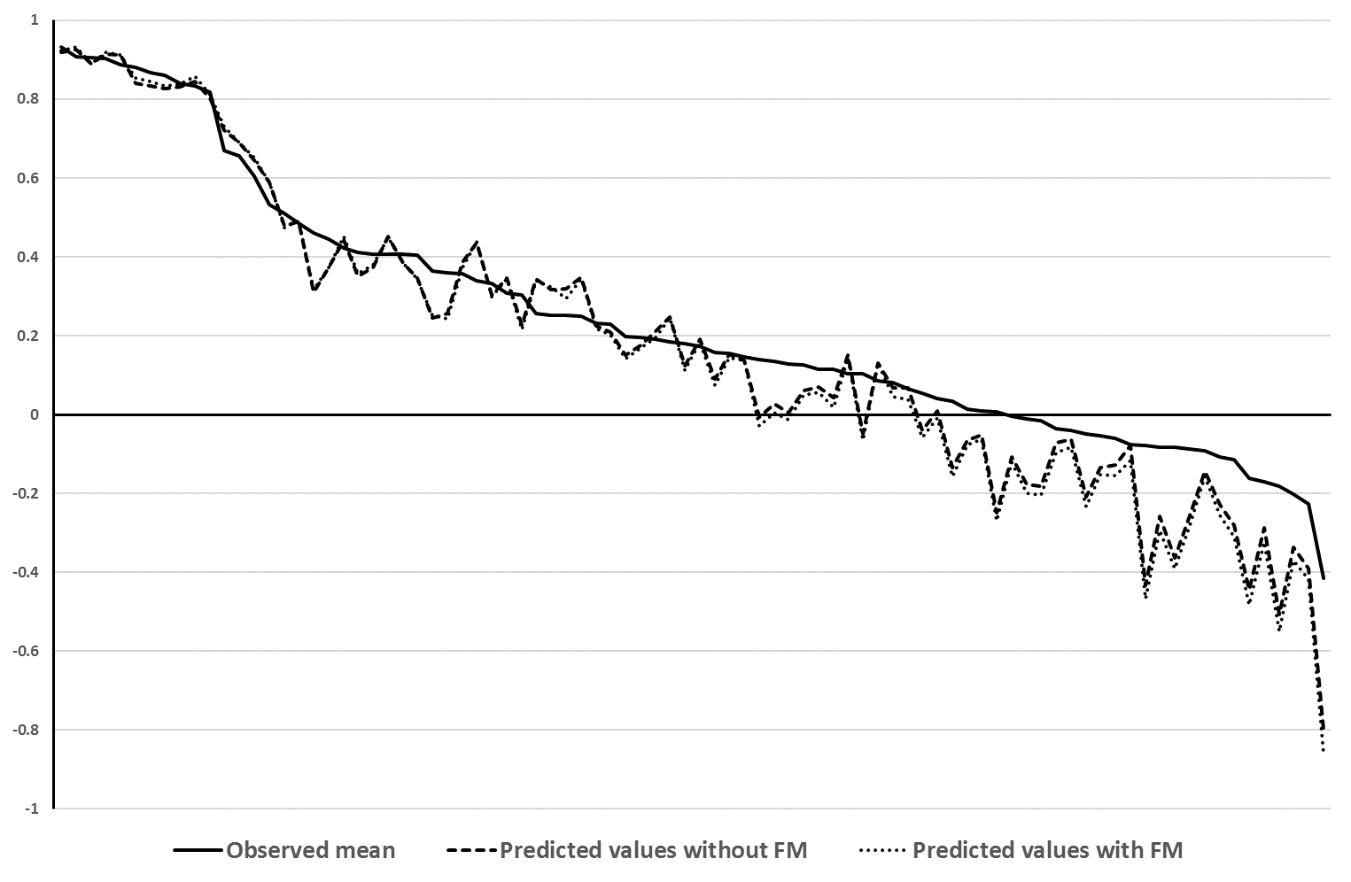

C-TTO: composite time trade-off

FM: Feedback module

Supplemental Material Table 4: Parameter estimates and main characteristics of published EQ-5D-5L value sets in Asian countries

|  |  |  |  |  |  |
| --- | --- | --- | --- | --- | --- |
|  | **Hong Kong** | **China** | **Japan** | **South Korea** | **Indonesia** |
| **MO2** | 0.109 | 0.058 | 0.065 | 0.046 | 0.119 |
| **MO3** | 0.182 | 0.139 | 0.113 | 0.058 | 0.192 |
| **MO4** | 0.371 | 0.253 | 0.179 | 0.133 | 0.410 |
| **MO5** | 0.529 | 0.303 | 0.240 | 0.251 | 0.613 |
| **SC2** | 0.087 | 0.043 | 0.038 | 0.032 | 0.101 |
| **SC3** | 0.113 | 0.102 | 0.070 | 0.05 | 0.140 |
| **SC4** | 0.271 | 0.185 | 0.118 | 0.078 | 0.248 |
| **SC5** | 0.352 | 0.222 | 0.161 | 0.122 | 0.316 |
| **UA2** | 0.067 | 0.039 | 0.057 | 0.021 | 0.090 |
| **UA3** | 0.094 | 0.094 | 0.092 | 0.051 | 0.156 |
| **UA4** | 0.234 | 0.171 | 0.155 | 0.100 | 0.301 |
| **UA5** | 0.282 | 0.205 | 0.173 | 0.175 | 0.385 |
| **PD2** | 0.076 | 0.051 | 0.041 | 0.042 | 0.086 |
| **PD3** | 0.147 | 0.122 | 0.068 | 0.053 | 0.095 |
| **PD4** | 0.307 | 0.221 | 0.124 | 0.166 | 0.198 |
| **PD5** | 0.354 | 0.266 | 0.193 | 0.207 | 0.246 |
| **AD2** | 0.080 | 0.043 | 0.078 | 0.033 | 0.079 |
| **AD3** | 0.140 | 0.104 | 0.111 | 0.046 | 0.134 |
| **AD4** | 0.293 | 0.189 | 0.173 | 0.102 | 0.227 |
| **AD5** | 0.348 | 0.227 | 0.197 | 0.137 | 0.305 |
| **Constant** | - | 0.121 | 0.062 | 0.096 | - |
| **N4** |  |  |  | 0.078 |  |
|  |  |  |  |  |  |
| **Valuation protocol** | EQ-VT 2.0 | EQ-VT 1.0 | EQ-VT 1.1 | EQ-VT 1.1 | EQ-VT 2.0 |
| **Source of data** | C-TTO + DC | C-TTO | C-TTO+DC | C-TTO | C-TTO+DC |
| **Modelling strategy** | Hybrid model | Multiplicative model | Hybrid model | Linear model | Hybrid model |
| **Feedback module** | Yes | No | No | No | Yes |

MO: mobility; SC: self-care; UA: usual activities; PD: pain/discomfort; AD: anxiety/depression; C-TTO: composite time trade-off; DC: discrete choice; EQ-VT: EuroQol Valuation Technology; N4: term indicating the health state contains level 4 or 5 at any dimension