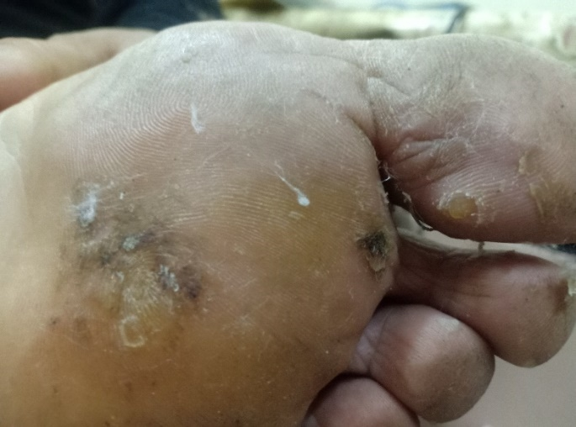
B
A
B
A

Fig.1: Patient no.5 before treatment (A) and clearance of treated and adjacent warts after 3 sessions of candida antigen injection (B)

B
A

Fig.2: Patient no.8 before treatment (A) and complete clearance of treated wart after one session of candida antigen injection (B).

B
A

Fig 3: Patient no.14 before treatment (A) and complete clearance of treated wart after 3 sessions of candida antigen injection (B)

