eIF4B and eIF4H mediate GR production from expanded G4C2 in a Drosophila model for C9orf72-associated ALS.

Lindsey D. Goodman¹, Mercedes Prudencio³, Ananth R. Srinivasan², Olivia M. Rifai², Virginia M-Y. Lee⁴, Leonard Petrucelli³, Nancy M. Bonini^{1,2}.

ADDITIONAL FIGURES

Figure S1
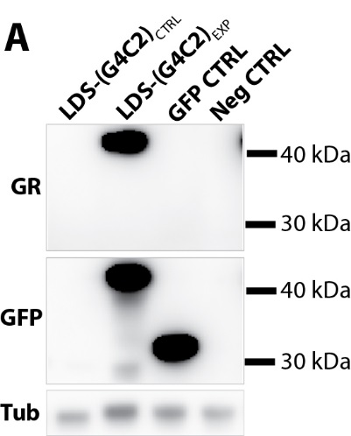
Figure S1: Extended LDS-G4C2 fly line characterization.
Western immunoblots were used to confirm GR dipeptide is produced and successfully tagged with GFP in expanded G4C2 flies (Fig. 1D). Blots were overexposed to see if GR/GFP dipeptide could be detected in control G4C2 flies. Shown is a representative image of the original blot, imaged at > 4X the original exposure. > 10X the original exposure also showed no GR/GFP dipeptide in control G4C2 flies (data not shown). Note that the faint band at a molecular weight below GFP alone in the LDS-(G4C2)_{EXP} lane is a non-specific band that is found in multiple lanes of the complete western immunoblot (see Supplementary Fig. 4 for Uncropped westerns).

Figure S2
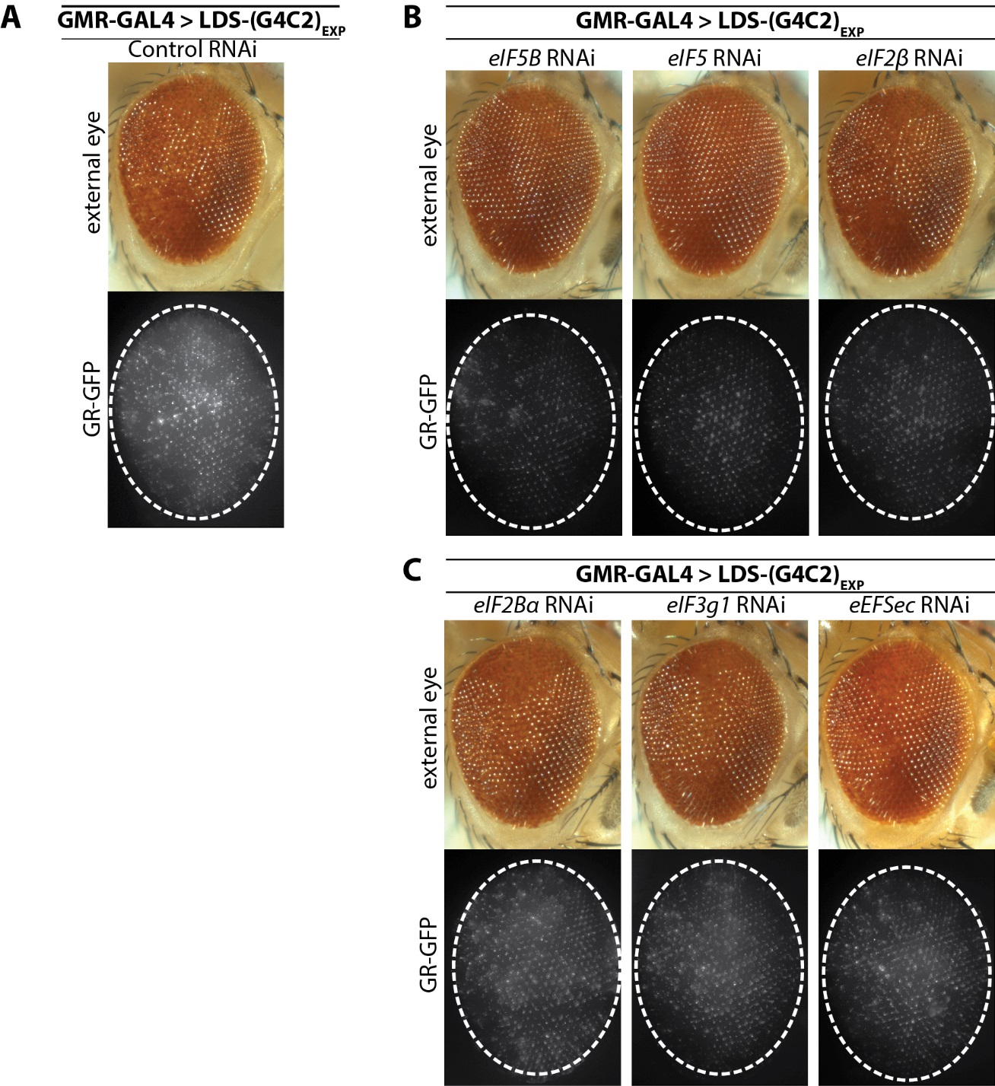
Figure S2: Extended translation factor screen data.
A. External eye and GR-GFP imaging in LDS-(G4C2)_{EXP} animals co-expressing control (Luc) RNAi. B. Additional examples of candidate RAN-translation factors, showing suppression of toxicity in the external eye and reduced GR-GFP levels. Note, eIF2β RNAi only mildly altered toxicity in the external eye. C. Examples of RNAi targeting translation factors that did not significantly alter LDS-(G4C2)_{EXP} toxicity nor GR-GFP levels. RNAi lines: control (JF01355), eIF5B (GL01593), eIF5 (HMS00159), eIF2β (HMC02396), eIF2Bα (HMC03768), eIF3g1 (GLC01430), eEFSec (GL01178). For full genotypes see Supplementary Table 1. Shown: representative images while all RNAi were tested 2+ times for effects on LDS-(G4C2)_{EXP} toxicity and GR-GFP levels.

Figure S3
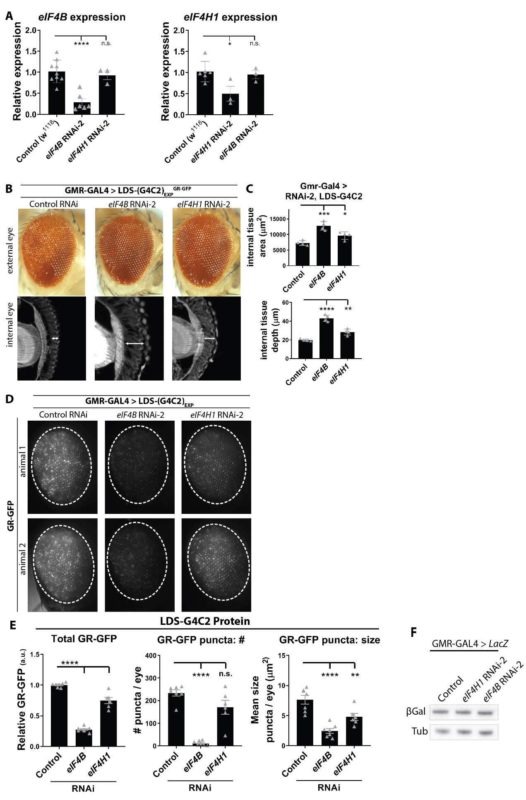
Figure S3: eIF4B and eIF4H1 RNAi-2 data.
eIF4B and eIF4H1 downregulation in LDS-(G4C2)_{EXP} flies using a second set of RNAi lines show similar results. A. RNA levels produced from eIF4B or eIF4H1 were assessed by qPCR in flies ubiquitously expressing RNAi-2 (by Daughterless-GAL4 driver). Shown: individual data points with mean±SD. B. Using GMR-GAL4, RNAi-2-mediated depletion of eIF4B or eIF4H1 in LDS-(G4C2)_{EXP} expressing flies results in reduced toxicity in both the external and internal eye: seen externally by recovered pigment and ommatidial structure, seen internally by recovered retinal tissue integrity. C. Blinded quantification of internal retina tissue was done by measuring the total surface area of tissue present and by measuring the depth of the tissue at the position of the optic chiasm. n=4 animals per genotype. Shown: individual data points each representing 1 animal, with mean±SD. D. Fluorescence imaging in LDS-(G4C2)_{EXP} expressing flies co-expressing eIF4B or eIF4H RNAi-2 results in reduced GR-GFP levels (GMR-GAL4). E. Blinded quantification of GR-GFP signal in LDS-(G4C2)_{EXP} animals relative to signal in control RNAi animals. Note that eIF4H1 RNAi-2 did not cause a significant reduction in GR-GFP puncta number, likely due to this RNAi only causing a 50% downregulation of eIF4H1; it did reduce puncta size and total GR-GFP fluorescence. n=6-7 animals per genotype. Shown: individual data points each representing 1 animal from two independent experiments with mean±SEM. F. A representative western immunoblot image for β-Galactosidase in LacZ flies co-expressing a control transgene, eIF4B RNAi-2, or eIF4H1 RNAi-2. Uncropped westerns (Sup. Fig. 4). Statistics: one-way ANOVAs with Tukey’s multiple comparison correction, p-values ****<0.0001, ***<0.001, **<0.01, *<0.05, no significance >0.05. RNAi lines: control (JF01355), eIF4B RNAi-2 (VSH330010), eIF4H1 RNAi-2 (KK108805). For full genotypes see Supplementary Table 1.

Figure S4
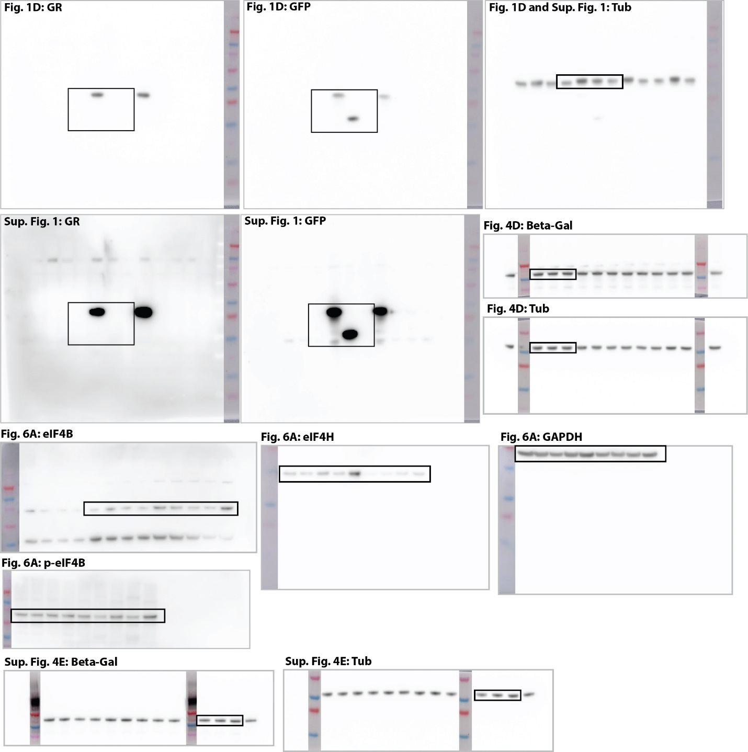
Figure S4: full Western immunoblot images for Fig. 1D, Sup. Fig. 1, Fig. 4D, Fig. 6A and Sup. Fig. 4E, including ladder, Novex sharp Protein Standard (Invitrogen #LC5800)

