ADDITIONAL FILE 1

The landscape of myeloid and astrocyte phenotypes in acute multiple sclerosis lesions
Calvin Park¹, Gerald Ponath¹, Maya Levine-Ritterman¹, Edward Bull¹, Eric C. Swanson², Philip L. De Jager³, Benjamin M. Segal⁴, David Pitt¹
¹ Department of Neurology, Yale School of Medicine, New Haven, CT, USA
²Fluidigm Corporation, Markham, ON, Canada
³Department of Neurology, Columbia University Medical Center, New York, NY
⁴Department of Neurology, University of Michigan, Ann Arbor, MI, USA
Corresponding author: David Pitt, Email: david.pitt@yale.edu

CONTENTS

Supplementary Tables Page

Table S1 (Antibodies used for brightfield and fluorescence histology) 2
Table S2 (Metal-conjugated antibodies used for IMC) 3

Supplementary Figures

Figure S1 4
Figure S2 5
Figure S3 6
Figure S4 7
Figure S5 8
Figure S6 9
Figure S7 10
Figure S8 11
Figure S9 12

Primary Antibody | Host | Clone | Company | Target/Significance | Primary Antibody Dilution | Secondary Antibody | Secondary Antibody Dilution
MBP | Rat | 12 | Millipore-Sigma | Myelin Basic Protein | 1:500  (Brightfield) | Invitrogen, 629540 | 1:500 (Brightfield)
CD68 | Rabbit | D4B9C | Cell Signaling | Activated macrophage/microglia transmembrane glycoprotein | 1:500 (Brightfield)  1:100  (Fluorescence) | Vector Laboratories, BA-1000 (Brightfield)  Invitrogen, A32731  (Fluorescence) | 1:500 (Brightfield)  1:1000  (Fluorescence)
MAP2 | Mouse | 5H11 | Novus | Neuron structural protein | 1:200  (Brightfield) | Vector Laboratories, BA-9200 | 1:500 (Brightfield)
CD74 | Mouse | LN2 | BioLegend | Microglial subtype marker | 1:100  (Fluorescence) | Invitrogen, B40961 | 1:3 (Tyramide Kit Fluorescence)
Additional file 1: Table S1 Antibodies used for brightfield and fluorescence histology

Antibody | Clone | Company | Target/Significance | Conjugated Metal Isotope | Conjugation Source | Dilution
LAMP1/CD107a | H4A3 | Fluidigm | Lysosomes | 151Eu | Fluidigm | 1:100
CD3 | Polyclonal | Fluidigm | T cells | 170Er | Fluidigm | 1:75
CD45 | 2B11 | Fluidigm | Leukocyte activation | 152Sm | Fluidigm | 1:100
CD68 | KP1 | Fluidigm | Activated macrophages/microglia | 159Tb | Fluidigm | 1:300
CD86 | Polyclonal | R&D | “M1” co-stimulatory molecule | 171Yb | Our Lab | 1:100
Ferritin heavy chain | 1-2.3.1.2 | Millipore-Sigma | Iron storage | 158Gd | Our Lab | 1:400
HLA-DR | YE2/36 HLK | Fluidigm | MHC Class II | 174Yb | Fluidigm | 1:200
Mac2 | M3/38 | Fluidigm | “M2” activation | 153Eu | Fluidigm | 1:600
MerTK | y323 | abcam | “M2” phagocytosis | 148Nd | Our Lab | 1:50
PLP | plpc1 | Bio-Rad | Myelin | 142Nd | Our Lab | 1:100
S100B | S100B/1706R | Novus | Astrocytes | 167Er | Our Lab | 1:400
TIM-3 | D5D5R | Fluidigm | Co-inhibitory molecule | 154Sm | Fluidigm | 1:100
Vimentin | RV202 | Fluidigm | Hypertrophic astrocytes | 143Nd | Fluidigm | 1:100
Additional file 1: Table S2 Metal-conjugated antibodies used for IMC
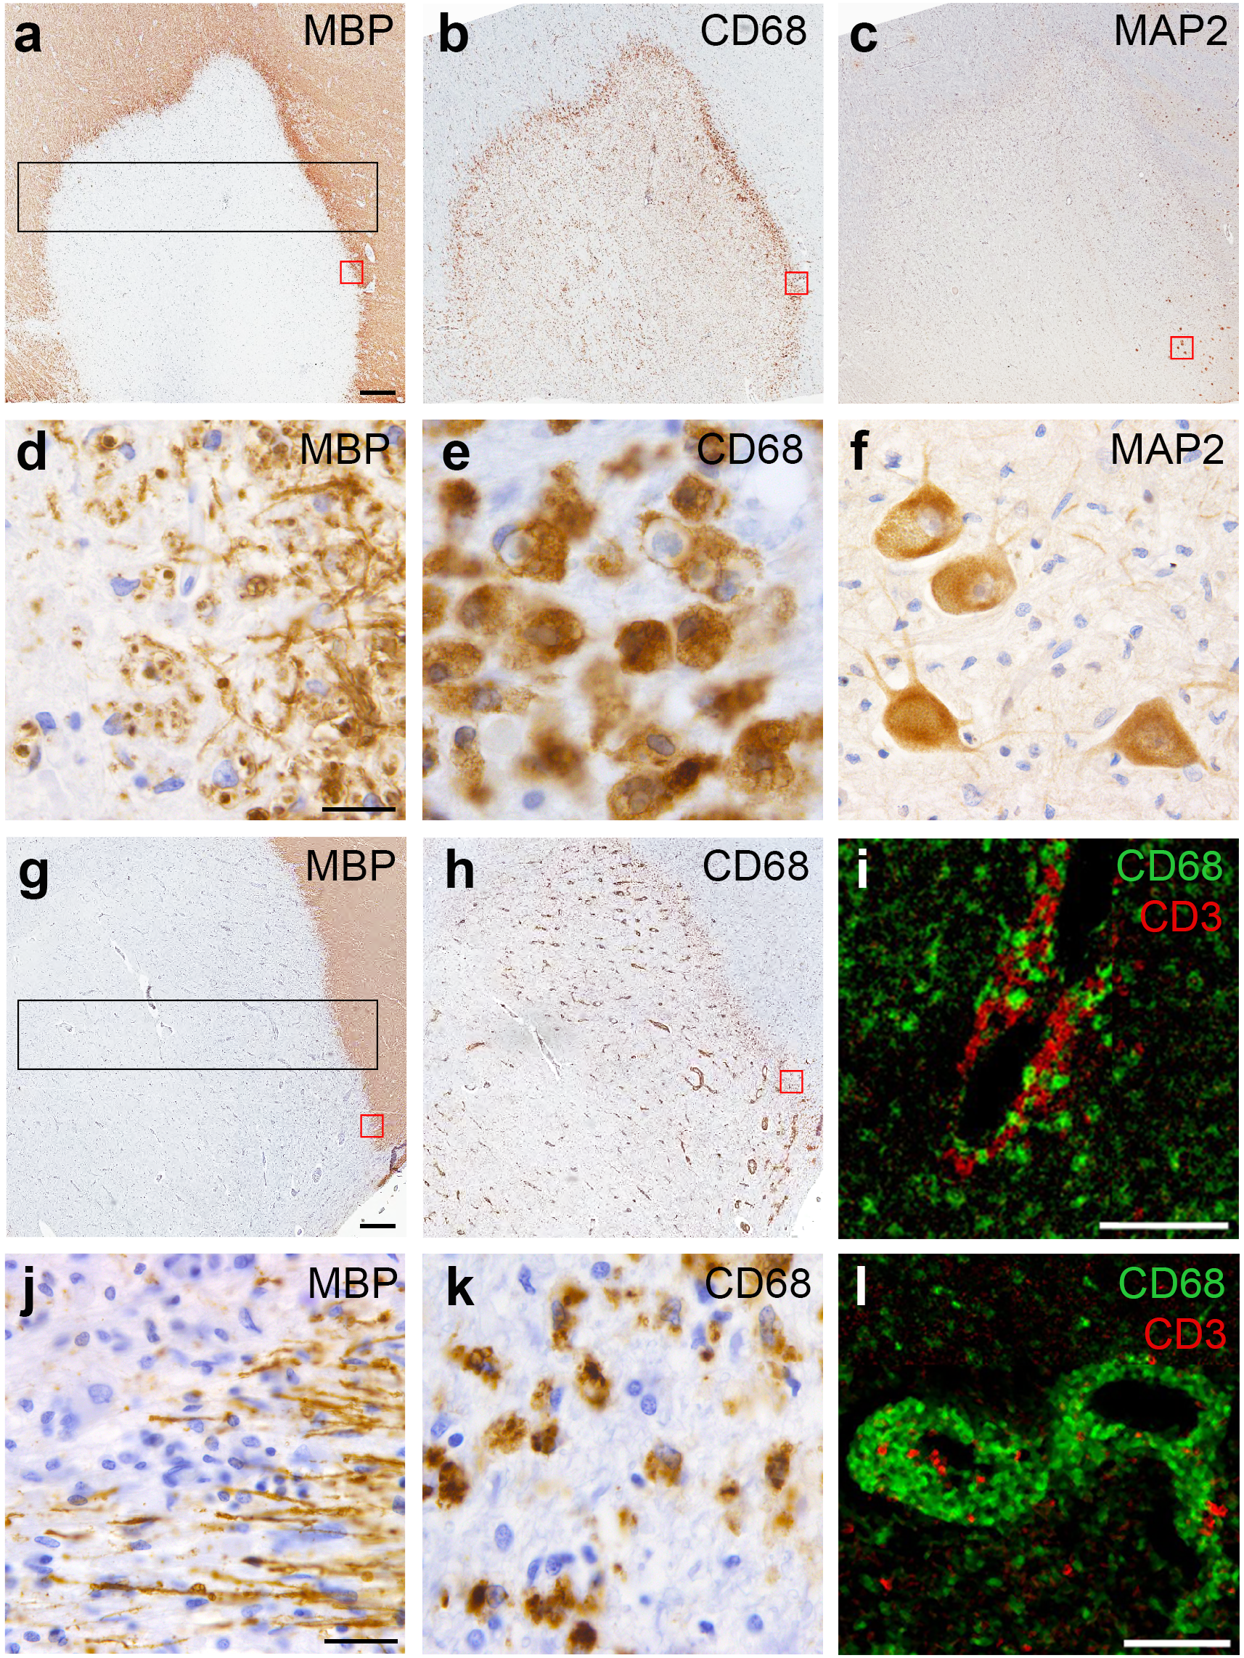

Additional file 1: Figure S1 Brightfield and imaging mass cytometry images of the MS lesions examined in this study. (a-f) Brightfield staining of the early, actively demyelinating lesion for (a) myelin basic protein (MBP), (b) CD68 (macrophages/microglia) and (c) the neuronal marker MAP2. The black rectangle in (a) shows the region that was laser-ablated for IMC, capturing the NAWM, hypercellular rim on both sides and lesion center. Red boxes in a-c correspond to magnified rim areas in d-f, demonstrating in (d) condensed myelin fragments, indicative of ongoing demyelination, (e) dense infiltration with foamy macrophages and (f) dispersed neuronal cell bodies in the right lesion rim. (i) Merged IMC images of perivascular CD68⁺ (green) and CD3⁺ (red) cells in the early lesion.
(g, h, j, k) Brightfield staining against MBP and CD68 in the late, post-demyelinating lesion. The black rectangle in (g) shows the region laser-ablated for IMC. (j, k) Details from (g) and (h) showing absence of myelin fragments and reduced myeloid cell density at the lesion rim compared to (e). (l) Merged IMC images of perivascular CD68⁺ (green) and CD3⁺ (red) cells in the late lesion. Brightfield images show hematoxylin counterstaining. Scale bars a-c, g, h = 500 μm. Scale bars d-f, j, k = 25 μm. Scale bars i, l = 100 μm

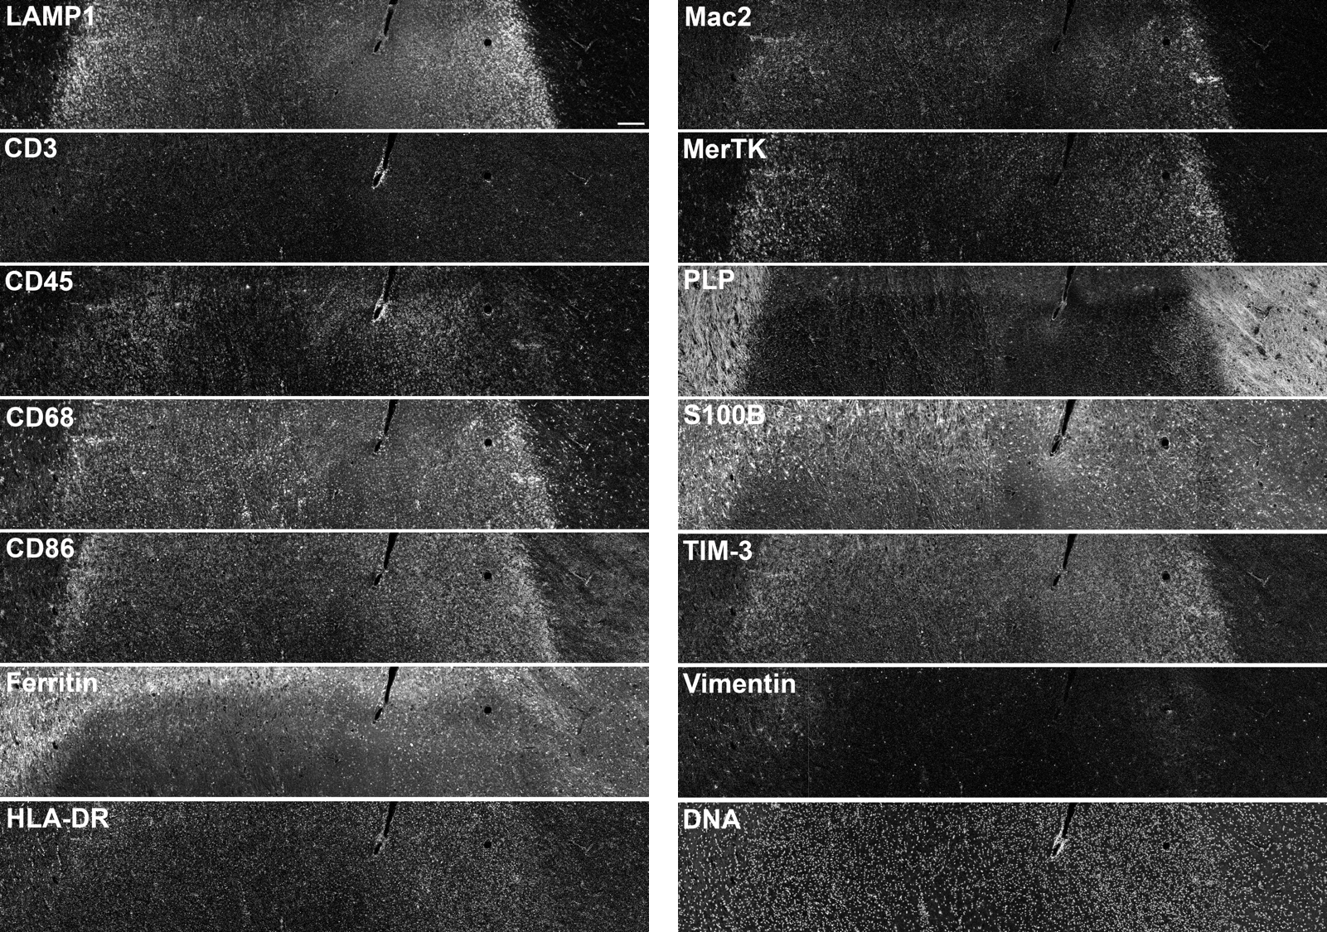

Additional file 1: Figure S2 Imaging mass cytometry histology images of the early lesion. The thirteen markers used for cell clustering as well as DNA counterstaining are shown. Scale bar = 200 μm

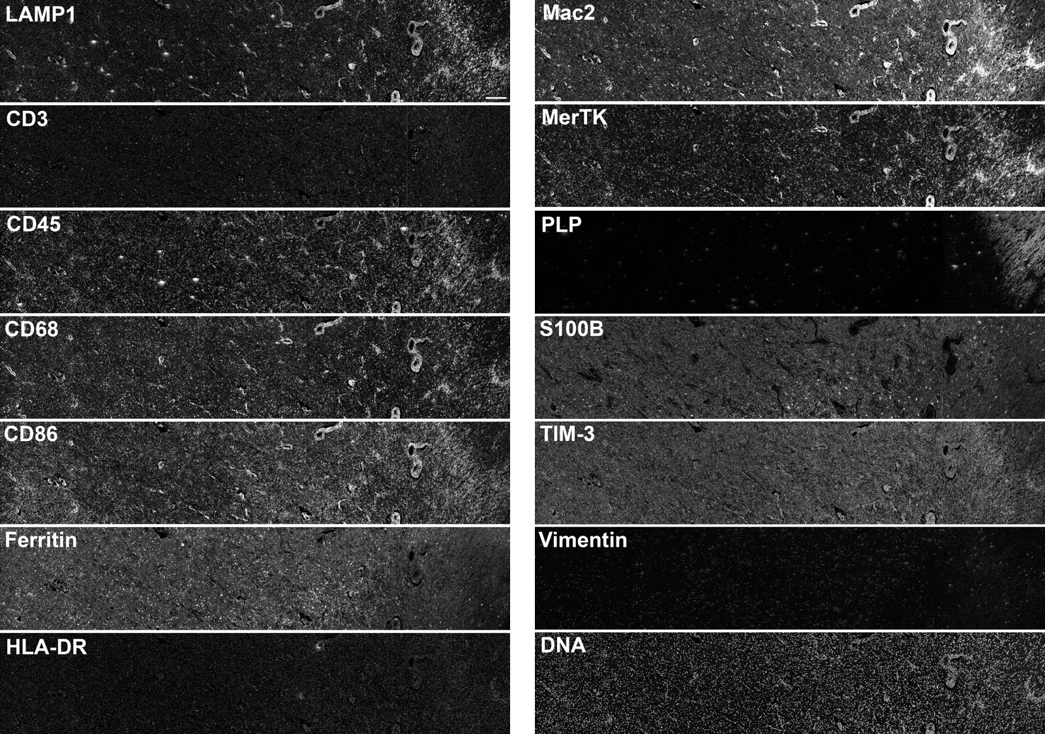
Additional file 1: Figure S3 Imaging mass cytometry histology images of the late lesion. The thirteen markers used for cell clustering as well as DNA counterstaining are shown. Scale bar = 200 μm

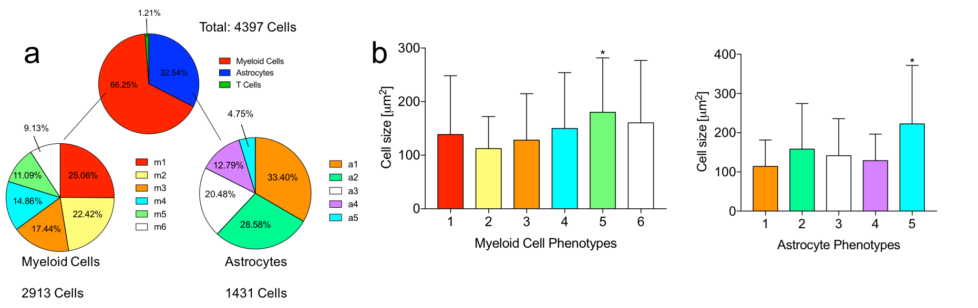
Additional file 1: Figure S4 Early lesion cell phenotype frequency and size. (a) Relative quantities of each cell phenotype. (b) Cell phenotype size. Cells of myeloid phenotype 5 (m5), which occupy the white matter outer rim, are significantly larger than all other myeloid phenotypes. Similarly, cells of astrocyte phenotype 5 (a5), which occupy the white matter outer rim, are significantly larger than all other astrocyte phenotypes. Data represent means + standard deviation. *p < 0.0001 by one-way ANOVA followed by the Tukey-Kramer multiple comparison test

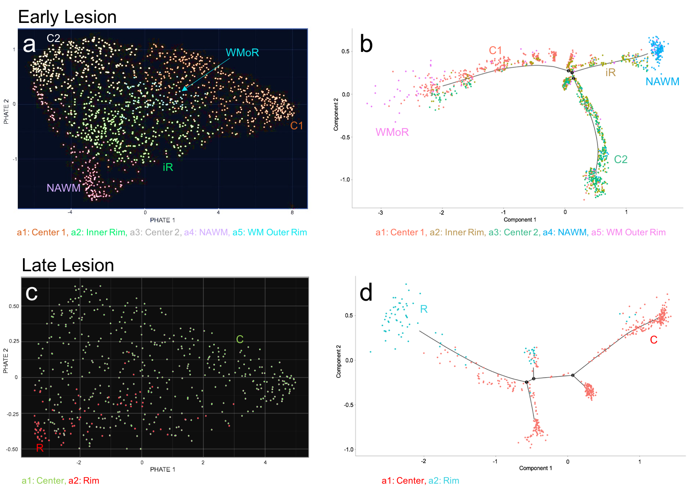
Additional file 1: Figure S5 Analyses of astrocyte phenotype transitions in the (a, b) early and (c, d) late lesion. Both PHATE mapping (a, c) and Pseudotime analyses (b, d) demonstrate no linear phenotype transition in either lesion. Phenotype color schemes on the PHATE and Pseudotime plots reflect the color palettes specific to each analysis. R = rim; WMoR = white matter outer rim; iR = inner rim; C = center; NAWM = normal-appearing white matter

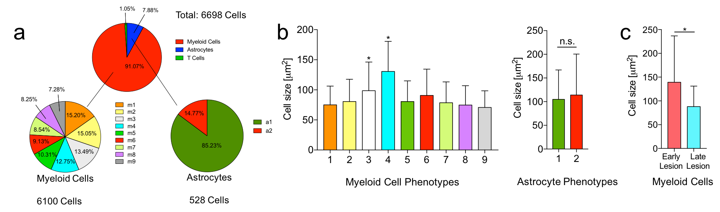

Additional file 1: Figure S6 Late lesion cell phenotype frequency and size. (a) Relative quantities of each cell phenotype. (b) Cell phenotype size. Cells of myeloid phenotypes 3 and 4 (m3, m4), in the rim and perivascular space, respectively, are significantly larger than all other myeloid phenotypes, which occupy the lesion center. (c) Myeloid cell size per lesion. Myeloid cells in the early lesion are significantly larger than those in the late lesion. Data represent means + standard deviation. *p < 0.0001 by one-way ANOVA followed by the Tukey-Kramer multiple comparison test for comparison of myeloid cell phenotype sizes, and by unpaired Student’s t-tests for comparison of astrocyte phenotype sizes and lesion myeloid cell sizes. n.s. = not significant

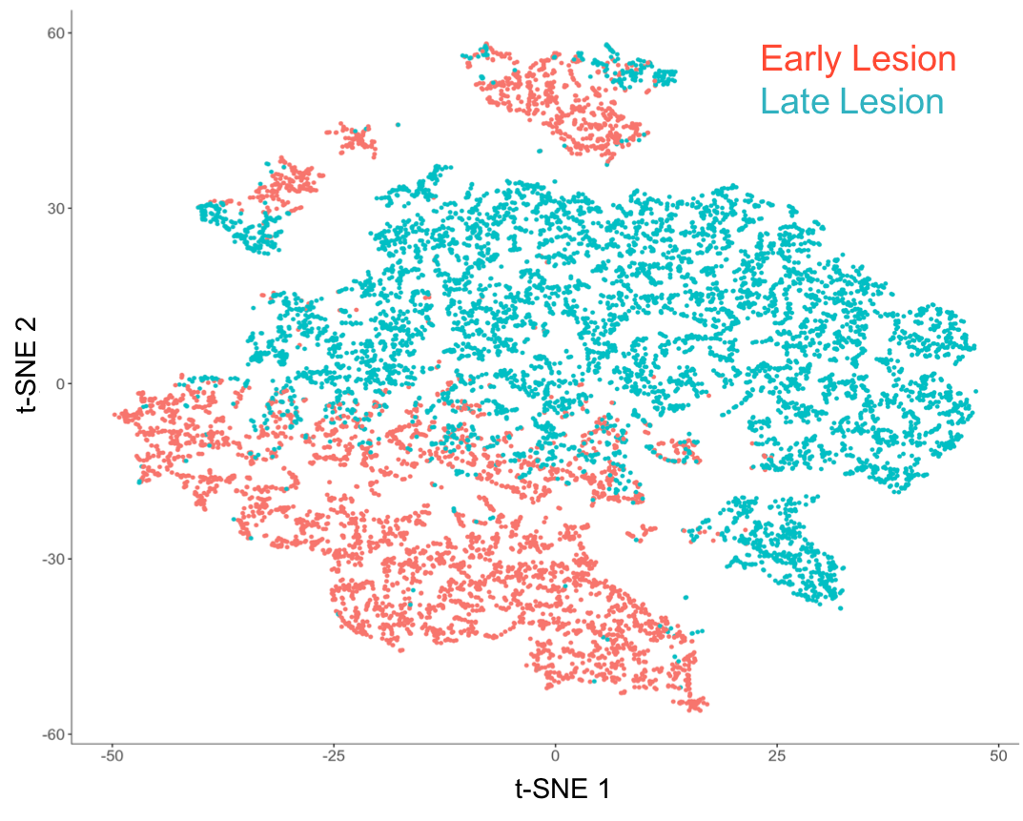
Additional file 1: Figure S7 Comparison of lesion cell character with t-SNE. The plot shows all analyzed cells from the early and late lesions. Cellular populations overlap to some degree but are predominantly distinct

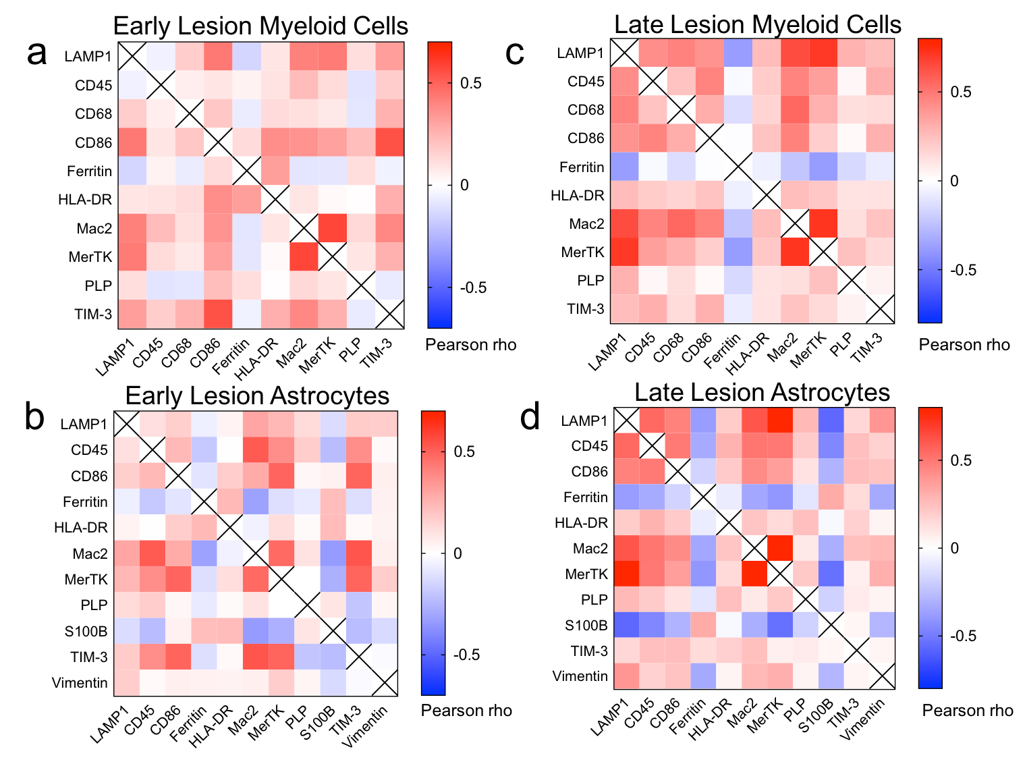
Additional file 1: Figure S8 Pearson correlation matrices for myeloid cells and astrocytes. Matrices for early lesion (a) myeloid cells (n = 2913) and (b) astrocytes (n = 1431), and late lesion (c) myeloid cells (n = 6100) and (d) astrocytes (n = 528) are shown

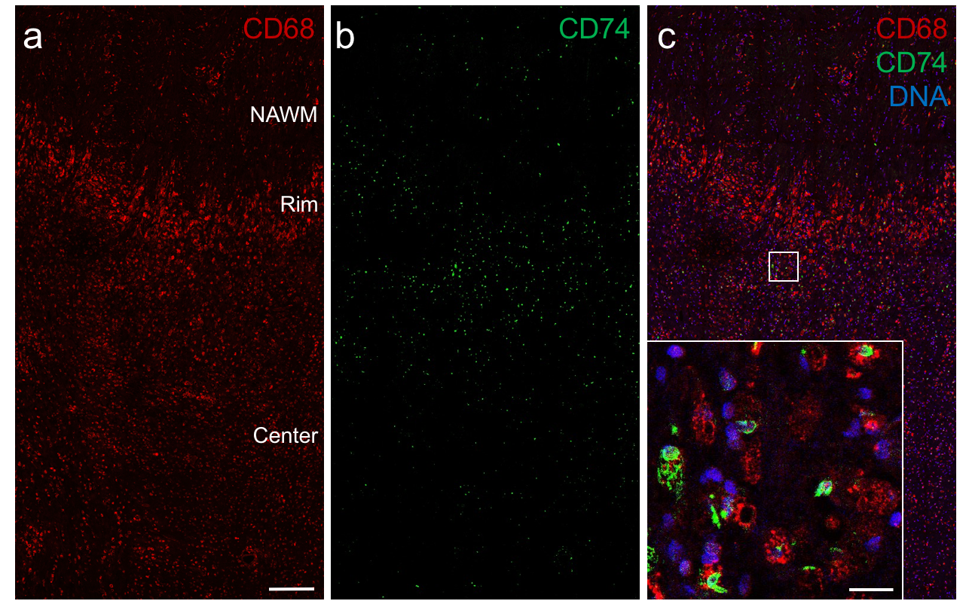
Additional file 1: Figure S9 Immunofluorescence staining of CD74 in the rim of the early lesion. Images of (a) CD68 (red) and (b) CD74 (green) staining are shown separately and (c) merged with nuclear counterstaining (blue). The magnified inset in (c) corresponds to the area demarcated by the white square and shows expression of CD74 in CD68⁺ myeloid cells. Scale bars a-c = 200 μm. Inset scale bar in c = 20 μm. NAWM = normal-appearing white matter

