Supplement
Effects of haloperidol and clozapine on synapse-related gene expression in specific brain regions of male rats

Martina von Wilmsdorff¹, Fabian Manthey², Marie-Luise Bouvier^{3,a}, Oliver Staehlin⁴, Peter Falkai⁵, Eva Meisenzahl-Lechner¹, Andrea Schmitt^{5,6}*, Peter J Gebicke-Haerter^{7,8}*

¹Department of Psychiatry and Psychotherapy, Medical Faculty, Heinrich-Heine-University, Düsseldorf, Germany
²Department of Psychiatry and Psychotherapy, Alexianer Krefeld GmbH, Krefeld, Germany
³Laboratory of Brain Morphology, Department of Psychiatry and Psychotherapy, LVR Klinikum, Heinrich-Heine-University, Duesseldorf, Germany
⁴Thermo Fisher Sci., Darmstadt, Germany
⁵Department of Psychiatry and Psychotherapy, Ludwig Maximilians-University (LMU) Munich, Munich, Germany
⁶Laboratory of Neuroscience (LIM27), Institute of Psychiatry, University of Sao Paulo, São Paulo, Brazil
⁷Central Institute of Mental Health, Medical Faculty Mannheim / Heidelberg University, Mannheim, Germany
⁸Facultad de Medicina, Universidad de Chile, Santiago, Chile

*authors contributed equally

ªCorresponding author:
Marie-Luise Bouvier
Laboratory of Brain Morphology, Department of Psychiatry and Psychotherapy, LVR Klinikum, Heinrich-Heine-University, Duesseldorf, Germany
Bergische Landstr.2
D-40629 Düsseldorf
Tel.: +49-(0)211-922-2751
E-Mail: Marie-Luise.Bouvier@lvr.de

Figure 1

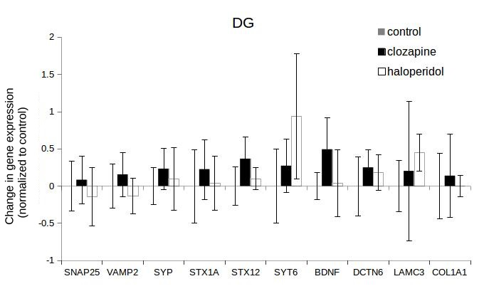
Haloperidol- versus clozapine-mediated gene regulation in the dentate gyrus (DG)
Figure 2

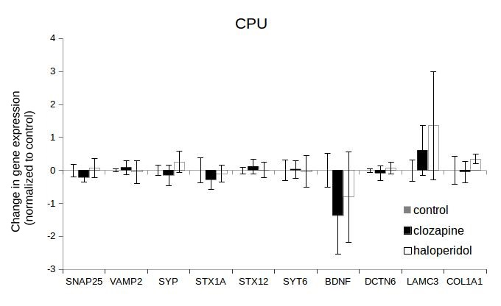
Haloperidol- versus clozapine-mediated gene regulation in caudate putamen (CPU)
Figure 3

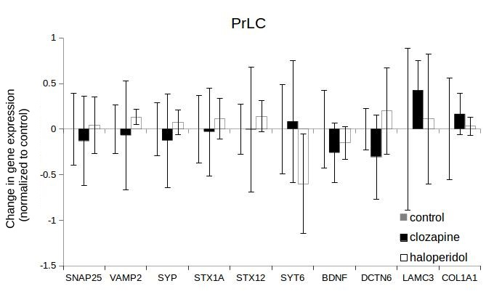
Haloperidol- versus clozapine-mediated gene regulation in the prelimbic cortex (PrLC)
Figure 4

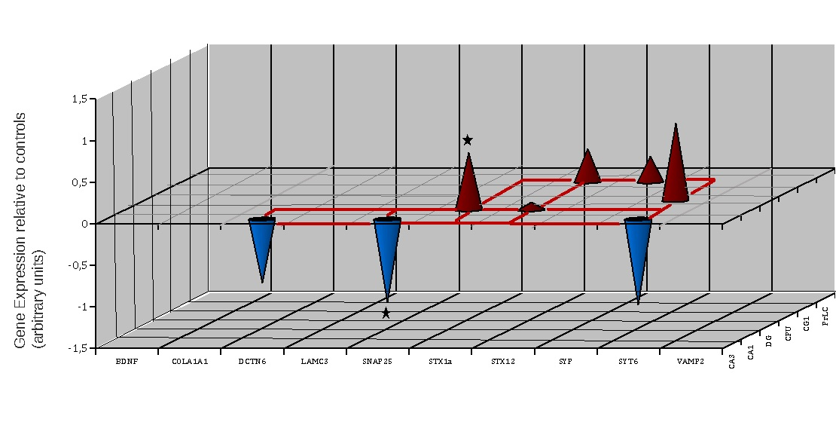
Patterns of gene regulation by haloperidol
Genes of interest displayed on the x-axis, expression levels (arbitrary units) on the y-axis and brain regions on the z-axis. Downregulations are in blue, upregulations in red; significant regulations are labelled with asterisks. Some tentative gene (protein) interactions within and across the brain regions are displayed by dotted lines on the zero plane. * = 0.05
Abbreviations of brain regions: CA1 = cornu ammonis 1, CA3 = cornu ammonis 3, CG1 = cingulate gyrus, CPU = caudate putamen, DG = dentate gyrus, PrLC = prelimbic cortex

Figure 5

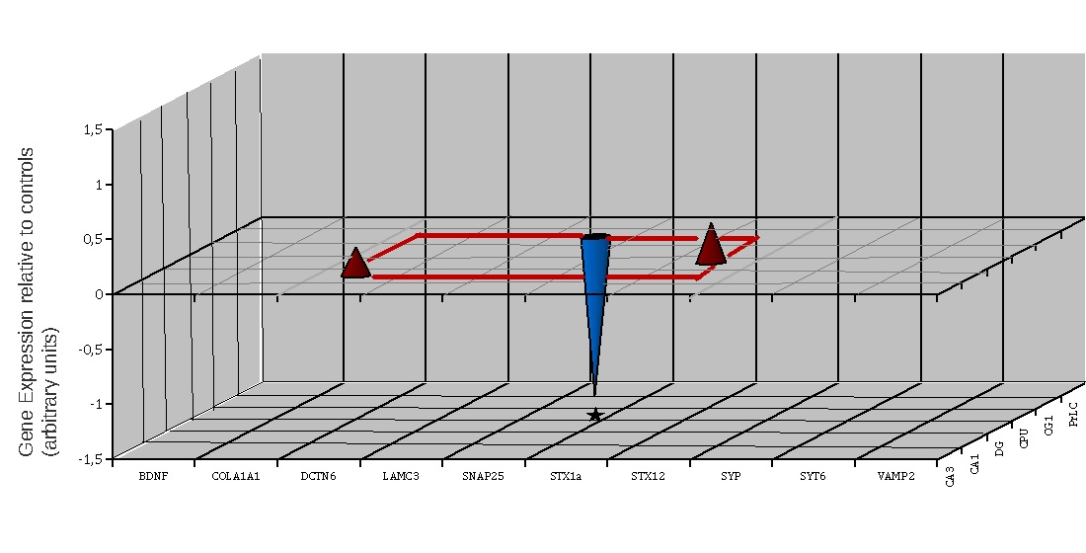
Patterns of gene regulation by clozapine
Genes of interest displayed on the x-axis, expression levels (arbitrary units) on the y-axis and brain regions on the z-axis. Downregulations are in blue, upregulations in red; significant regulations are labelled with asterisks. * = 0.05
Abbreviations of brain regions: CA1 = cornu ammonis 1, CA3 = cornu ammonis 3, CG1 = cingulate gyrus, CPU = caudate putamen, DG = dentate gyrus, PrLC = prelimbic cortex

