Multi-dimensional assessment of idiopathic pulmonary fibrosis across a wide range of disease severity
Hana Serajeddini¹, Paola Rogliani², Marco Mura^{1,3}

¹Division of Respirology, Western University, London, Ontario, Canada
²Malattie Respiratorie, University of Rome “Tor Vergata”, Rome, Italy
³Division of Respirology, University Health Network, Toronto, Ontario, Canada

Supplemental Figure 1.
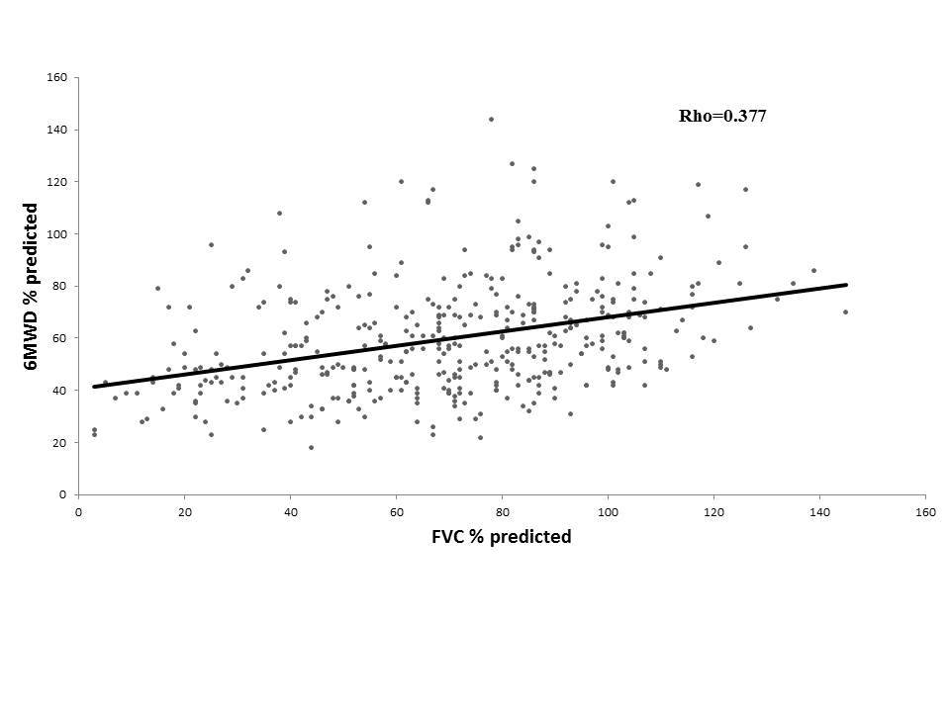
Supplemental Figure 1 legend. Relationship between FVC (% pred) and 6MWD (% pred).
SUPPLEMENTAL TABLES
Supplemental Table 1A. Stepwise regression analysis: predictors of MRCDS.
 | F ratio | p value | VIF (with MRCDS)
6MWD (% pred | 45.6 | <0.0001 | 1.30
FVC (% pred) | 19.3 | <0.0001 | 1.14
DLCO (% pred) | 16.4 | <0.0001 | 1.20

Supplemental Table 1B. Stepwise regression analysis: predictors of 6MWD (% pred).
 | F ratio | p value | VIF (with 6MWD % pred)
MRCDS | 45.6 | <0.0001 | 1.30
DLCO (% pred) | 23.5 | <0.0001 | 1.18
FVC (% pred) | 11.3 | <0.0009 | 1.17

Supplemental Table 1C. Stepwise regression analysis (predictors of FVC % pred). DLCO % pred was not retained as a significant predictor.
 | F ratio | p value | VIF (with FVC  % pred)
MRCDS | 24.9 | <0.0001 | 1.33
6MWD (% pred) | 19.2 | <0.0001 | 1.33
Abbreviations as in Table 1 and 2.

Supplemental Table 2. Multivariate regression analysis, independent predictors (ordinal variables with cutoffs identified by ROC analysis) of 18-month mortality.
 | Hazard Ratio (C.I.) | p value | Chi Square of the model
Model 1  - MRCDS >3  - 6MWD m ≤333  - FVC % ≤58 | - 1.39 (1.05-1.83)  - 1.71 (1.31-2.25)  - 1.97 (1.50-2.59) | - 0.0206  - 0.0001  - < 0.0001 | 74.2
Model 1  - MRCDS >3  - 6MWD % ≤68  - FVC % ≤58 | - 1.33 (1.01-1.75)  - 1.92 (1.47-2.52)  - 1.93 (1.47- 2.55) | - 0.0450  - < 0.0001  - < 0.0001 | 80.4
Model 2  - MRCDS >3  - 6MWD % ≤68  - DLCO %≤37 | - 1.65 (1.21-2.23)  - 2.05 (1.50-2.79)  - 1.22 (0.67-1.66) | - 0.0015  - <0.0001  - n.s. | 50.9
*VIF seen in table 3 were all very low suggesting independent predictive value of variables. Abbreviations as in Table 1 and 2.

Supplemental Table 3. Multivariate regression analysis, independent predictors (continuous variables) of 18-month mortality, in patients stratified according to FVC % pred.
 | Hazard Ratio (C.I.) | p value | Chi Square of the model
FVC <57% pred (n=206)  - MRCDS  - 6MWD (m)  - FVC (% pred) | - 1.08 (0.88-1.33)  - 0.99 (0.99-0.99)  - 0.98 (0.96-0.99) | - n.s.  - <0.0001  - 0.0282 | 47.8
FVC ≥57% pred  (n=231)  - MRCDS  - 6MWD (m)  - FVC (% pred) | - 1.80 (1.42-2.30)  - 0.99 (0.99-0.99)  - 0.98 (0.96-0.99) | - <0.0001  - 0.0005  - 0.0018 | 67.2

Supplemental Table 4. Univariate regression analysis. Predictors of 18-month mortality, considering LTx as competing event.
Variables | Hazard Ratio (C.I.) | p value
Age  Age ≤70 | 1.04 (1.02-1.06)  0.63 (0.42-0.95) | <0.0001  0.0260
BMI  BMI ≤28 | 0.96 (0.92-1.01)  1.28 (0.86-1.90) | n.s.  n.s.
MRCDS  MRCDS >3 | 2.18 (1.70-2.78)  4.01 (2.74-6.02) | <0.0001  <0.0001
6MWD m  6MWD m ≤333 | 0.99 (0.99-1.00)  3.99 (2.52-6.30) | <0.0001  <0.0001
6MWD % pred  6MWD ≤68 % pred | 0.97 (0.97-0.98)  3.12 (2.04-4.79) | <0.0001  <0.0001
FVC % pred  FVC ≤58 % pred | 0.99 (0.98-1.00)  1.40 (0.95-2.07) | <0.0001  n.s.
DLCO % pred  DLCO ≤37 % pred | 0.95 (0.94-0.97)  4.47 (2.76-7.24) | <0.0001  <0.0001
n.s. = not significant. Abbreviations as in Table 1.

Supplemental Table 5A. Multivariate regression analysis, independent predictors (continuous variables) of 18-month mortality, considering LTx as competing event.
 | Hazard Ratio (C.I.) | p value | Chi Square  of the model
Model 1  - MRCDS  - 6MWD (m)  - FVC (% pred) | - 1.60 (1.19-2.14)  - 0.99 (0.99-1.00)  - 1.00 (0.99-1.01) | - 0.002  - <0.001  - n.s. | 57.3
Model 2  - MRCDS  - 6MWD (% pred)  - FVC (% pred) | - 1.70 (1.27-2.29)  - 0.98 (0.97-0.99)  - 1.01 (1.00-1.02) | - <0.001  - <0.001  - n.s. | 50.1
Model 3  - MRCDS  - 6MWD (% pred)  - DLCO (% pred) | - 1.84 (1.33-2.54)  - 0.99 (0.98-1.00)  - 0.98 (0.97-1.00) | - <0.001  - 0.011  - 0.060 | 55.3
n.s. = not significant. Abbreviations as in Table 1.

Supplemental Table 5B. Multivariate regression analysis, independent predictors (ordinal variables with cutoffs identified by ROC analysis) of 18-month mortality, considering LTx as competing event.
 | Hazard Ratio (C.I.) | p value | Chi Square  of the model
Model 1  - MRCDS >3  - 6MWD m ≤333  - FVC % ≤58 | - 2.72 (1.75-4.21)  - 2.88 (1.75-4.74)  - 0.81 (0.52-1.26) | - <0.0001  - <0.0001  - n.s. | 51.1
Model 2  - MRCDS >3  - 6MWD % ≤68  - FVC % ≤58 | - 2.91 (1.87-4.52)  - 2.23 (1.37-3.65)  - 0.79 (0.50-1.26) | - <0.0001  - 0.001  - n.s. | 46.2
Model 3  - MRCDS >3  - 6MWD % ≤68  - DLCO % ≤37 | - 2.83 (1.75-4.59)  - 1.52 (0.91-2.55)  - 2.43 (1.39-4.22) | - <0.0001  - n.s.  - 0.002 | 57.6
Abbreviations as in Table 1.

