Additional file 1

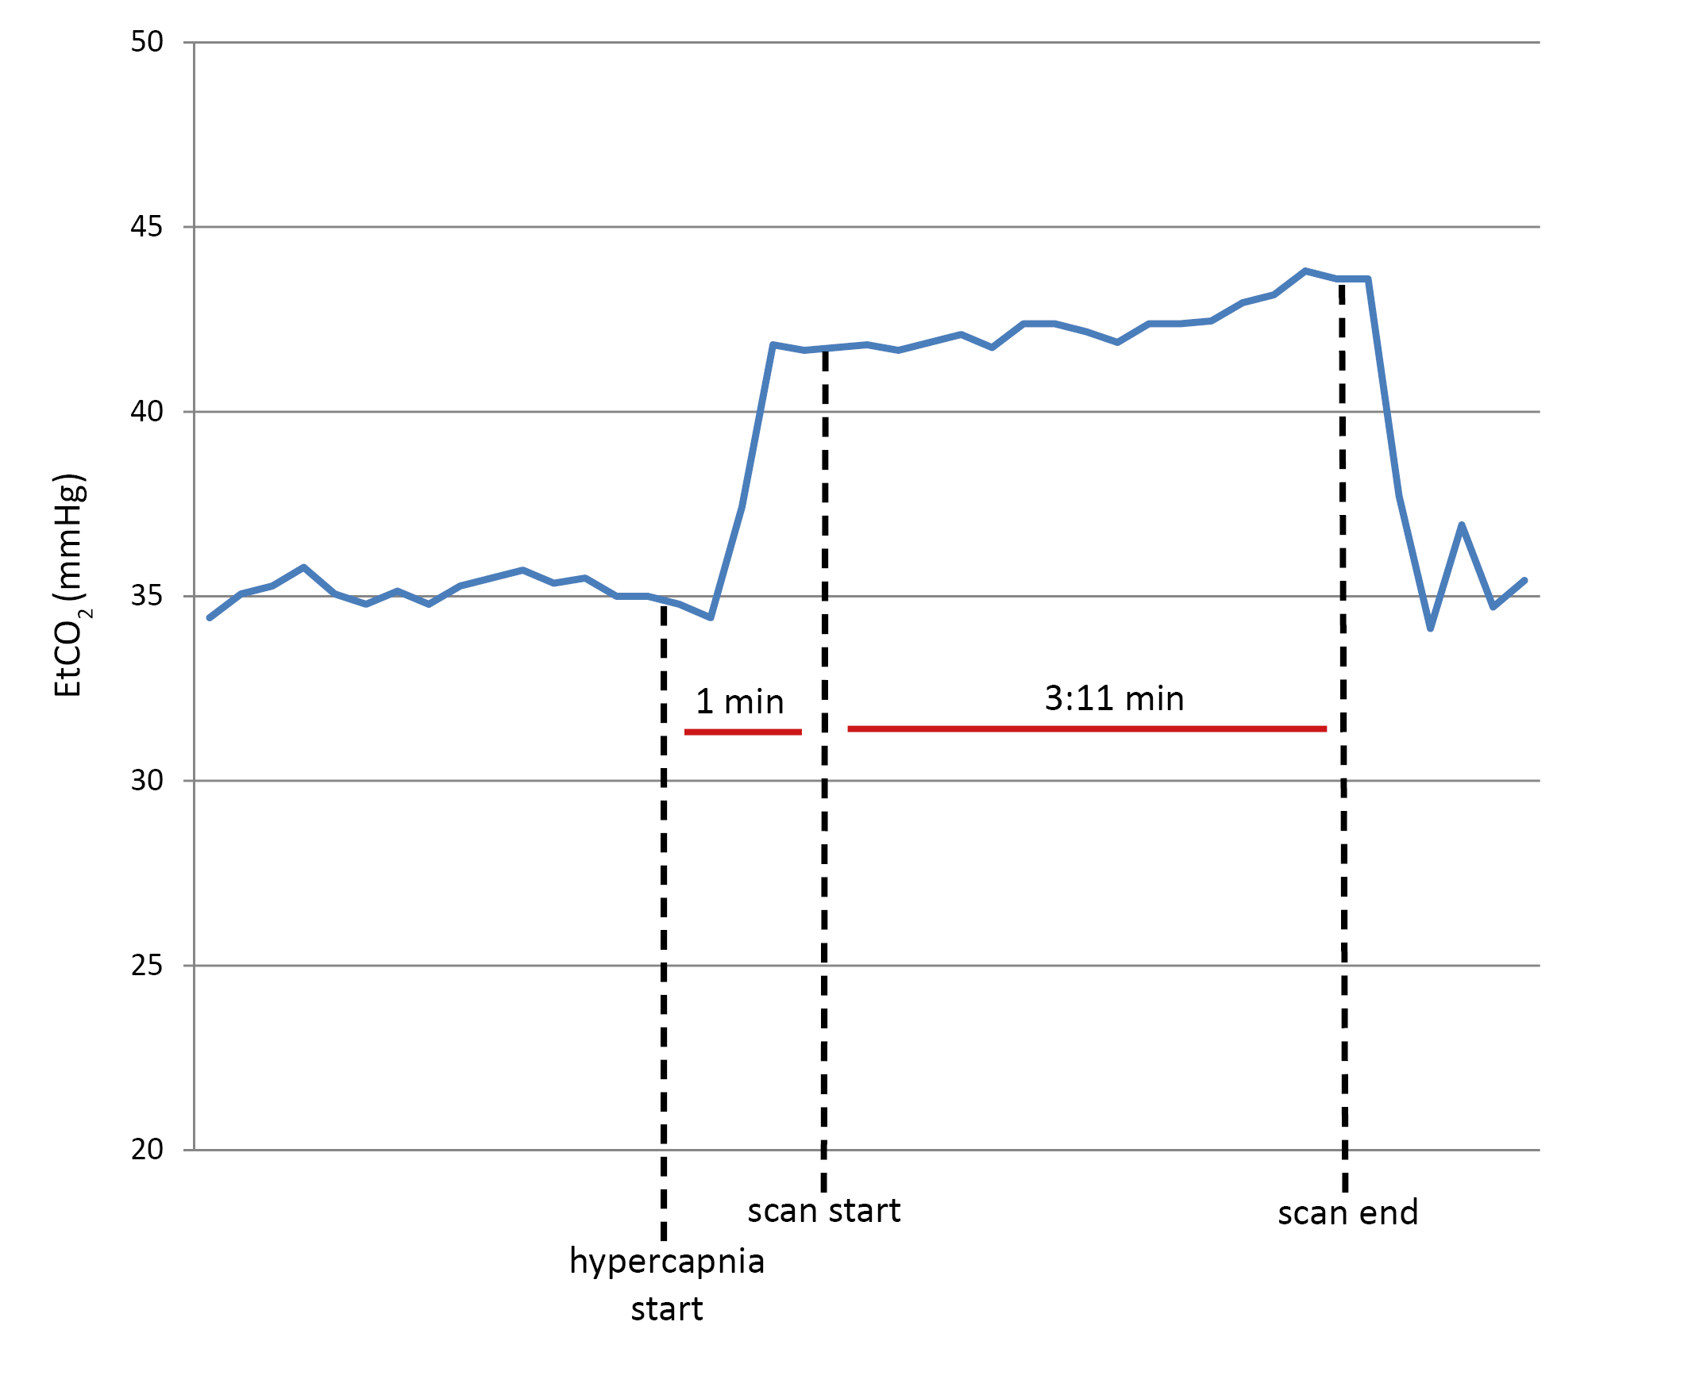
Fig. S1. Hypercapnia challenge (EtCO₂ on y-axis) and timing of 3DT1-weighted sequence acquisition for Subject 7.

