Supplemental Figure 1 Example of a physician-patient communication regarding skin toxicities (patient brochure)
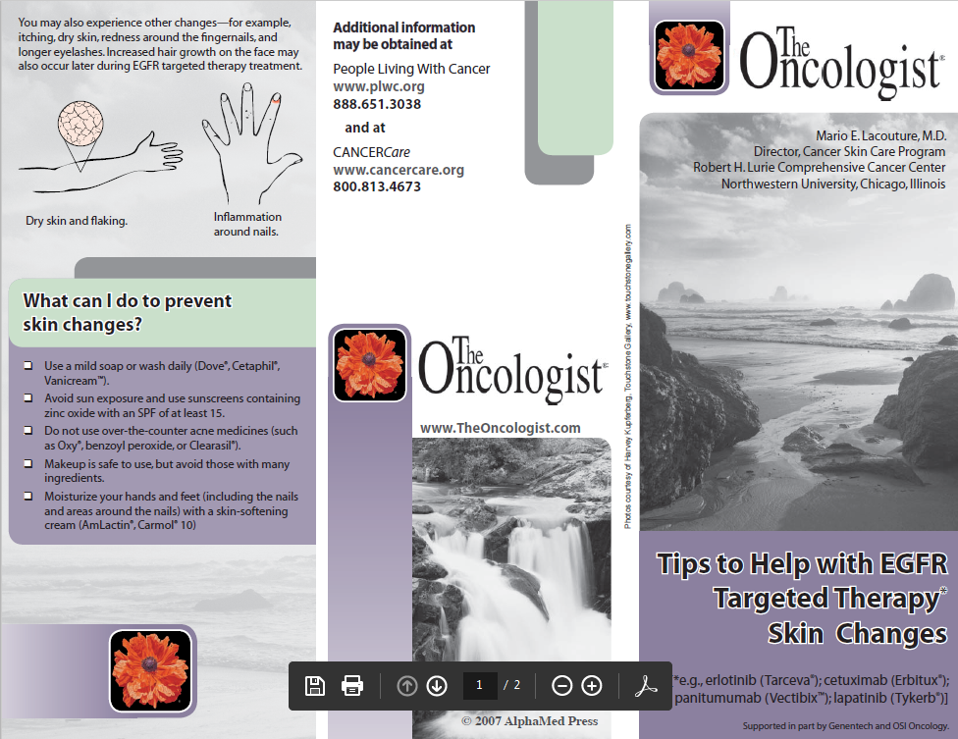
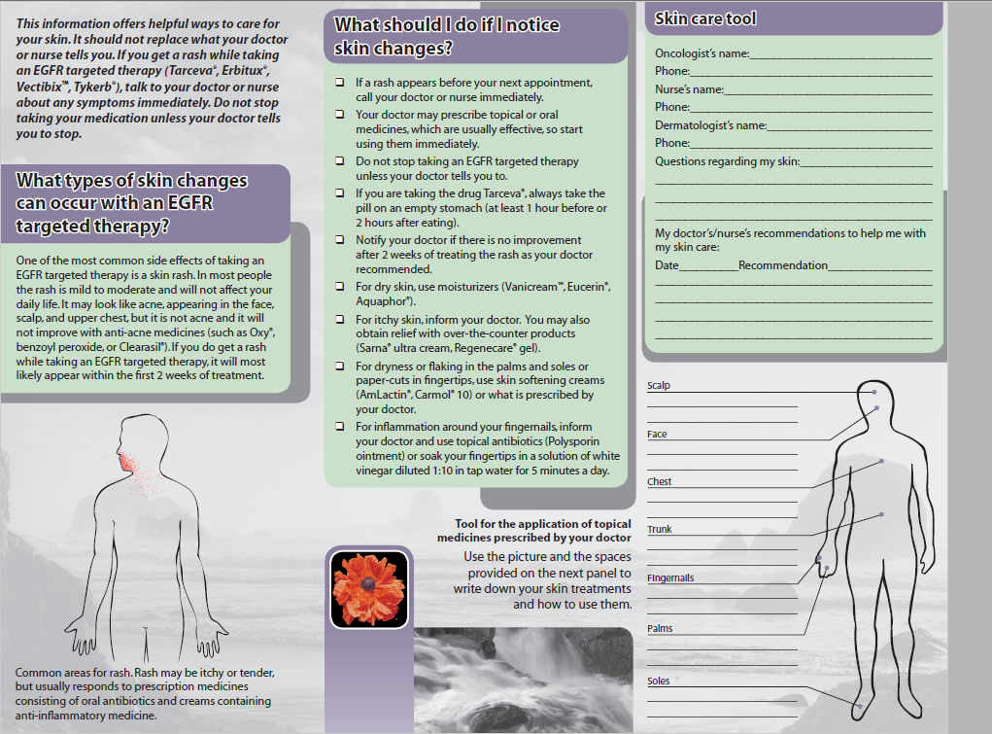
Lynch TJ Jr, Kim ES, Eaby B, Garey J, West DP, Lacouture ME. Epidermal growth factor receptor inhibitor-associated cutaneous toxicities: an evolving paradigm in clinical management. Oncologist. 2007;12(5):610-621, patient brochure. http://theoncologist.alphamedpress.org/content/suppl /2007/08/27/12.5.610.DC1/Patient_Brochure.pdf. Accessed July 21, 2016.

