Supplementary data

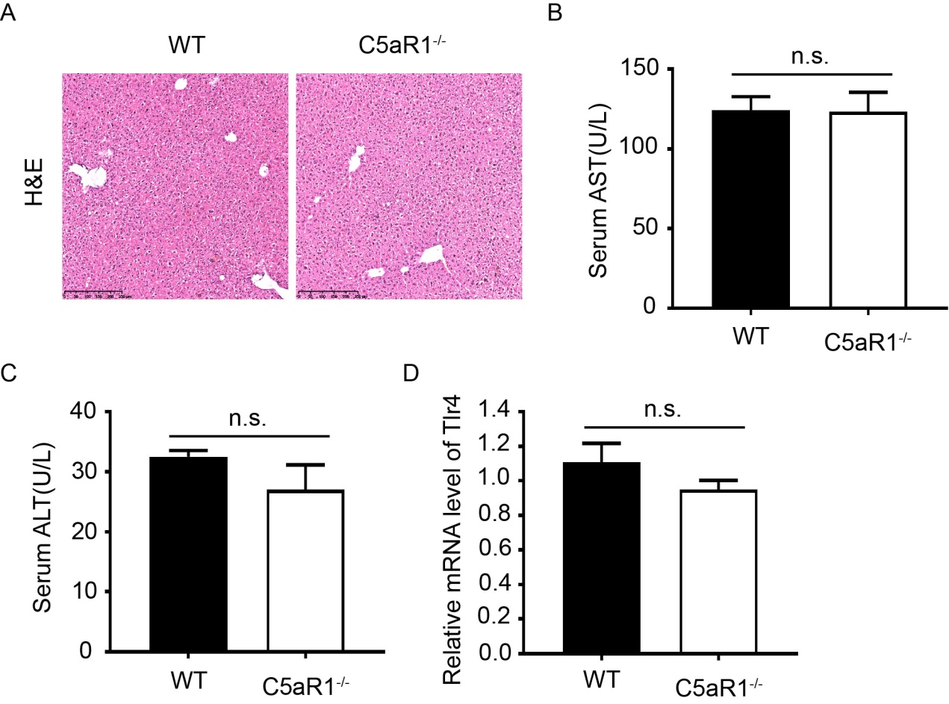

Supplementary Figure 1 C5aR1^{-/-} and wild type mice fed with normal diet.
A. H&E staining of liver tissue sections. B. Serum level of AST. C. Serum level of ALT. D. The mRNA level of Tlr4.

Supplementary Table 1 Primers used in this study
Gene | Forward primer | Reverse primer
IL-6 | TGATGCACTTGCAGAAAACA | ACCAGAGGAAATTTTCAATAGGC
Tnf | CCACCACGCTCTTCTGTCTAC | AGGGTCTGGGCCATAGAACT
IL-1 | TGTGAAATGCCACCTTTTGA | GGTCAAAGGTTTGGAAGCAG
F4/80 | TCAAGGCCATTGCCCAGATT | CATCCCGTACCTGACGGTTG
Sma | CTACTGCCGAGCGTGAGATT | CGTTCTGGAGGGGCAATGAT
Col1a1 | GCACGTCTGGTTTGGAGAGA | TCCAAGGGAGCCACATCGAT
Tgf1 | AGTGGCTGAACCAAGGAGAC | CTGTGTGTCCAGGCTCCAAA
Fasn | GCCGTGTCCTTCTACCACAA | GGATCGGAGCATCTCTGGTG
Acc | TGAGGAGGACCGCATTTATC | GAAGCTTCCTTTGTGACCAG
Srebf1 | CGGGACAGCTTAGCCTCTAC | TCCATTGCTGGTACCGTGAG
iNOS | CGTTCCTGGAGGTGCTTGAA | TGGAAGCCACTGACACTTCG
MCP1 | CACTCCCGTCCTTACATGGC | GAGCTCCAAGGGTGACAGTG
MRC2 | GTGGGACGGTTCTGTCCATT | GCCTCCTTTGGGGTTGAAGT
CD163 | GAAGCGACGACAGATTCAGC | TGTGCCTCTGAATGACCCCT
Tlr4 | TTGCTGGGGCTCATTCACTC | AGACTCGGCACTTAGCACTG
Nlrp3 | CTTCTGCACCCGGACTGTAA | TAGCAGTGAAGAGCAGTGCG
GAPDH | CCCACTAACATCAAATGGGG | CCTTCCACAATGCCAAAGTT

