Supplemental Table 1. Five groups derived according to changes in total cholesterol during adolescence

|  |  |  |
| --- | --- | --- |
| Change groups | The first year of high school  (age 15-16) | The third year of high school  (age 17-18) |
| Consistently low | Lower tertile | Lower tertile |
| Decreased | Middle or upper tertile | Lower tertile |
| Upper tertile | Middle tertile |
| Consistently moderate | Middle tertile | Middle tertile |
| Increased | Lower or middle tertile | Upper tertile |
| Lower tertile | Middle tertile |
| Consistently high | Upper tertile | Upper tertile |

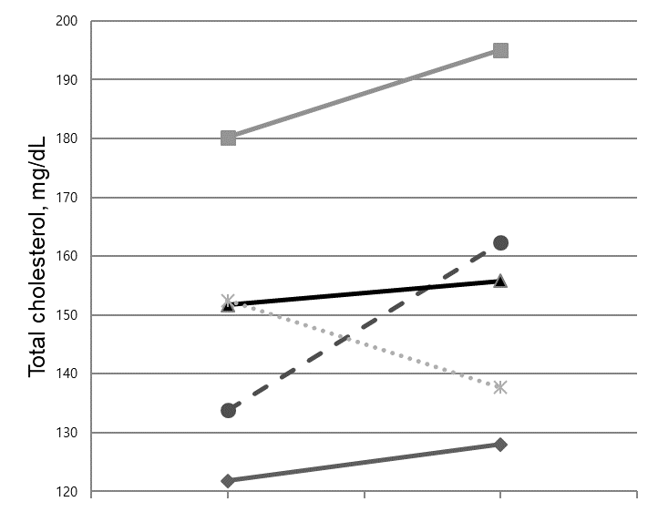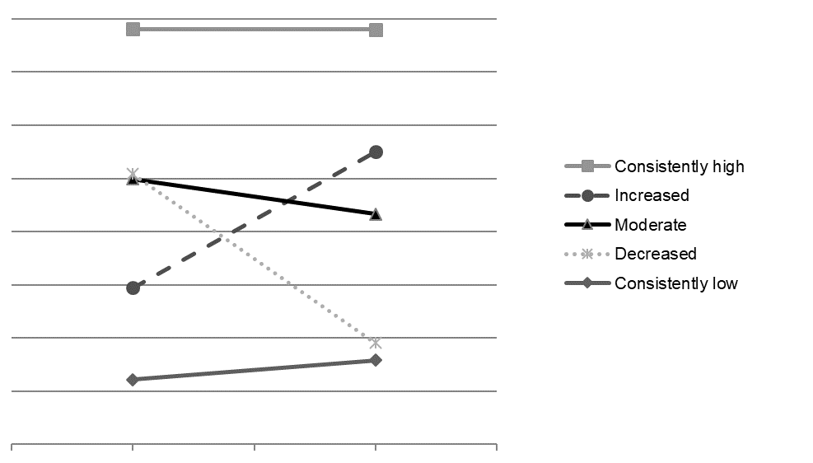

The first year

The first year

The third year

The third year

Females

Males

Supplemental Figure. Five groups derived according to changes in total cholesterol during adolescence.

Supplemental table 2. Baseline characteristics of follow-up responders and non-responders (n=1071)

|  |  |  |  |  |  |  |  |  |  |  |  |  |  |  |  |
| --- | --- | --- | --- | --- | --- | --- | --- | --- | --- | --- | --- | --- | --- | --- | --- |
| Characteristic | Males (n=557) | | | | | | |  | Females (n=514) | | | | | | |
| Follow-up  responders  (n=239) | | | Follow-up  non-responders (n=318) | | | *p*-value |  | Follow-up  responders  (n=305) | | | Follow-up  non-responders (n=209) | | | *p*-value |
| Age, years | 15.9 | ± | 0.4 | 15.9 | ± | 0.4 | 0.189 |  | 15.9 | ± | 0.4 | 15.9 | ± | 0.4 | 0.390 |
| Depressive symptoms, score | 6 | [4-10] | | 7 | [4-10] | | 0.046 |  | 7 | [4-11] | | 8 | [5-12] | | 0.095 |
| Height, cm | 171.4 | ± | 5.4 | 171.5 | ± | 5.2 | 0.826 |  | 160.0 | ± | 5.0 | 159.3 | ± | 5.1 | 0.133 |
| Weight, kg | 65.3 | ± | 10.3 | 65.2 | ± | 10.9 | 0.947 |  | 54.5 | ± | 7.5 | 53.9 | ± | 7.2 | 0.384 |
| Body mass index, kg/m2 | 22.2 | ± | 3.2 | 22.1 | ± | 3.3 | 0.817 |  | 21.3 | ± | 2.6 | 21.2 | ± | 2.6 | 0.887 |
| Waist circumference, cm | 73.7 | ± | 8.3 | 73.6 | ± | 8.0 | 0.900 |  | 68.1 | ± | 6.9 | 69.3 | ± | 6.5 | 0.049 |
| Systolic blood pressure, mmHg | 114.5 | ± | 12.4 | 115.5 | ± | 13.1 | 0.352 |  | 103.6 | ± | 10.2 | 104.6 | ± | 11.1 | 0.305 |
| Diastolic blood pressure, mmHg | 60.7 | ± | 7.8 | 62.0 | ± | 7.8 | 0.060 |  | 60.1 | ± | 7.3 | 60.4 | ± | 7.5 | 0.625 |
| Total cholesterol, mg/dL | 148.3 | ± | 25.4 | 149.0 | ± | 23.9 | 0.732 |  | 163.1 | ± | 26.8 | 161.4 | ± | 25.3 | 0.480 |
| HDL cholesterol, mg/dL | 44.2 | ± | 10.0 | 44.1 | ± | 9.9 | 0.829 |  | 50.7 | ± | 11.0 | 48.7 | ± | 10.8 | 0.048 |
| Triglycerides, mg/dL | 76 | [60-95] | | 77 | [59-99] | | 0.492 |  | 76 | [60-91] | | 73 | [59-91] | | 0.258 |
| Monthly household income |  |  |  |  |  |  |  |  |  |  |  |  |  |  |  |
| Not answered | 64 | (26.8) | | 97 | (30.5) | | 0.435 |  | 77 | (25.3) | | 65 | (31.1) | | 0.518 |
| < 3.0 million KRW | 38 | (15.9) | | 53 | (16.6) | |  | 42 | (13.8) | | 32 | (15.5) | |
| 3.0-<5.0 million KRW | 75 | (31.4) | | 81 | (25.3) | |  | 103 | (33.8) | | 63 | (30.6) | |
| ≥ 5.0 million KRW | 62 | (25.9) | | 87 | (27.2) | |  | 83 | (27.2) | | 49 | (23.8) | |
| Health behaviors |  |  | |  |  | |  |  |  |  | |  |  | |  |
| Smoking (≥100 cigarettes) | 17 | (7.1) | | 28 | (8.8) | | 0.479 |  | 1 | (0.3) | | 2 | (1.0) | | 0.356 |
| Drinking (≥1 time/month) | 13 | (5.4) | | 47 | (14.8) | | <.001 |  | 13 | (4.3) | | 13 | (6.2) | | 0.306 |
| Regular exercise (≥1 time/week) | 236 | (98.7) | | 309 | (97.2) | | 0.089 |  | 304 | (99.7) | | 205 | (98.1) | | 0.782 |

Data are expressed as a mean ± standard deviation, median [interquartile range], or number (%).